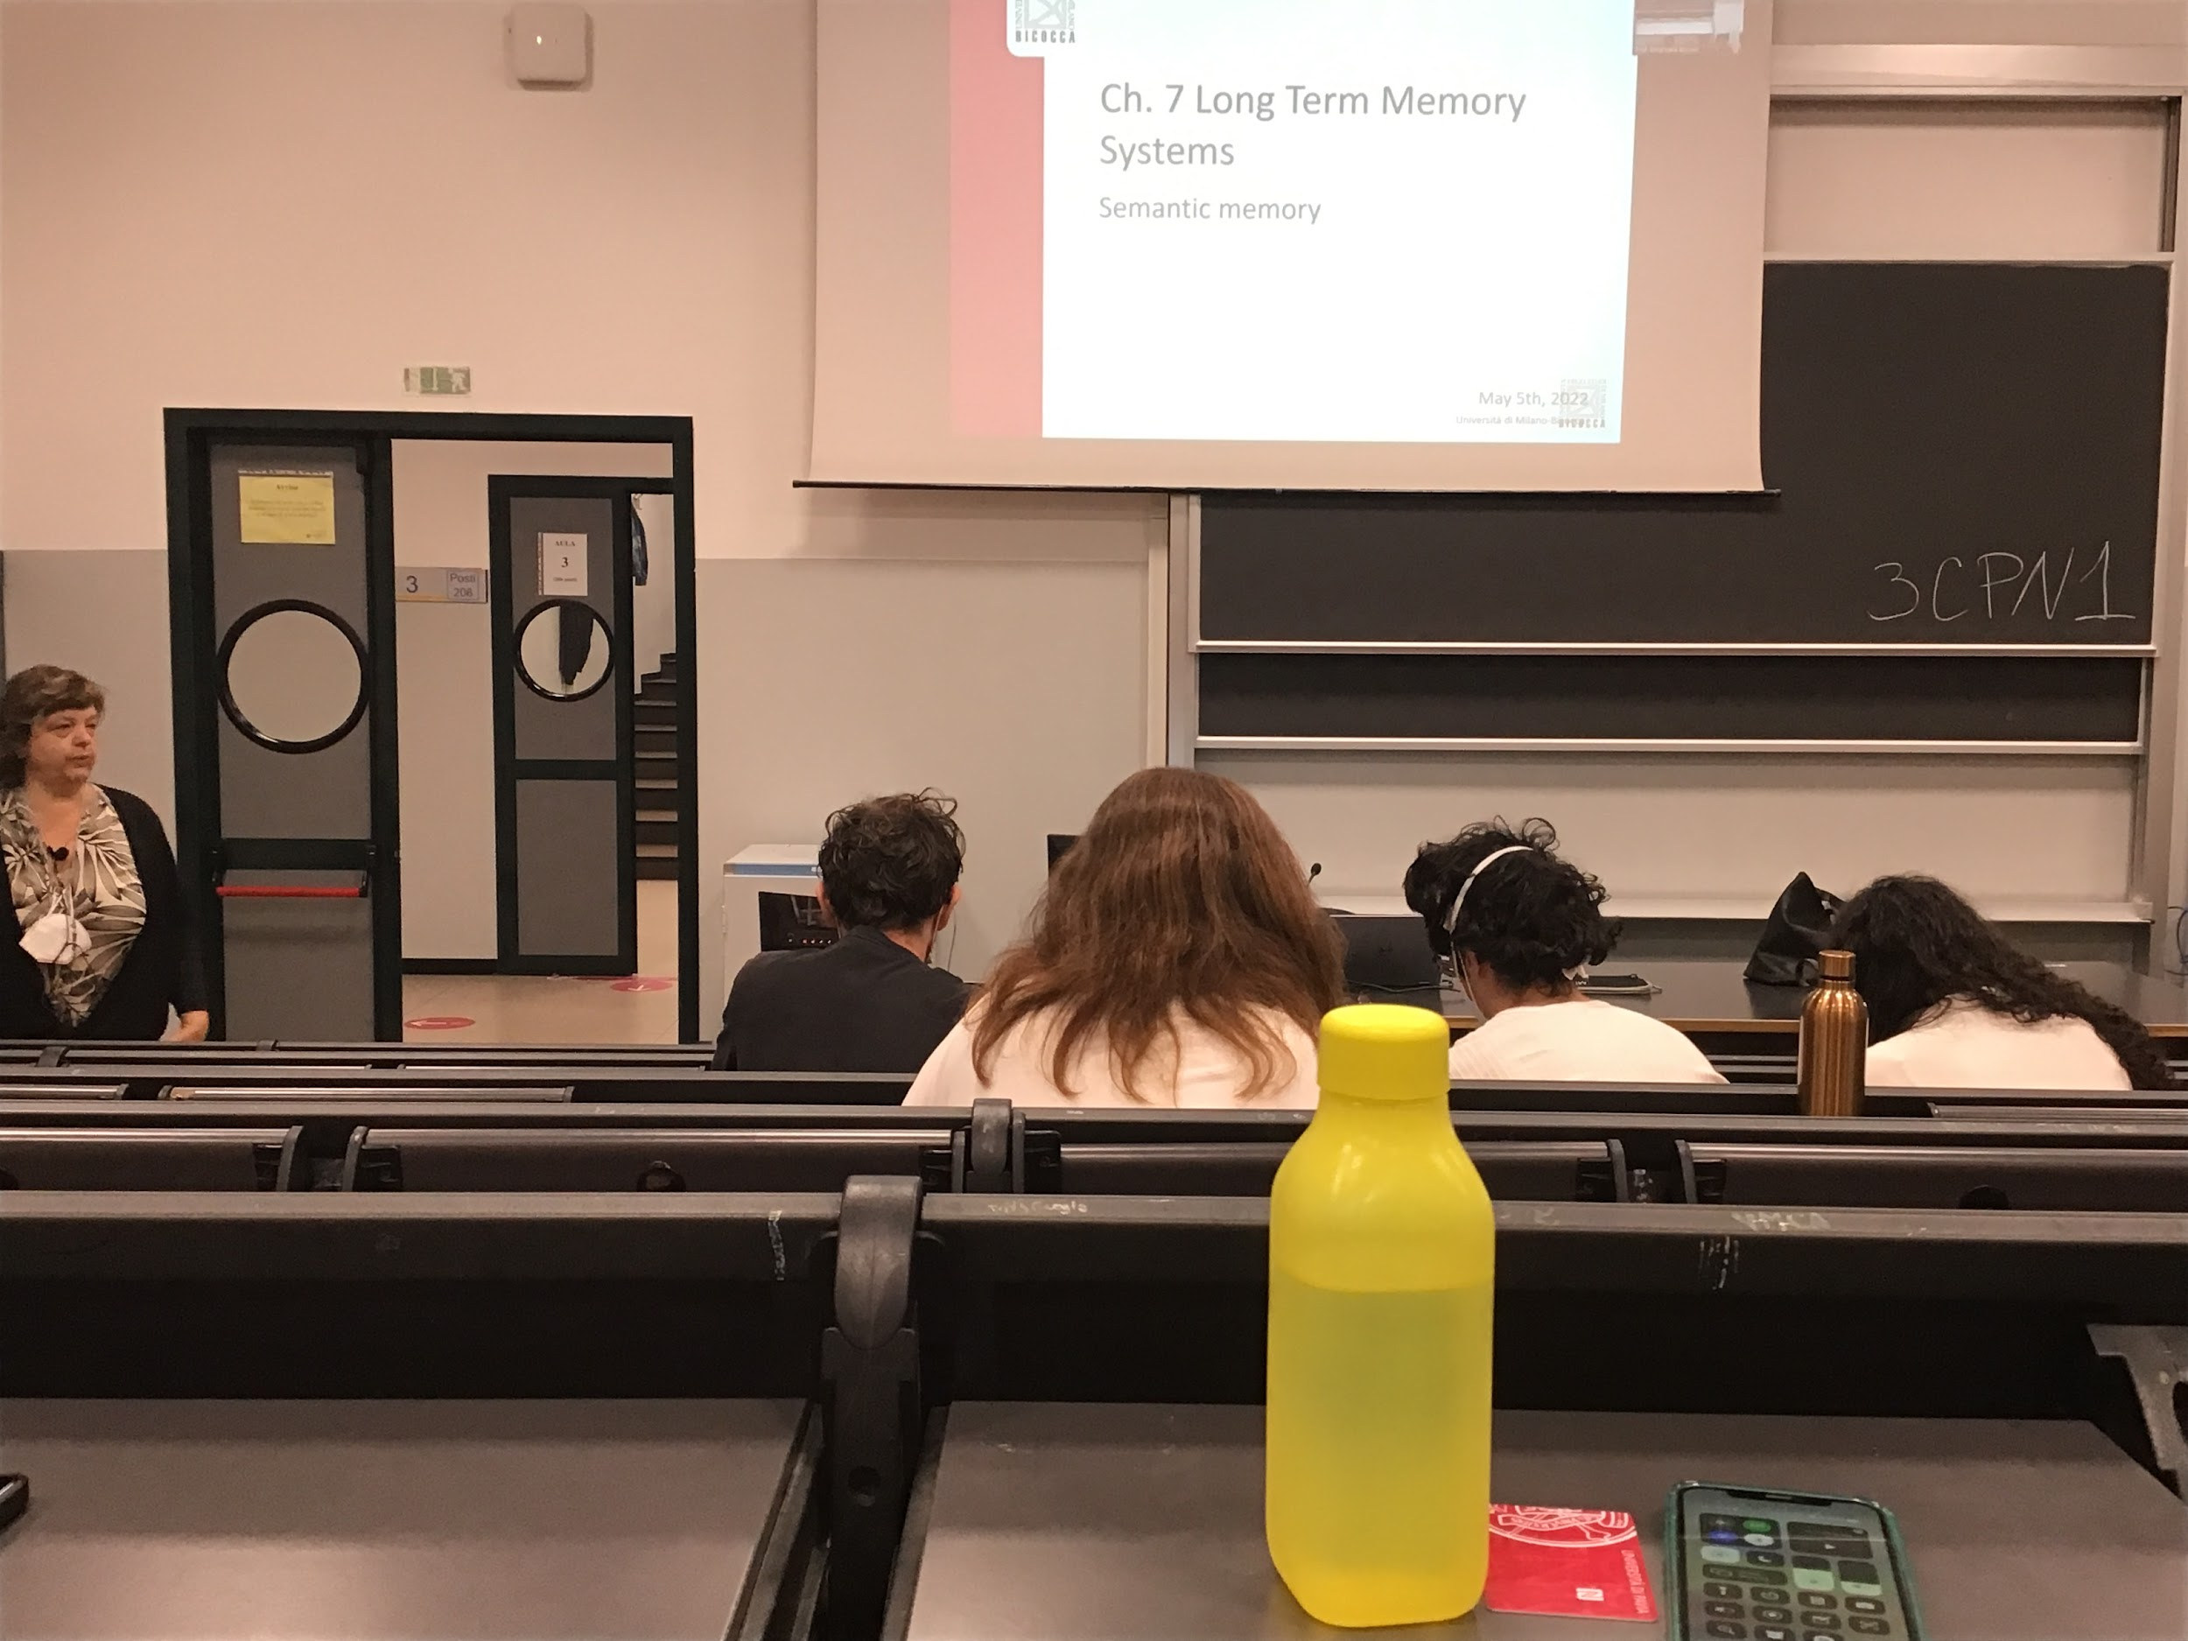

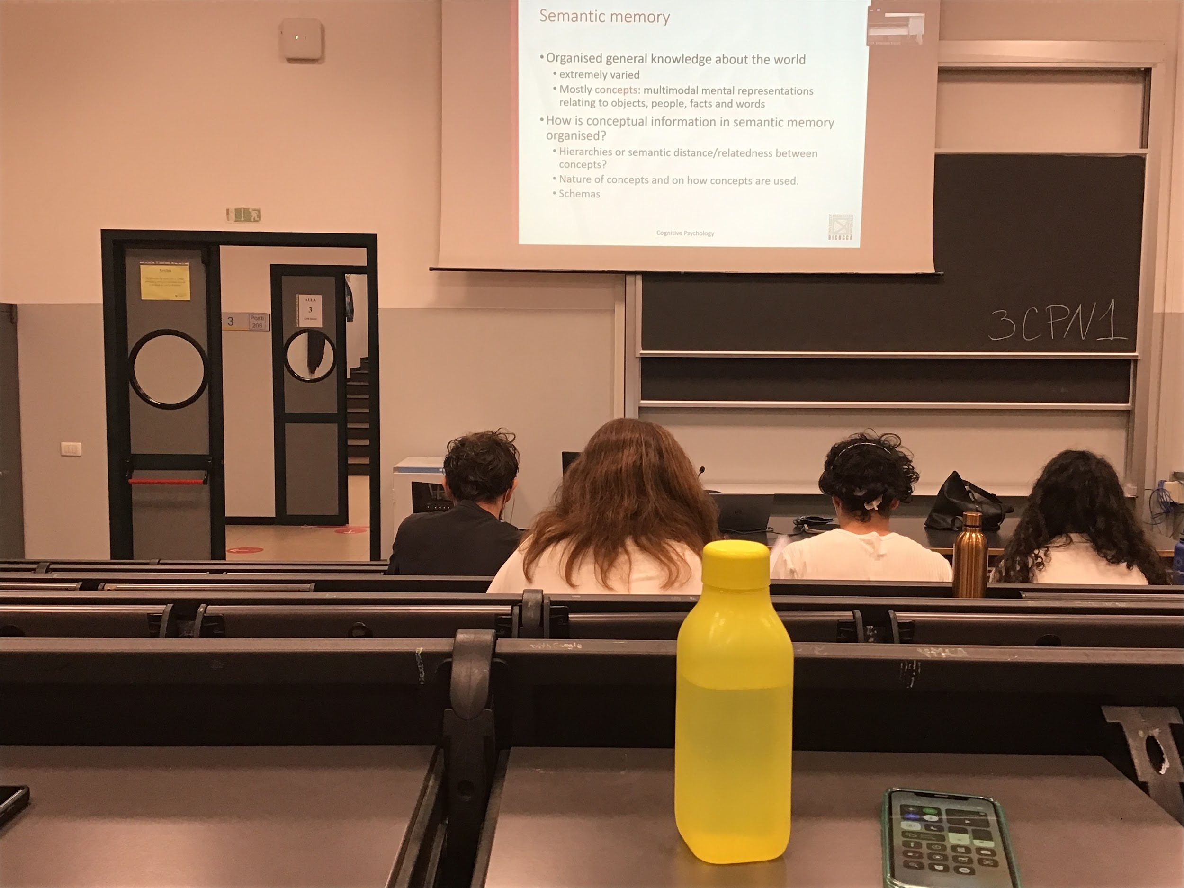

Semantic memory is an organised structure in which we save mostly concepts, we also save more complex structure

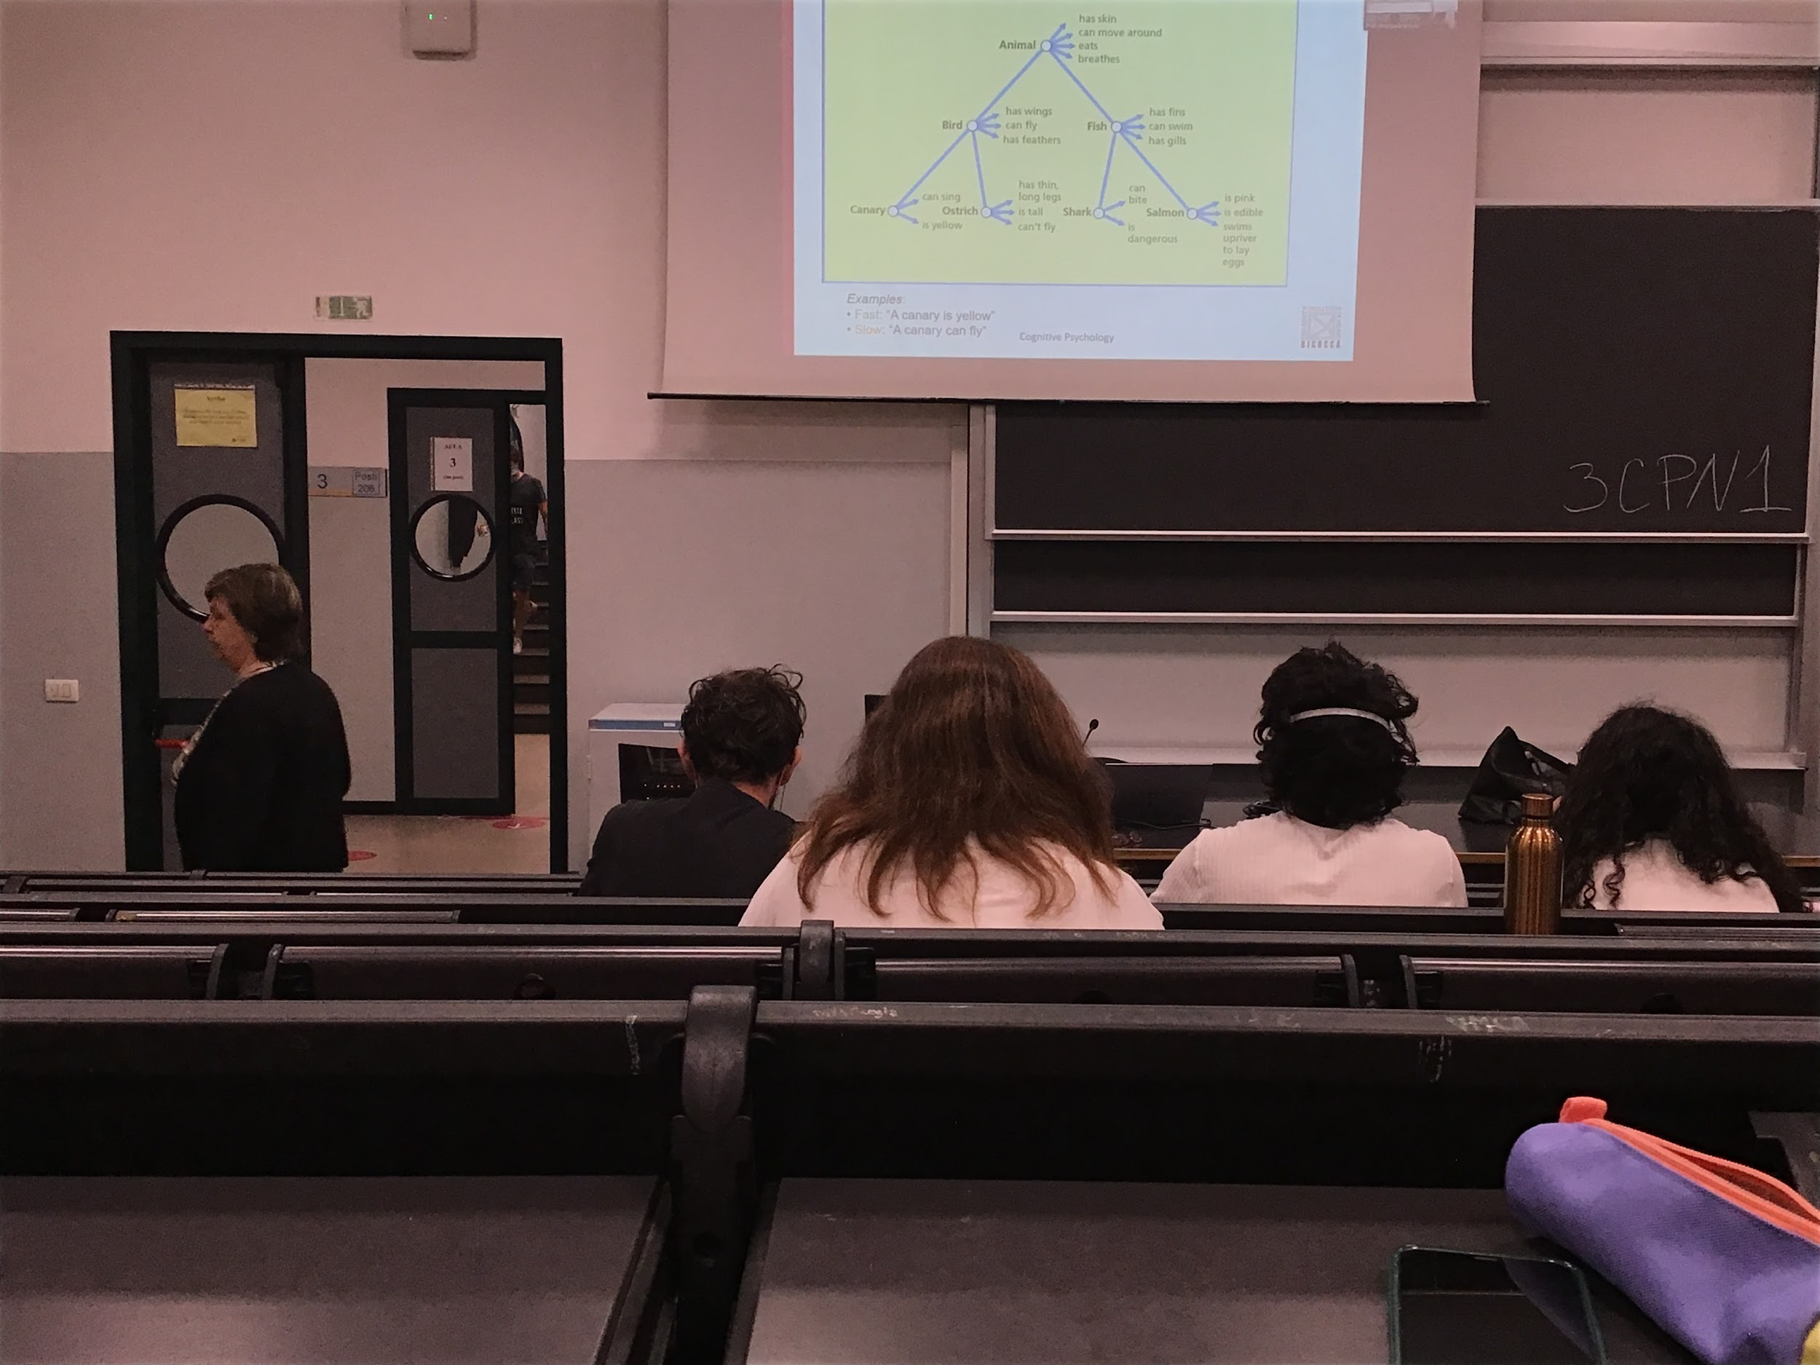

**Hierarchical concept**, at each node superordinate (most general), basic and subordinate (most specific one). To each node is associate some kind of property that is common for all the nodes that are under it

Data in support of hierarchical structure: people are timed when answered to this type of question. If the question was related to the same level you are faster at responding, if you have to navigate in the hierarchical it takes longer time

Idea of the hierarchical structure was interesting, one of the first approaches in which psychologist decided that semantic memory is organised, too rigid organization

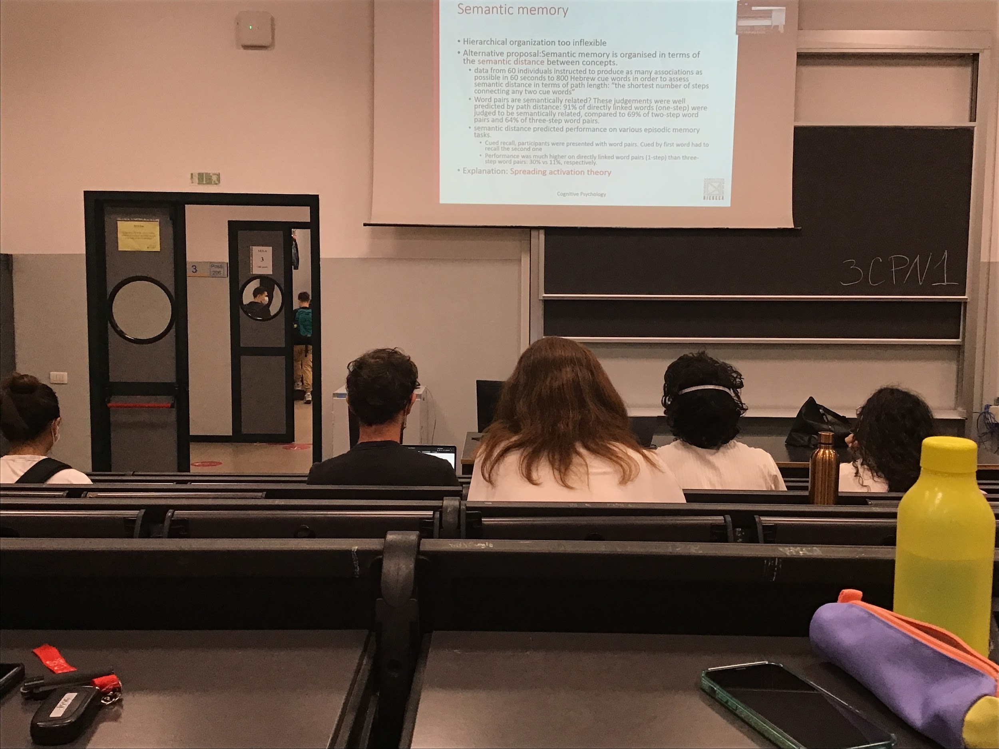

Second type of model. **Semantic distance**: each concept is a node, not strictly organised in hierarchy. Each node connected to different concept that have something in common

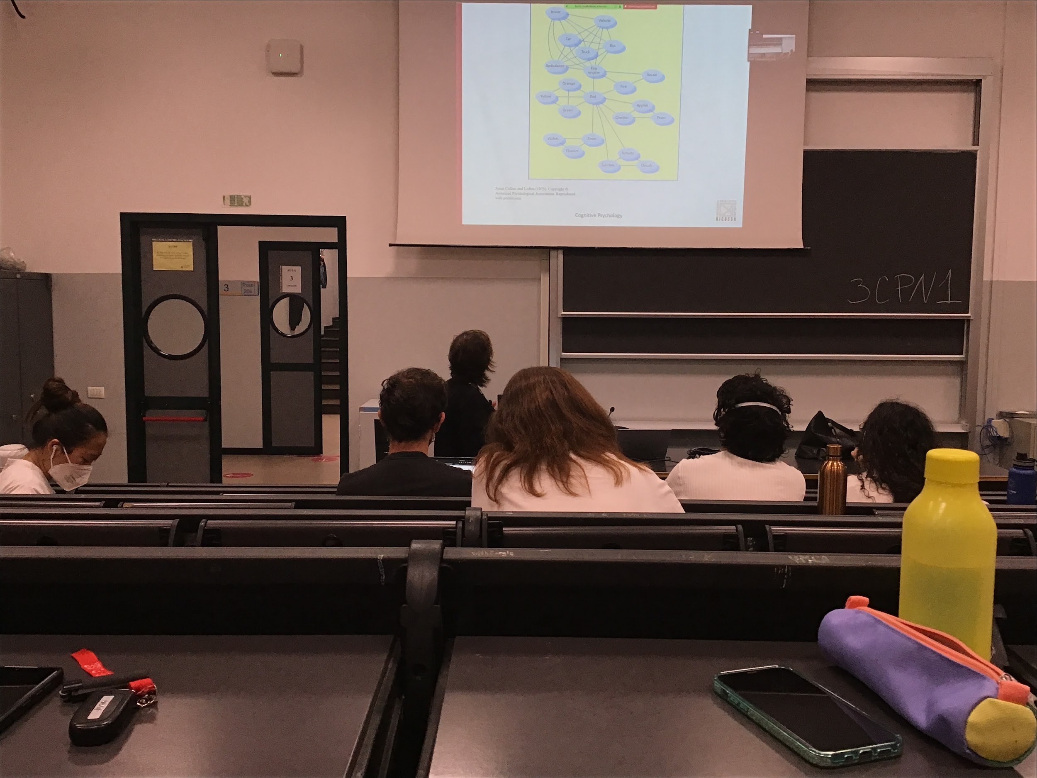

According to the previous organised house and fire engine are in two different trees, in this approach one concept can be closed by even if they don’t belong to the same subordinate category

Idea: when I activate in some way the fire engine node and this activation spreads around all the close nodes. Further I go from the original node the activation becomes lower

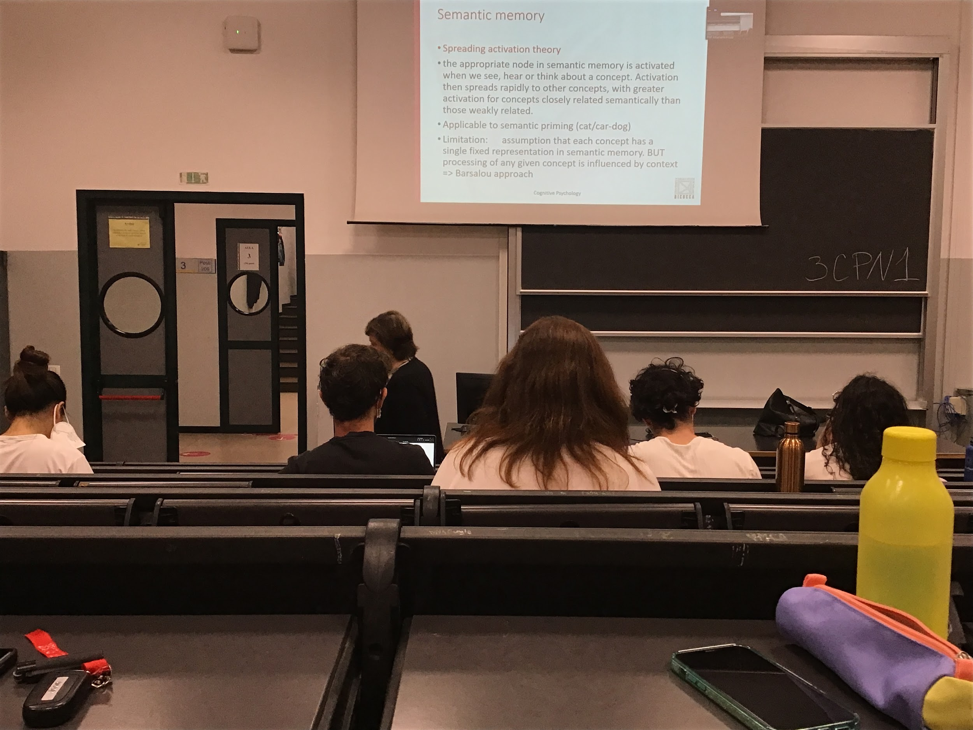

Both approaches (hierarchical and the semantic distance) **have the assumption that each concept has a single fixed representation in semantic memory**. When I think about a bike I think about an object that has 2 wheels, pedals… but it is too strict

In each given moment when I am thinking about an object I am influenced about the context. I pay attention to specific characteristics of that object

The traditional view was that cognition is between perception and action, I perceive, create concepts and then make an action

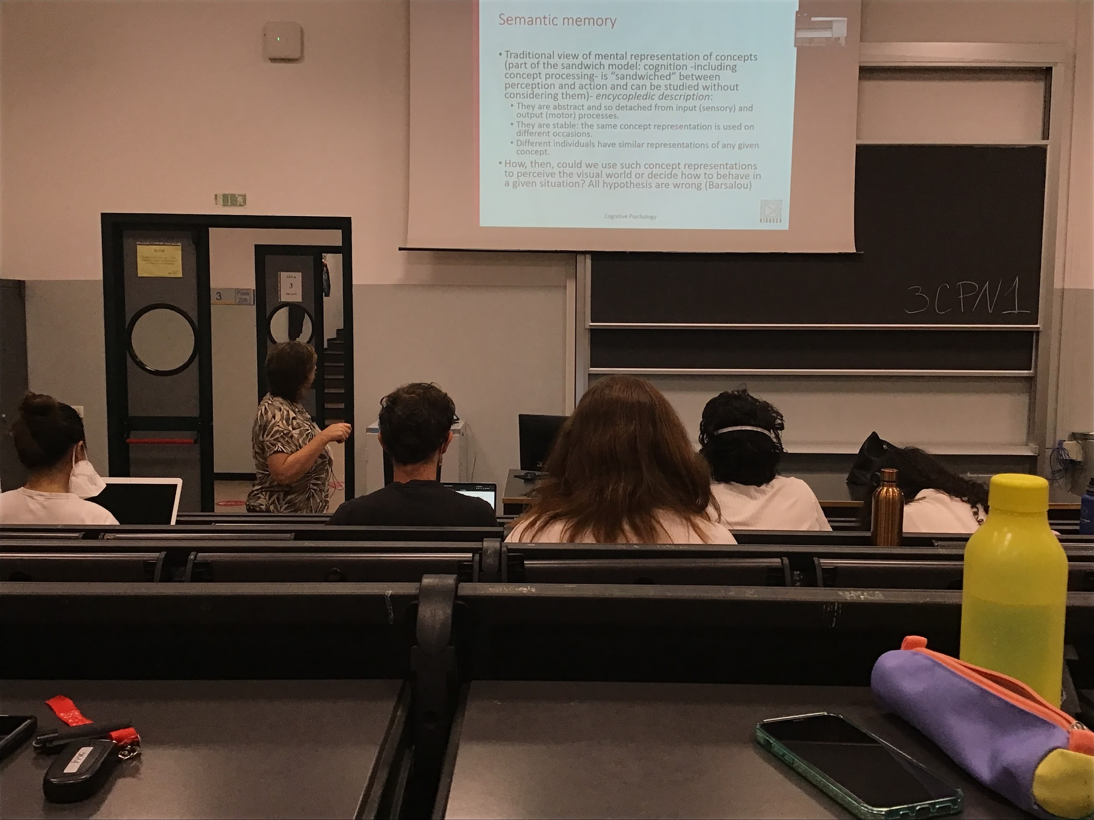

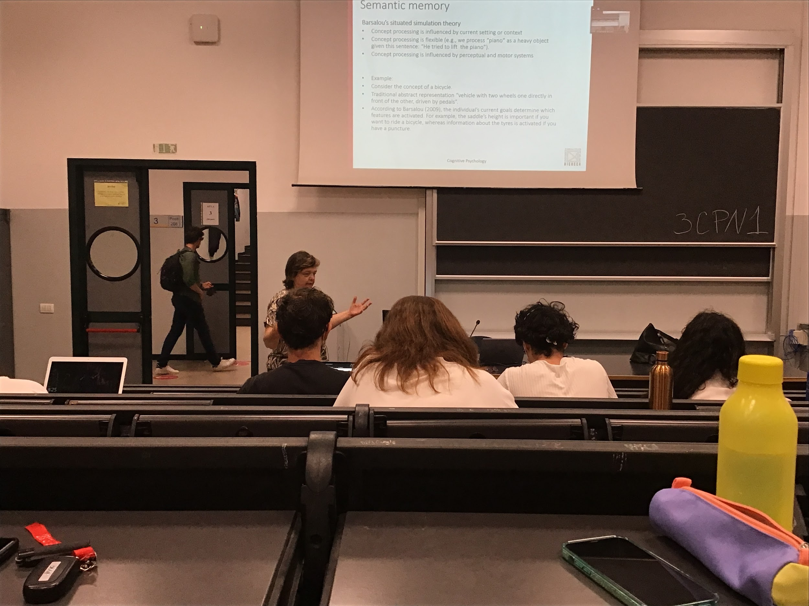

In reality the way I process a concept depends a lot on the context I am, processing a concept is flexible

Different representation of the piano

* if I think that some is playing it
* If I have to image to move a piano from one floor to another

**We activate different characteristic of the object depending on what we need to do (our task)**

Concept processing is influenced by the perception and by the motor system

If the original hierarchical concept a bike is represented with some specific characteristic according to Barsalou there is a different representation depending on what we want to do with the bike

* If we want to ride a bike that is not our we think to higher or lower the saddle

Move our representation of the concept according to what is needed at that moment

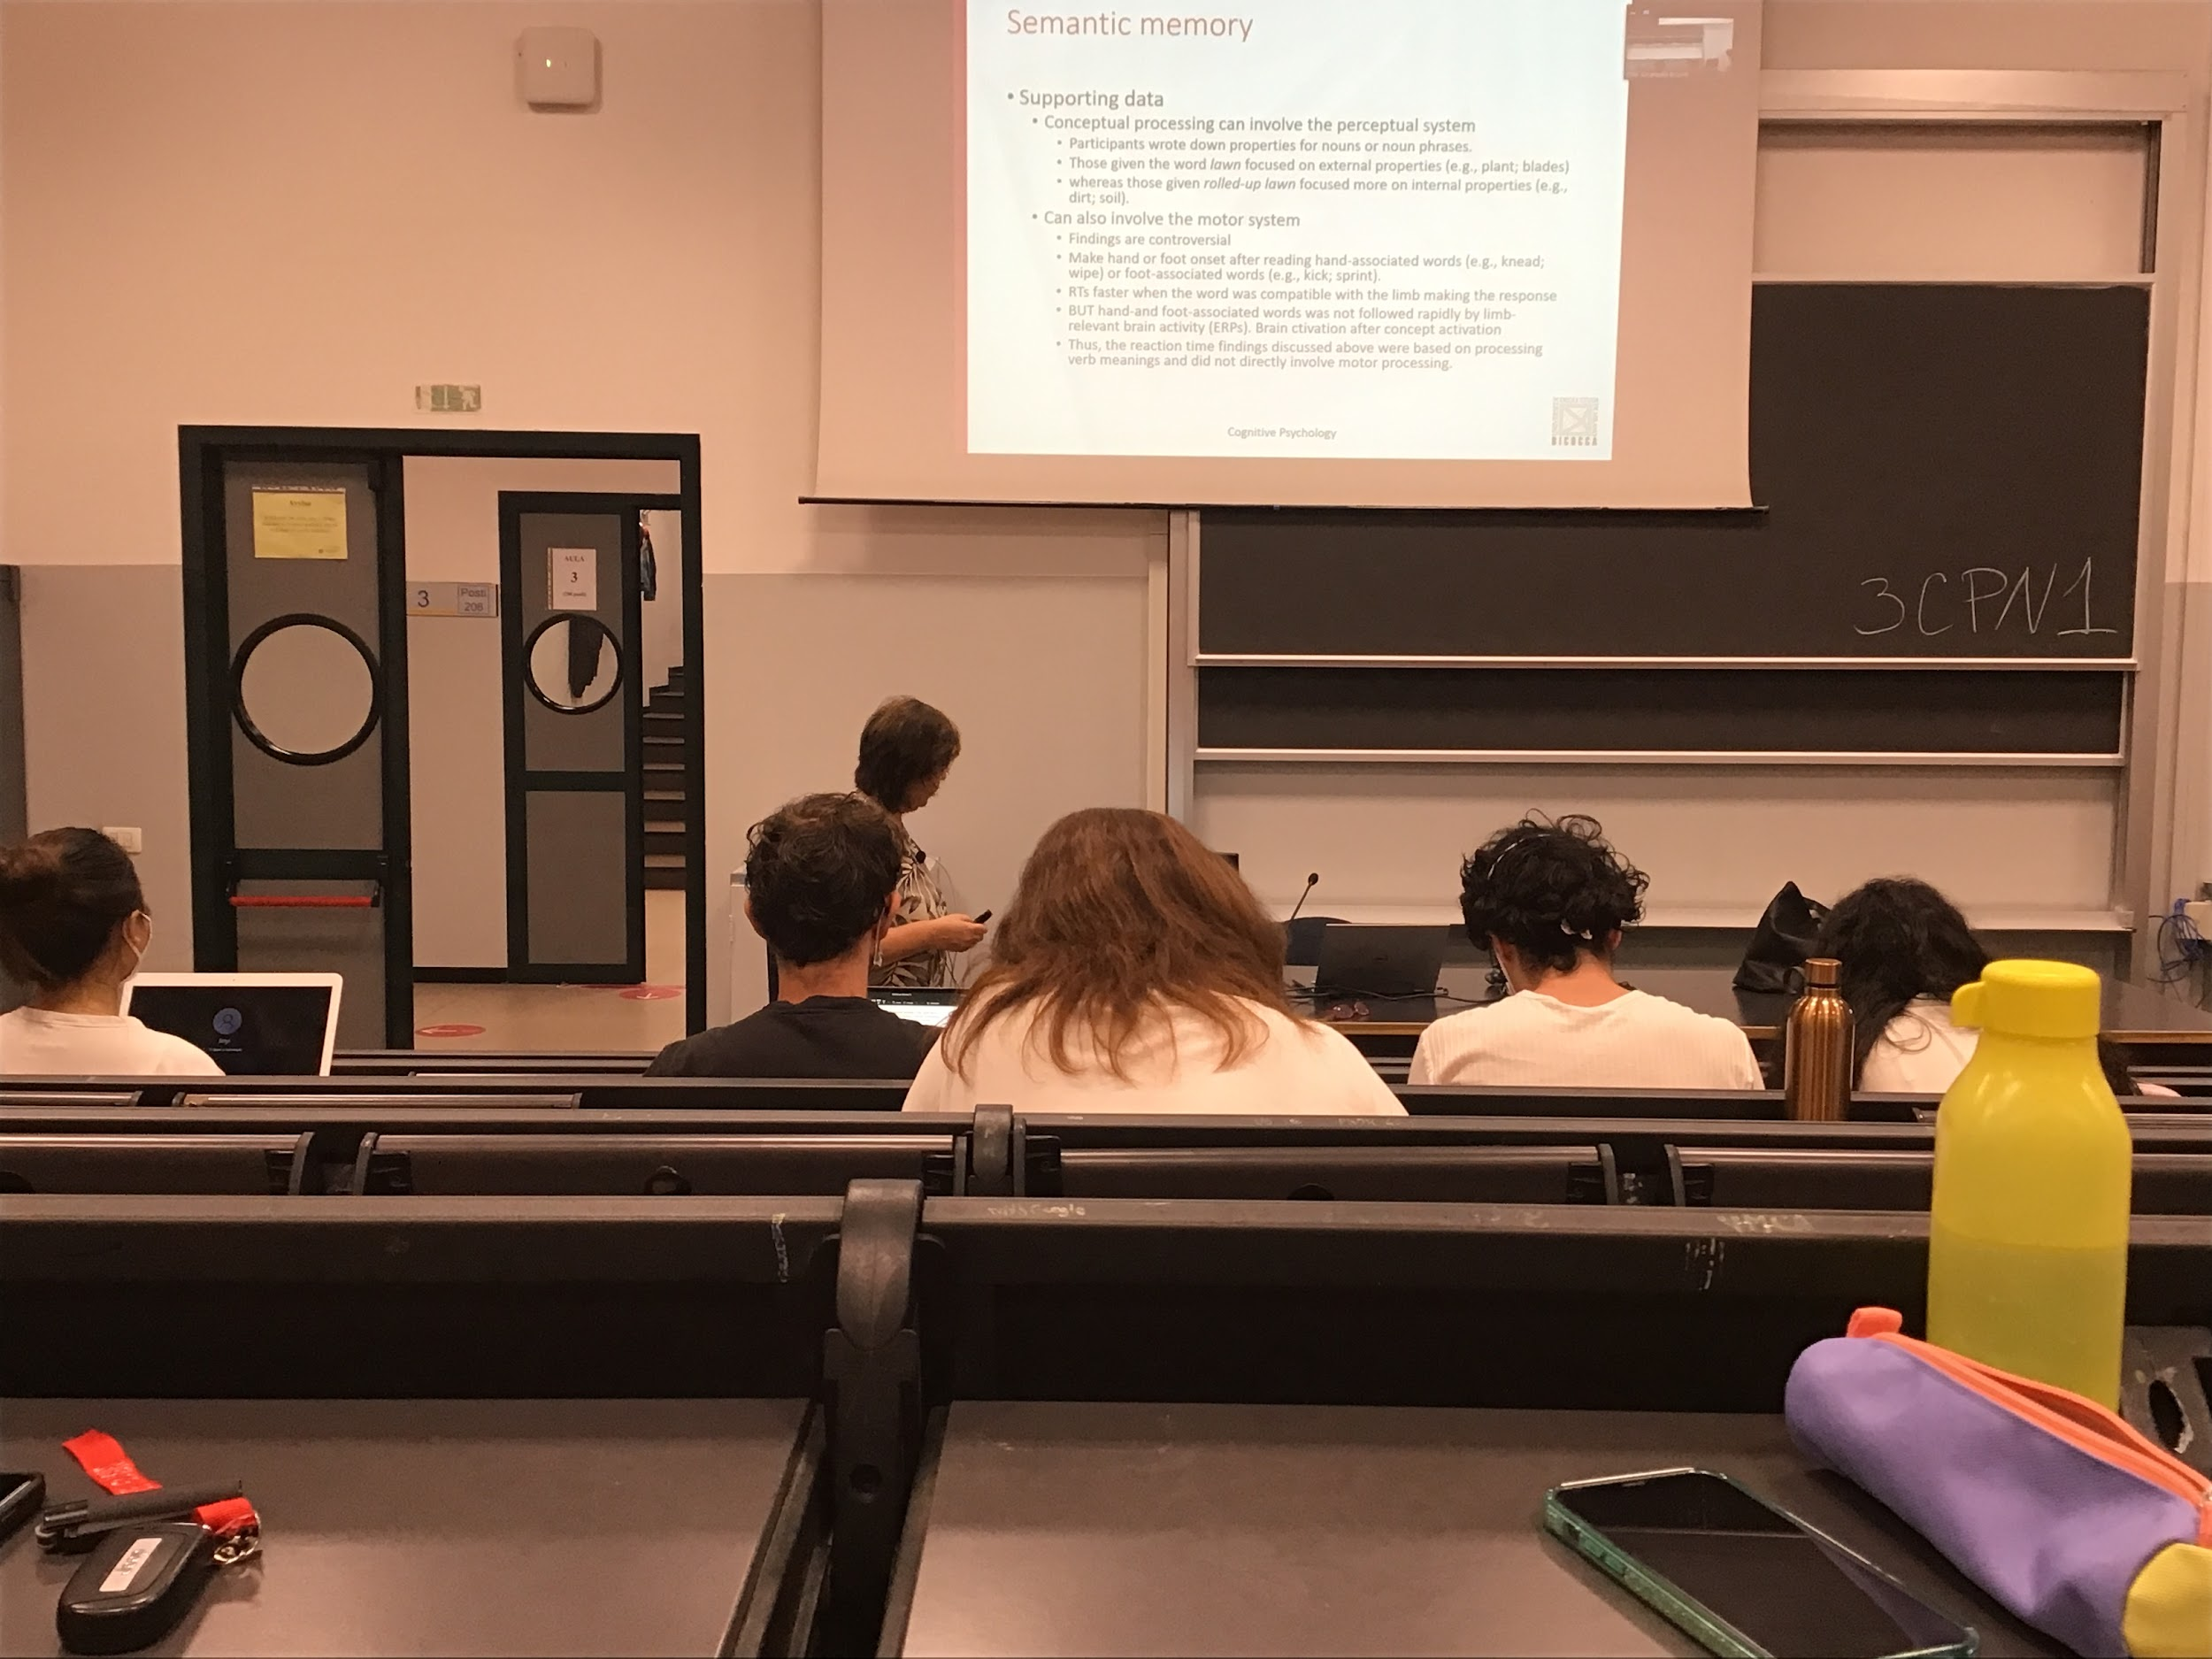

Data in favour of this theory is the fact that we process concepts and the perceptual system modulates the way we process the concept.

Experiment: write down all the concepts that came up in their mind connected to a word.

What kind of representation you activate in a given moment depends on the context. Clear that there is a connection with the perceptual system less clear connection with the motor system (finding are controversial)

Experiment: words associated with hand *wiping*, or word associated with foot *kicking, sprinting…* if I to classify these words with my hands I am fast with hand associated words, while if I have to associate words related with food I am faster when I have to classy them with my foot

Seems to be from the behaviour point of view the fact that the concept is related to motor representations

In reality was not found a correlation with brain activation

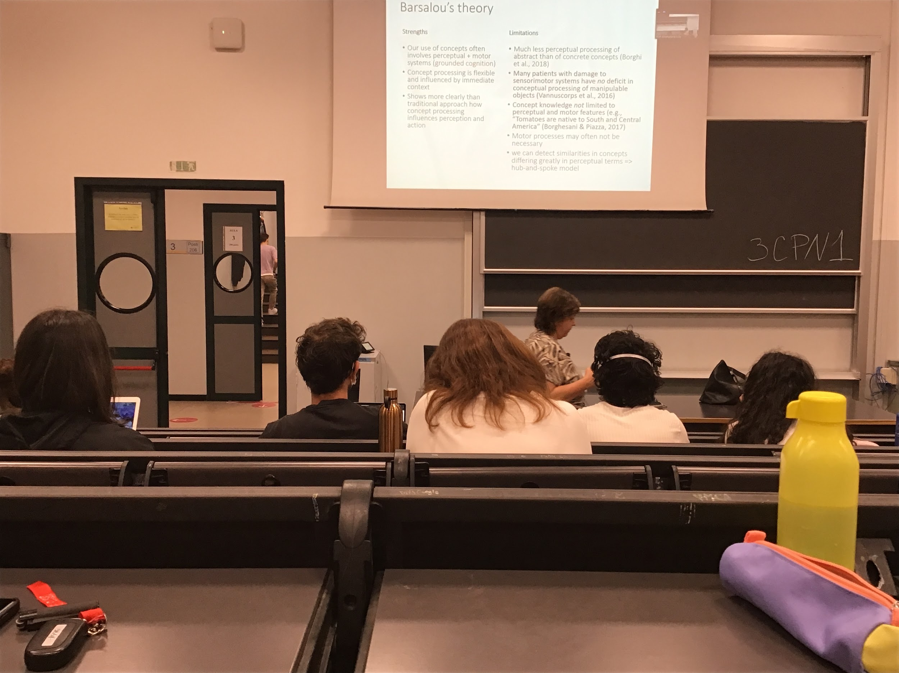

Barsalou theory was a step forward with respect to the previous theory, he added idea that concepts are not in the store

Concept are connected to perceptual and motor system

Activate different parts of concepts depending on my task and my concept it helps a lot, explain a lot of data not explained by the two traditional theory

Still not a perfect model, does not explain very well how can we deal with abstract concept

There are some similarities in concepts that can not come up with the model

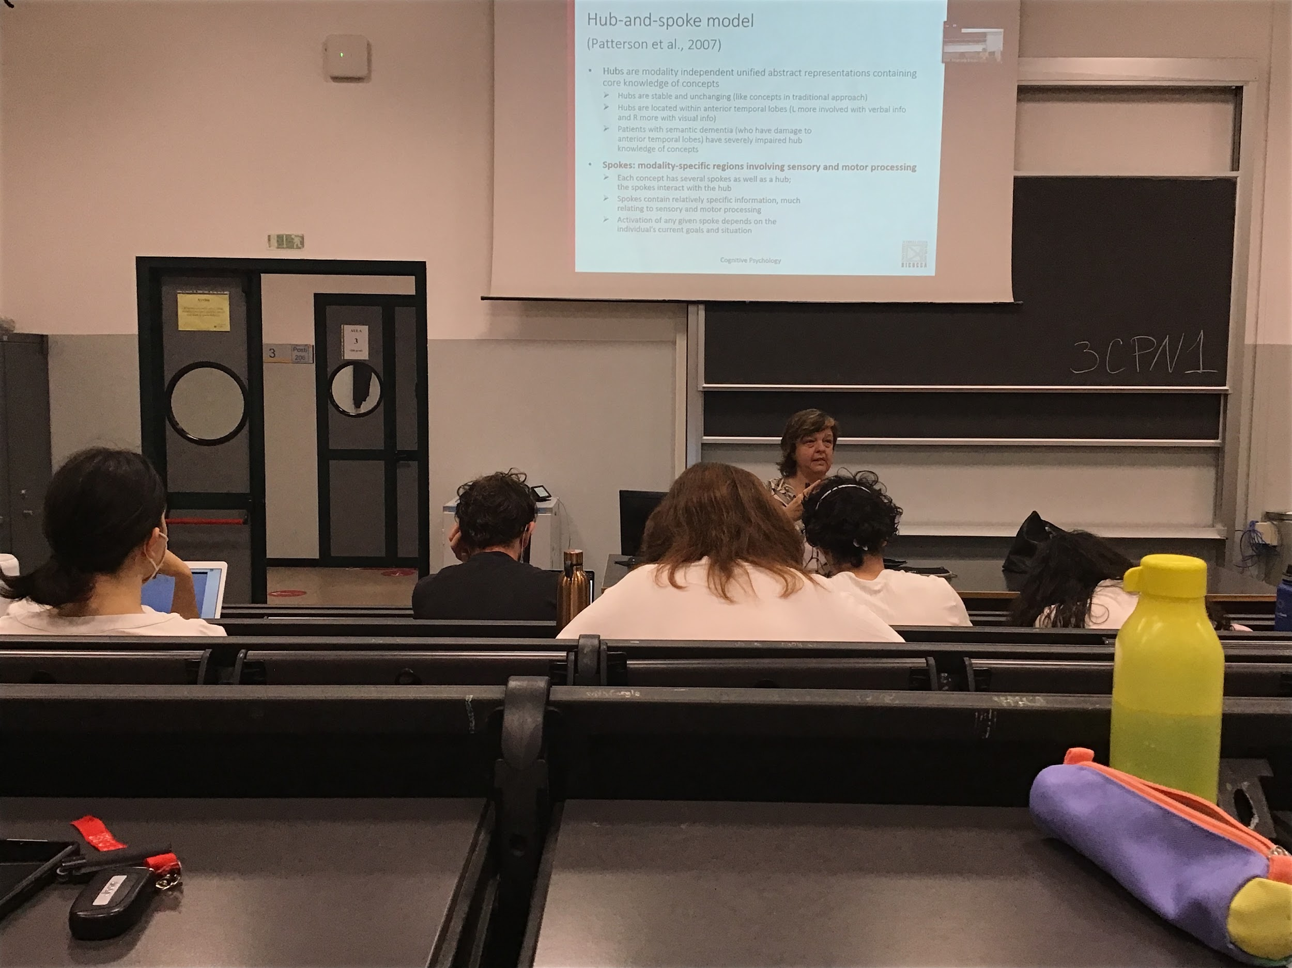

**Hub and spoke model**:

Further step on the Barsalau’s theory

Hub central unit that stores specific general information about the concept is the central storing information, containing the core knowledge of the concept. Similar to enciclopedic. Stable and unchanging. Located within the anterior temporal lobes

There are different spoke connected to the hub that gives it colour to the information

Patients with semantic dementia have problems with the anterior temporal lobes have severely imparied knowledge concept

Each object is the hub is connected to different spoke

Activation of any spoke depends on my goal and my situation

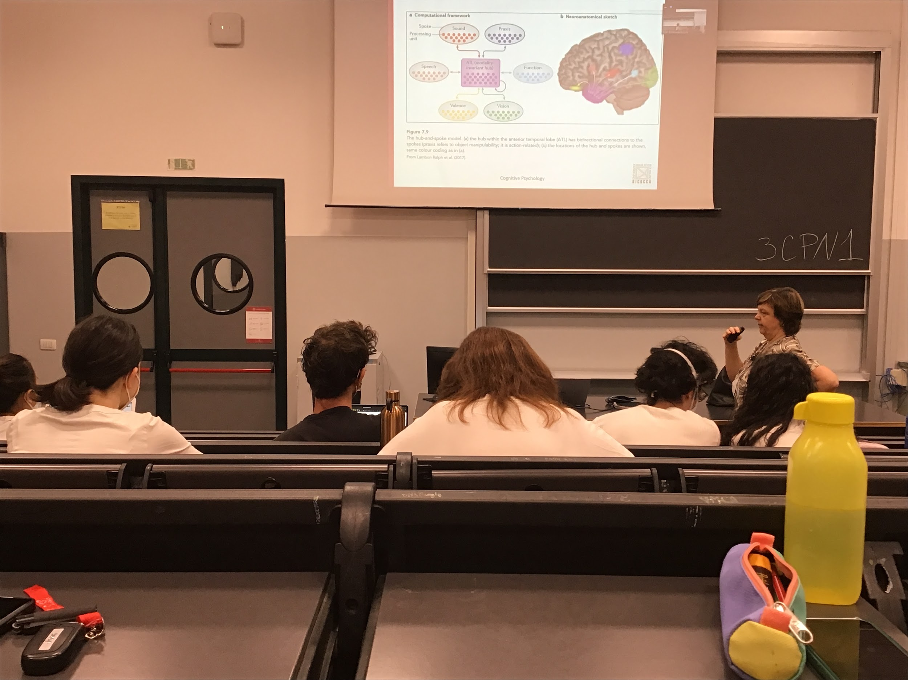

Each concept is stored in the hub and each concept is represented with a different flavour and on focusing more on specific characteristic

Valence: positive or negative concept

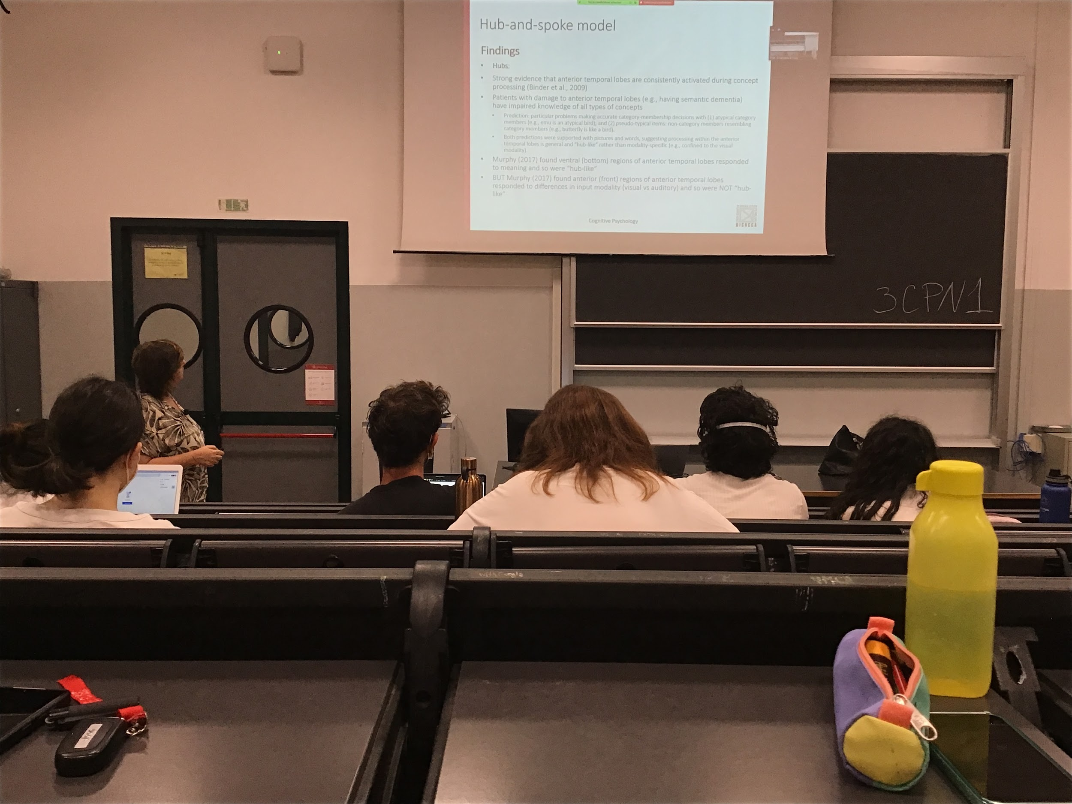

Lot of support for the hub and spoke model

There is a neuropsychological data and patient data support the hubs theory

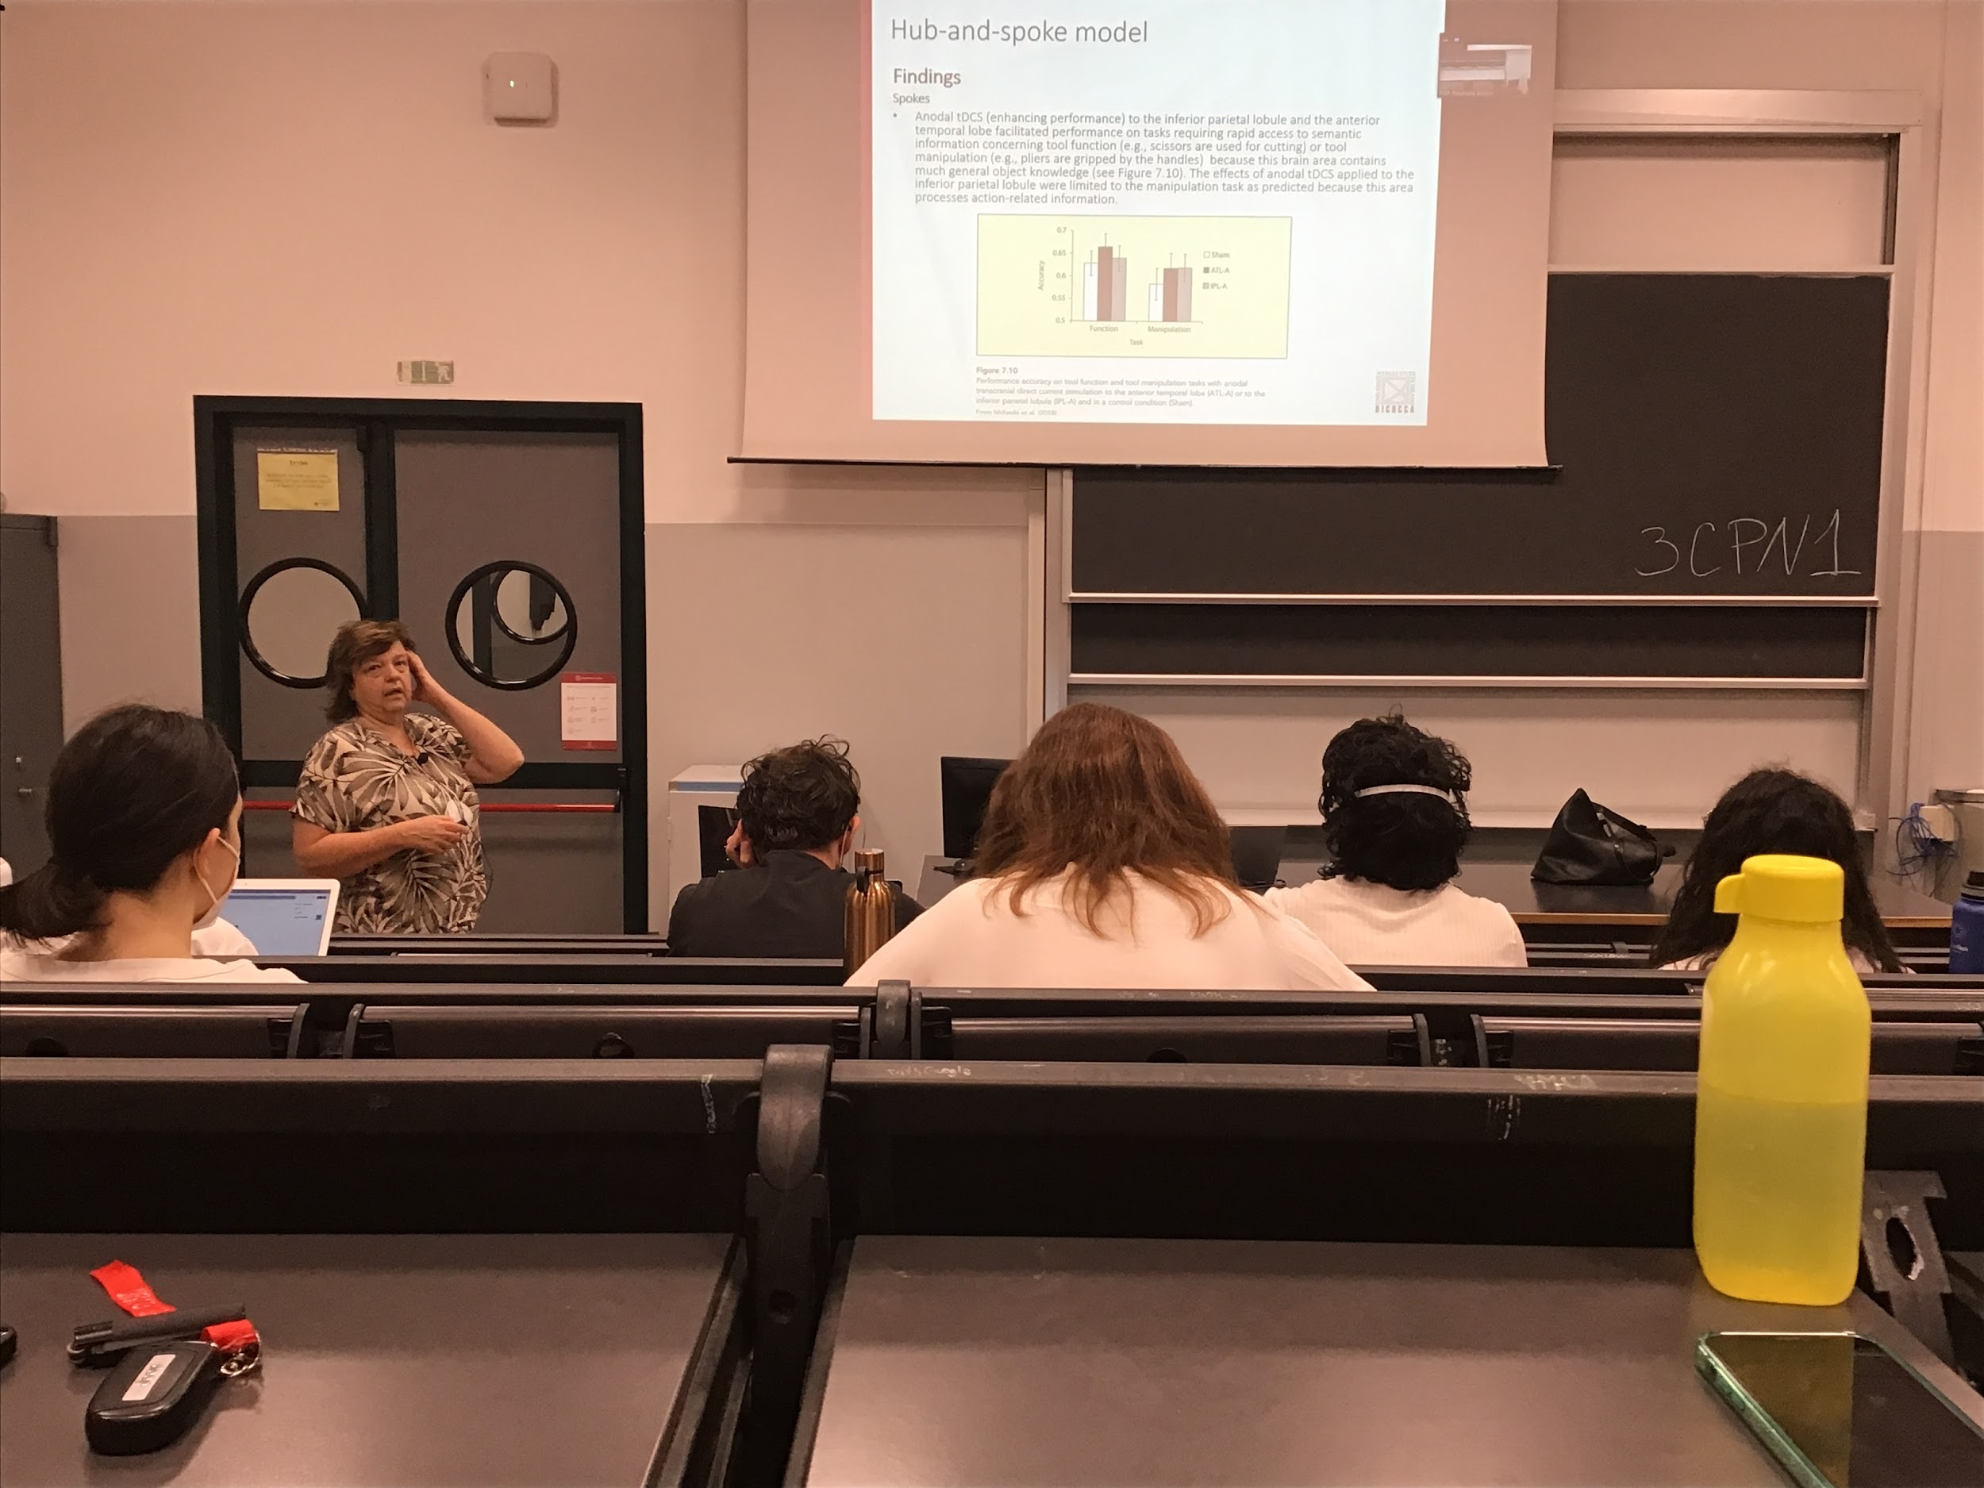

Data in favour also that the spoke are related to specific characteristic of the concept that we are talking about

Use tDCS (putting current in the brain) this preactivated specific areas

**Activation to specific part of the brain there is increase performance** in tool function and manipulating tool that are specific to that area

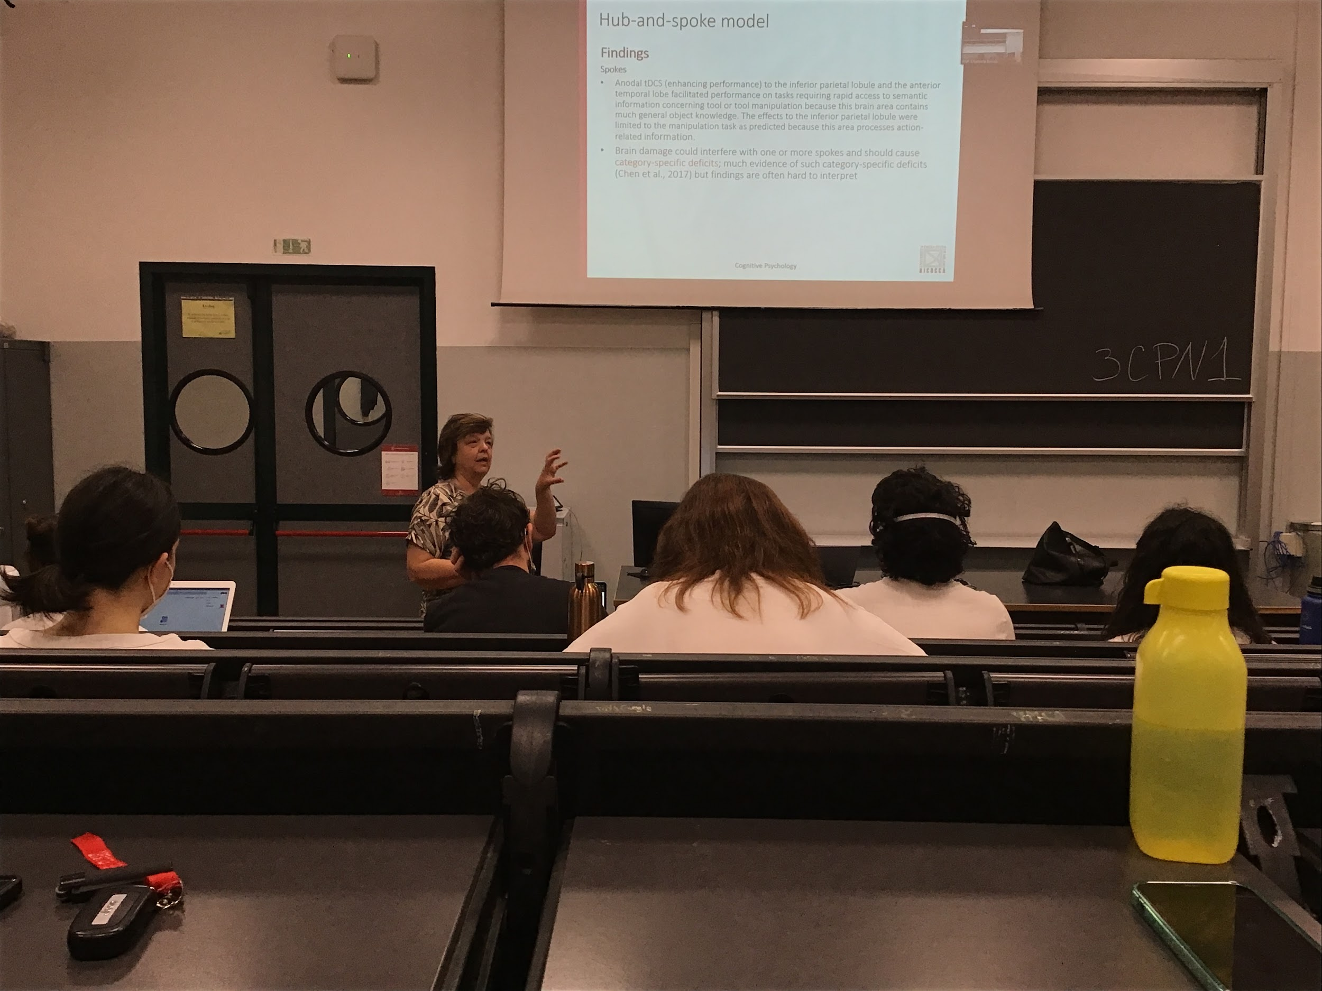

There is another pool of data that with brain damage that show support for this type of structure

Category-specific-deficit

A lot of data show that patients with specific lesions are unable to classify objects of specific category

One of the most studied category: difference between living and nonliving objects

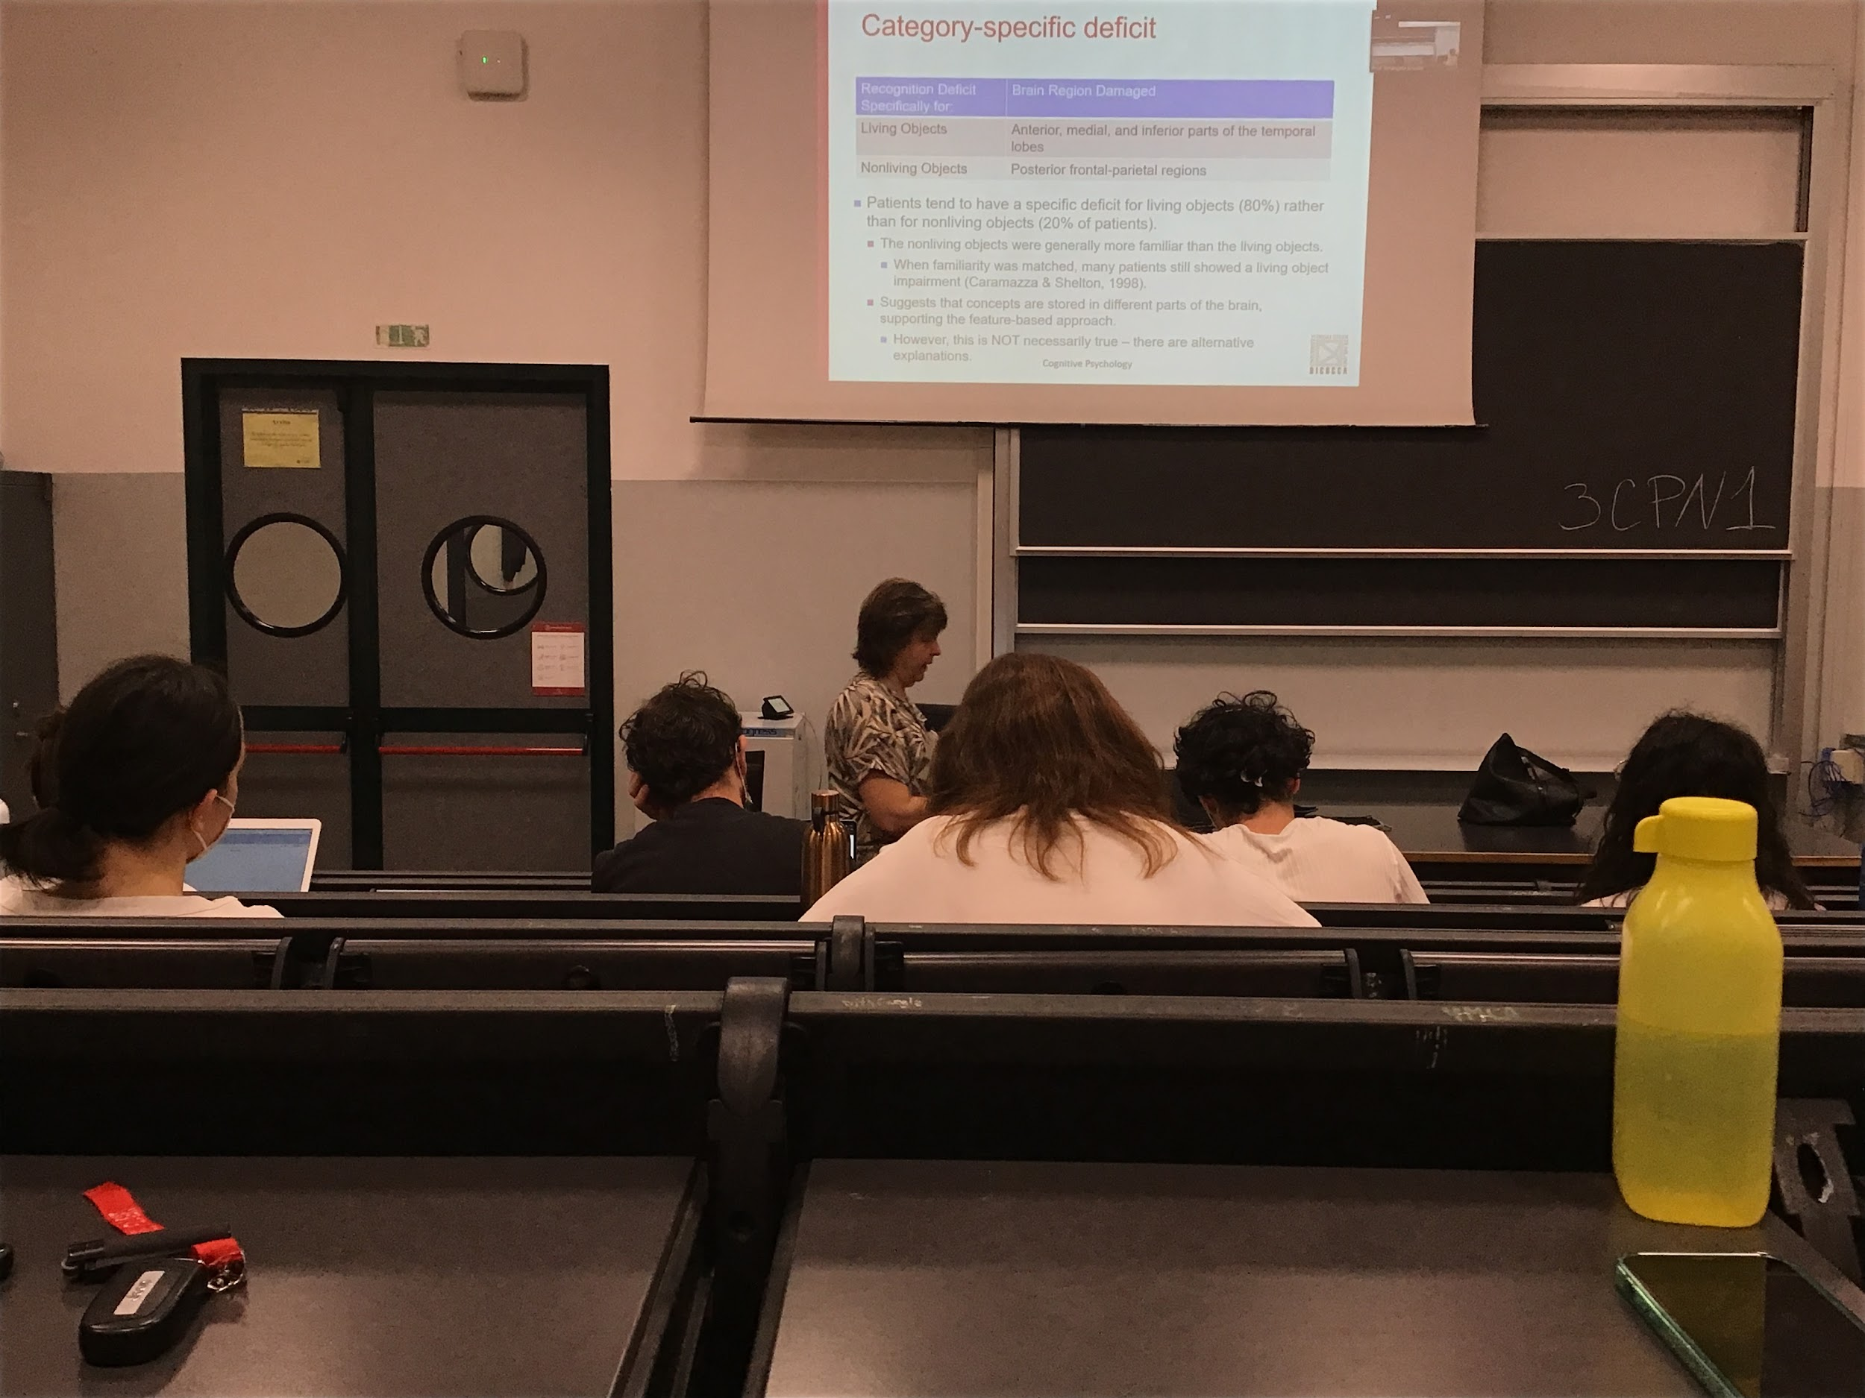

If I ask to classify animals your **performance is much worse than nonliving objects**

Support of the hub and spoke model

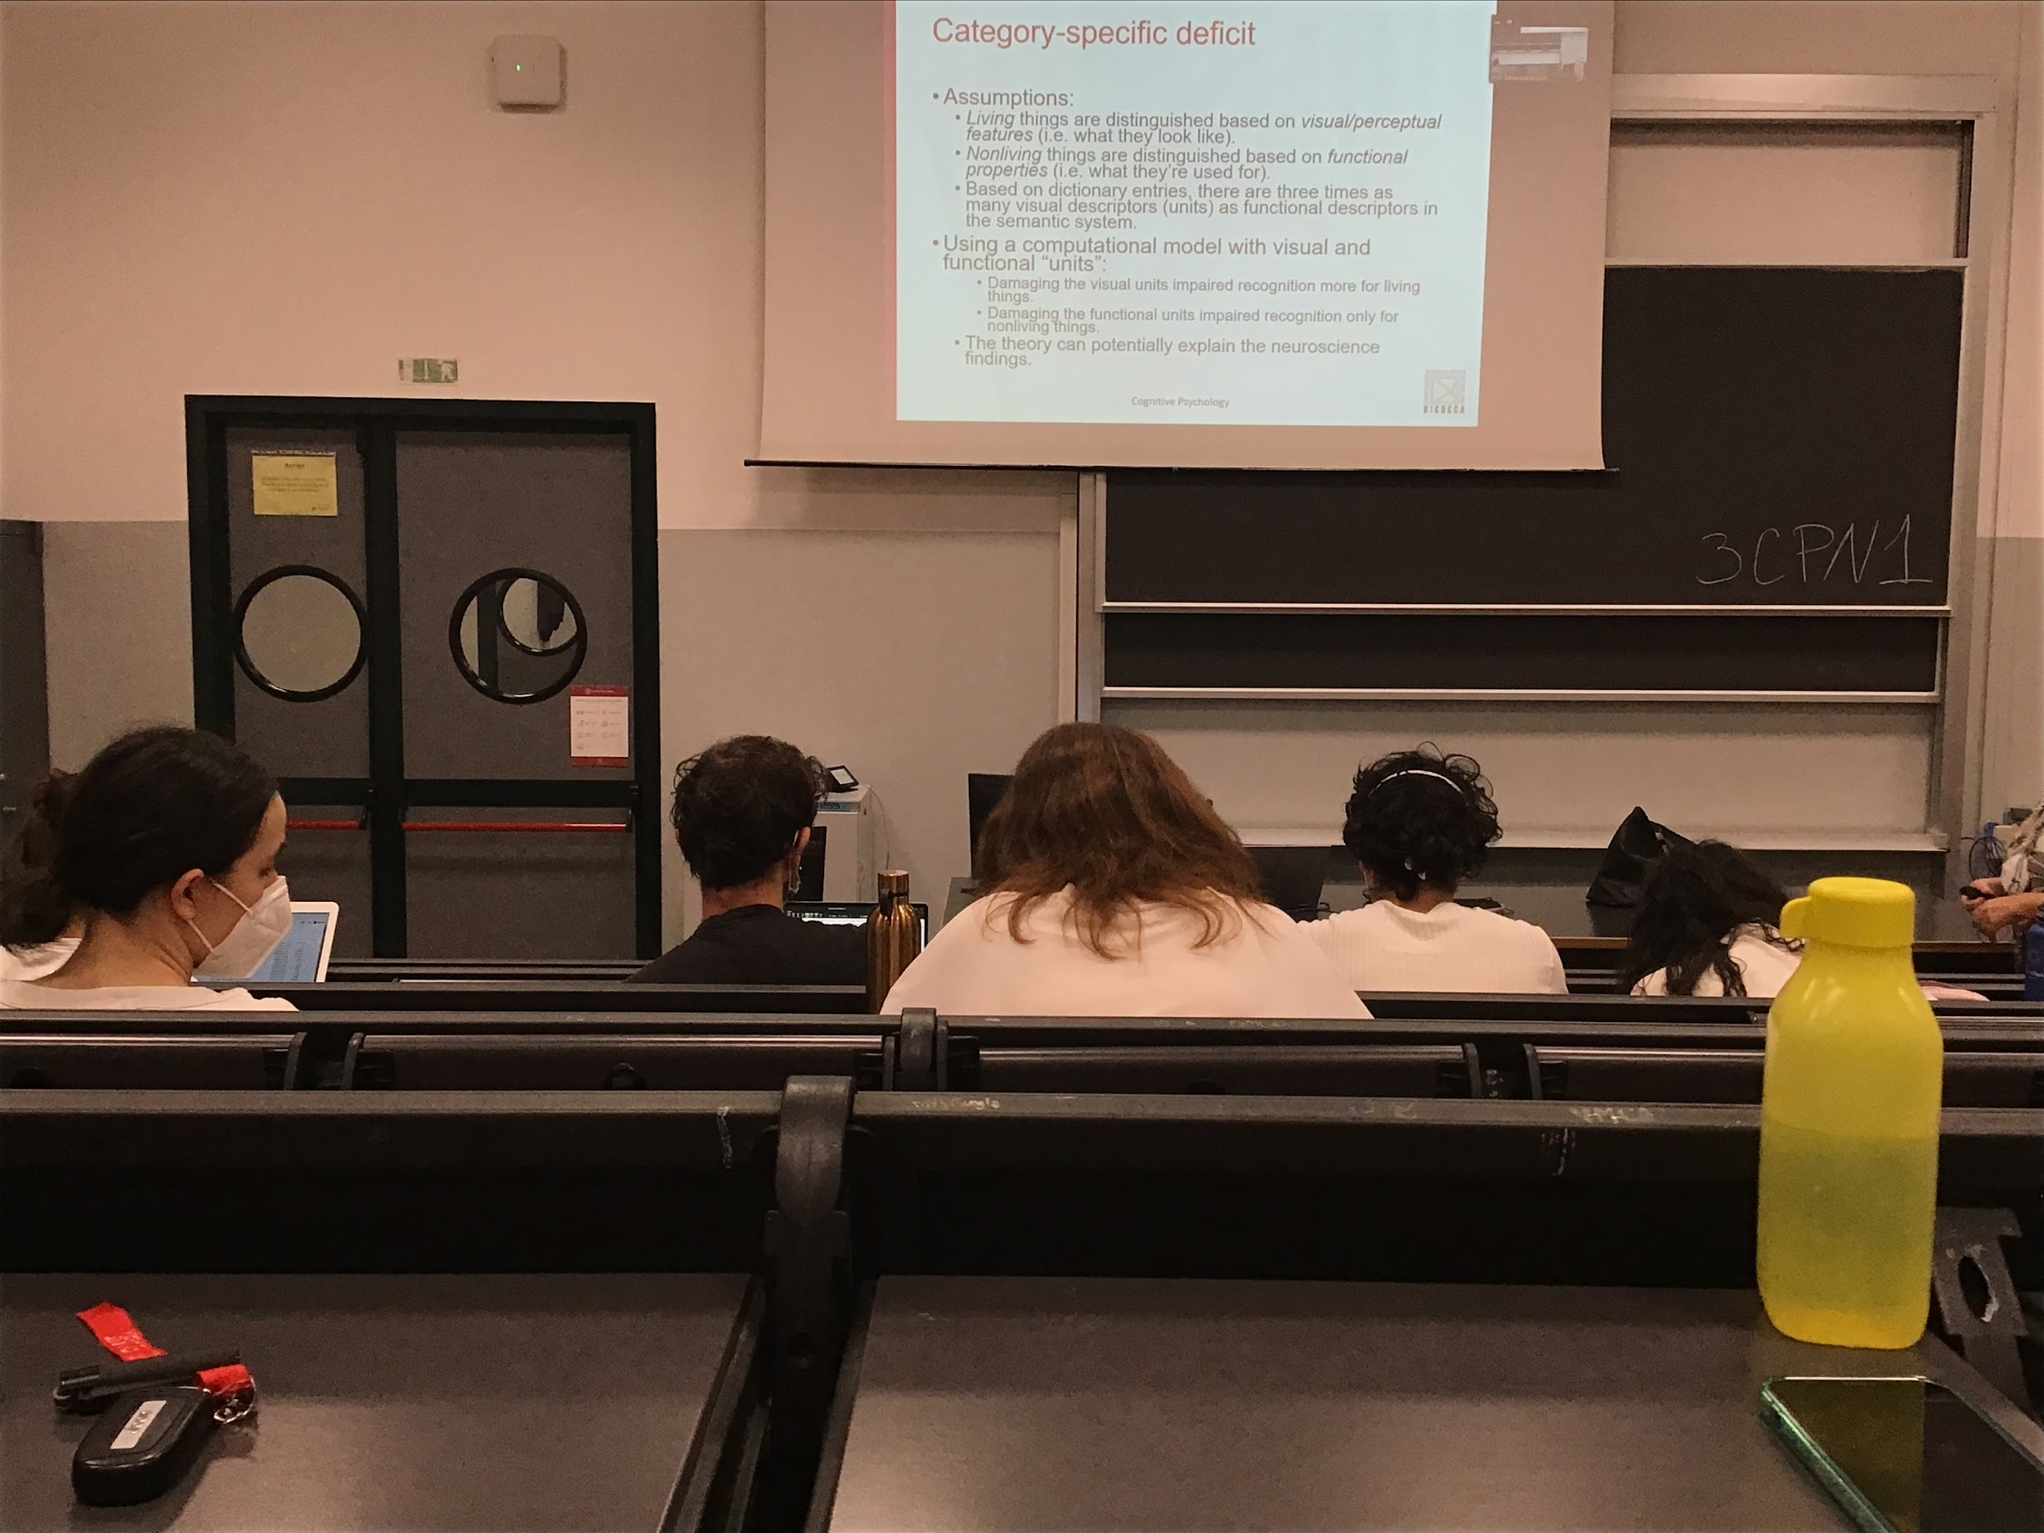

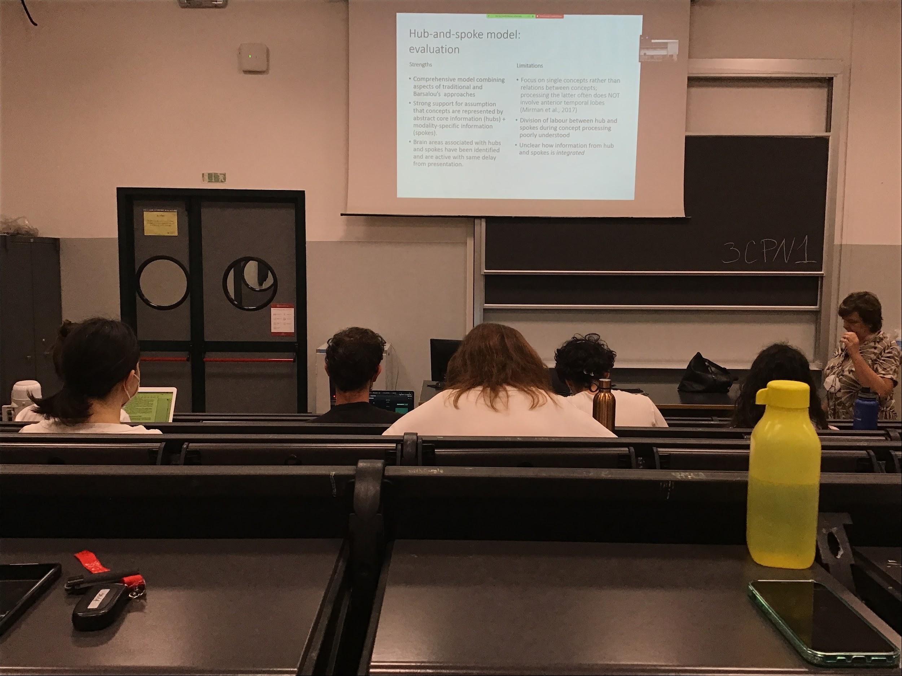

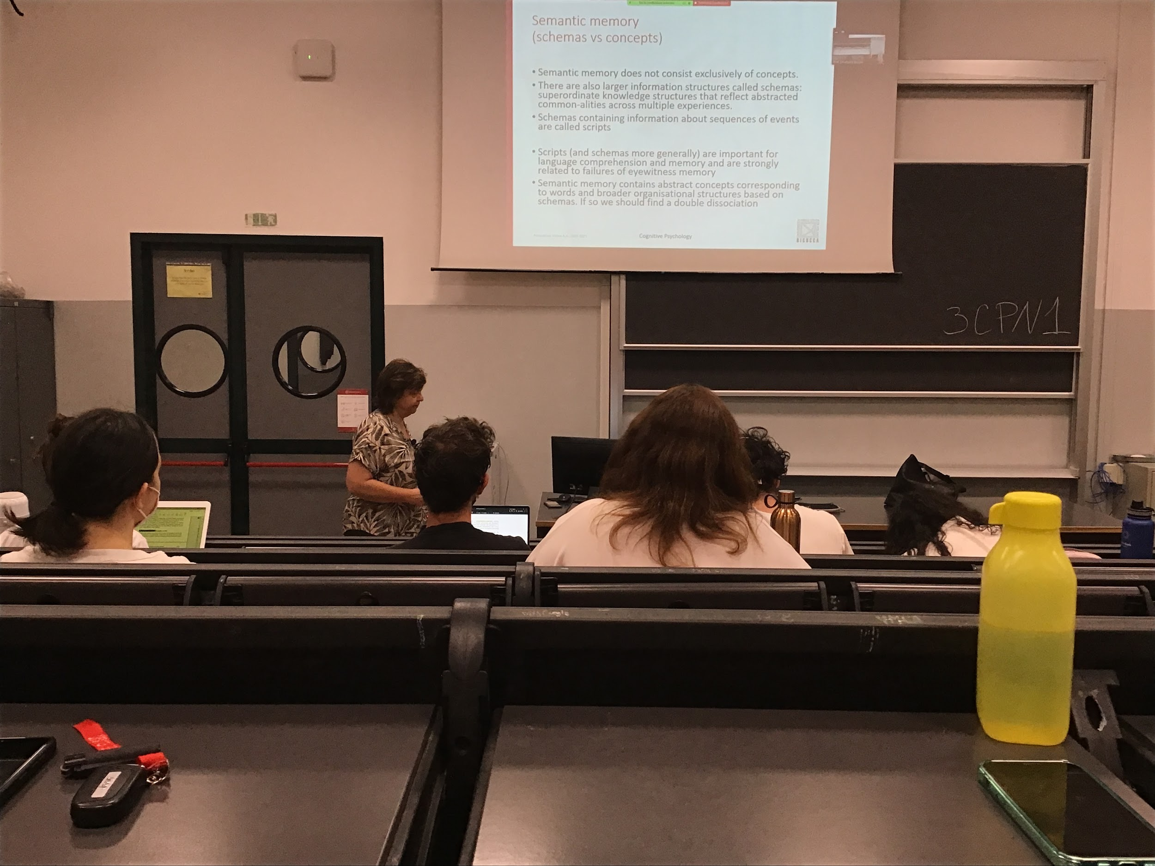

In semantic memory do not save only concepts, also more complex structures to perform different tasks and to help programs our future

**Schemas**: there are structure that reflects things that are common in different experiences

Something that put together different types of information

Schema: general idea that we have this general structure

A specific type of schemas are scripts that do not only gives us an idea on what goes with what

**I have a schema for a bedroom: idea that there is a bed, a chair,…**

**Script**: on top of objects presents add a temporal sequence of events

A script is very strong and it can create some problems. Since memory is reconstructive sometimes I add details that are not there because are not in my script

Scripts and schemas are important for language comprehension and memory. Every time we try to process some kind of information we try to see if it fits with our schema

Semantic memory contains both schema and scripts, if both things are different we should find a double dissociation

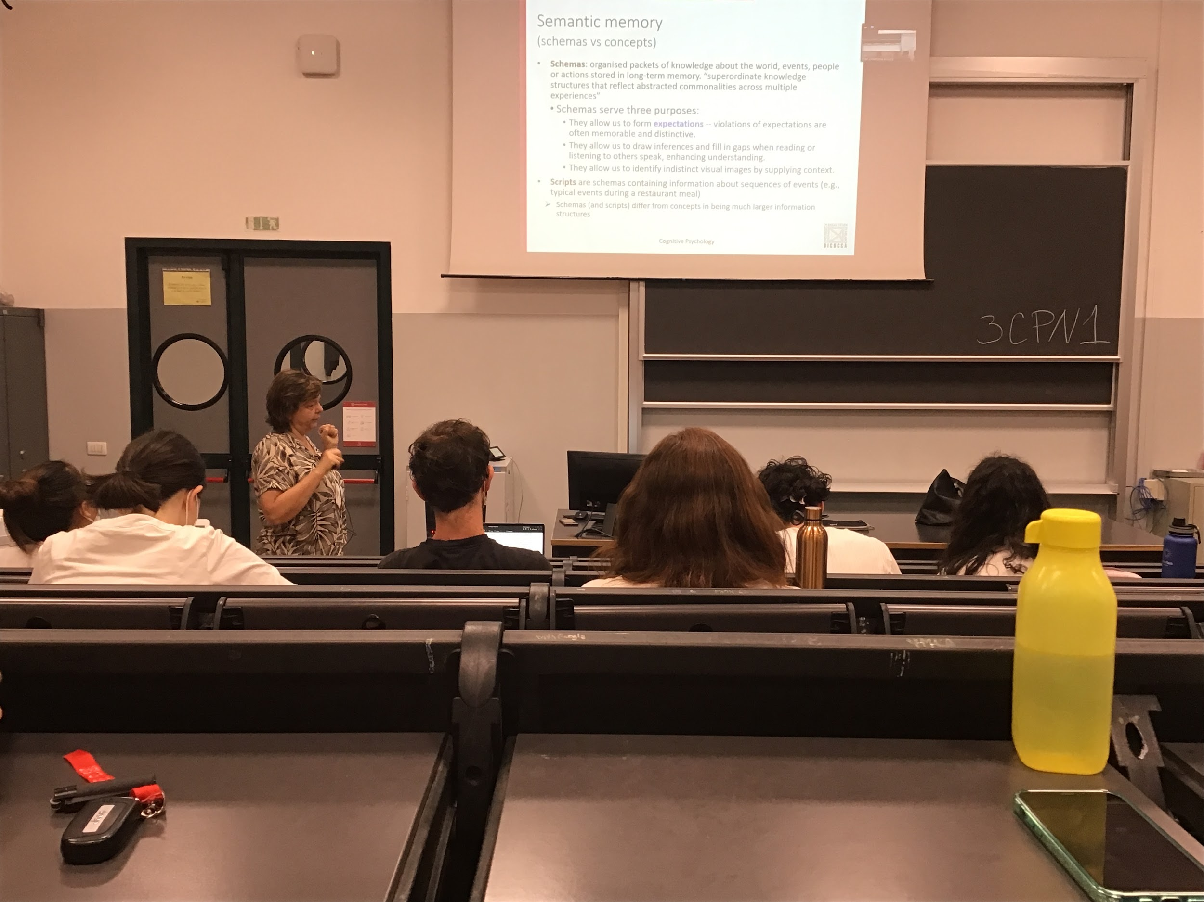

Schemas contains information about group of objects that goes together, have 3 porupuses

* **Allow us to form expectations**. If I tell you *this is my bedroom* and you go in and you don’t see the bed you realise that there is something that does not fit in your schema. You expect something
* **Allows us to reason with others in our social interactions**. When I am listening to somebody else they give some granted some specific details
* **They help us to come up with perceptual representations of some situations** that in that case enable to reason in some kind of way

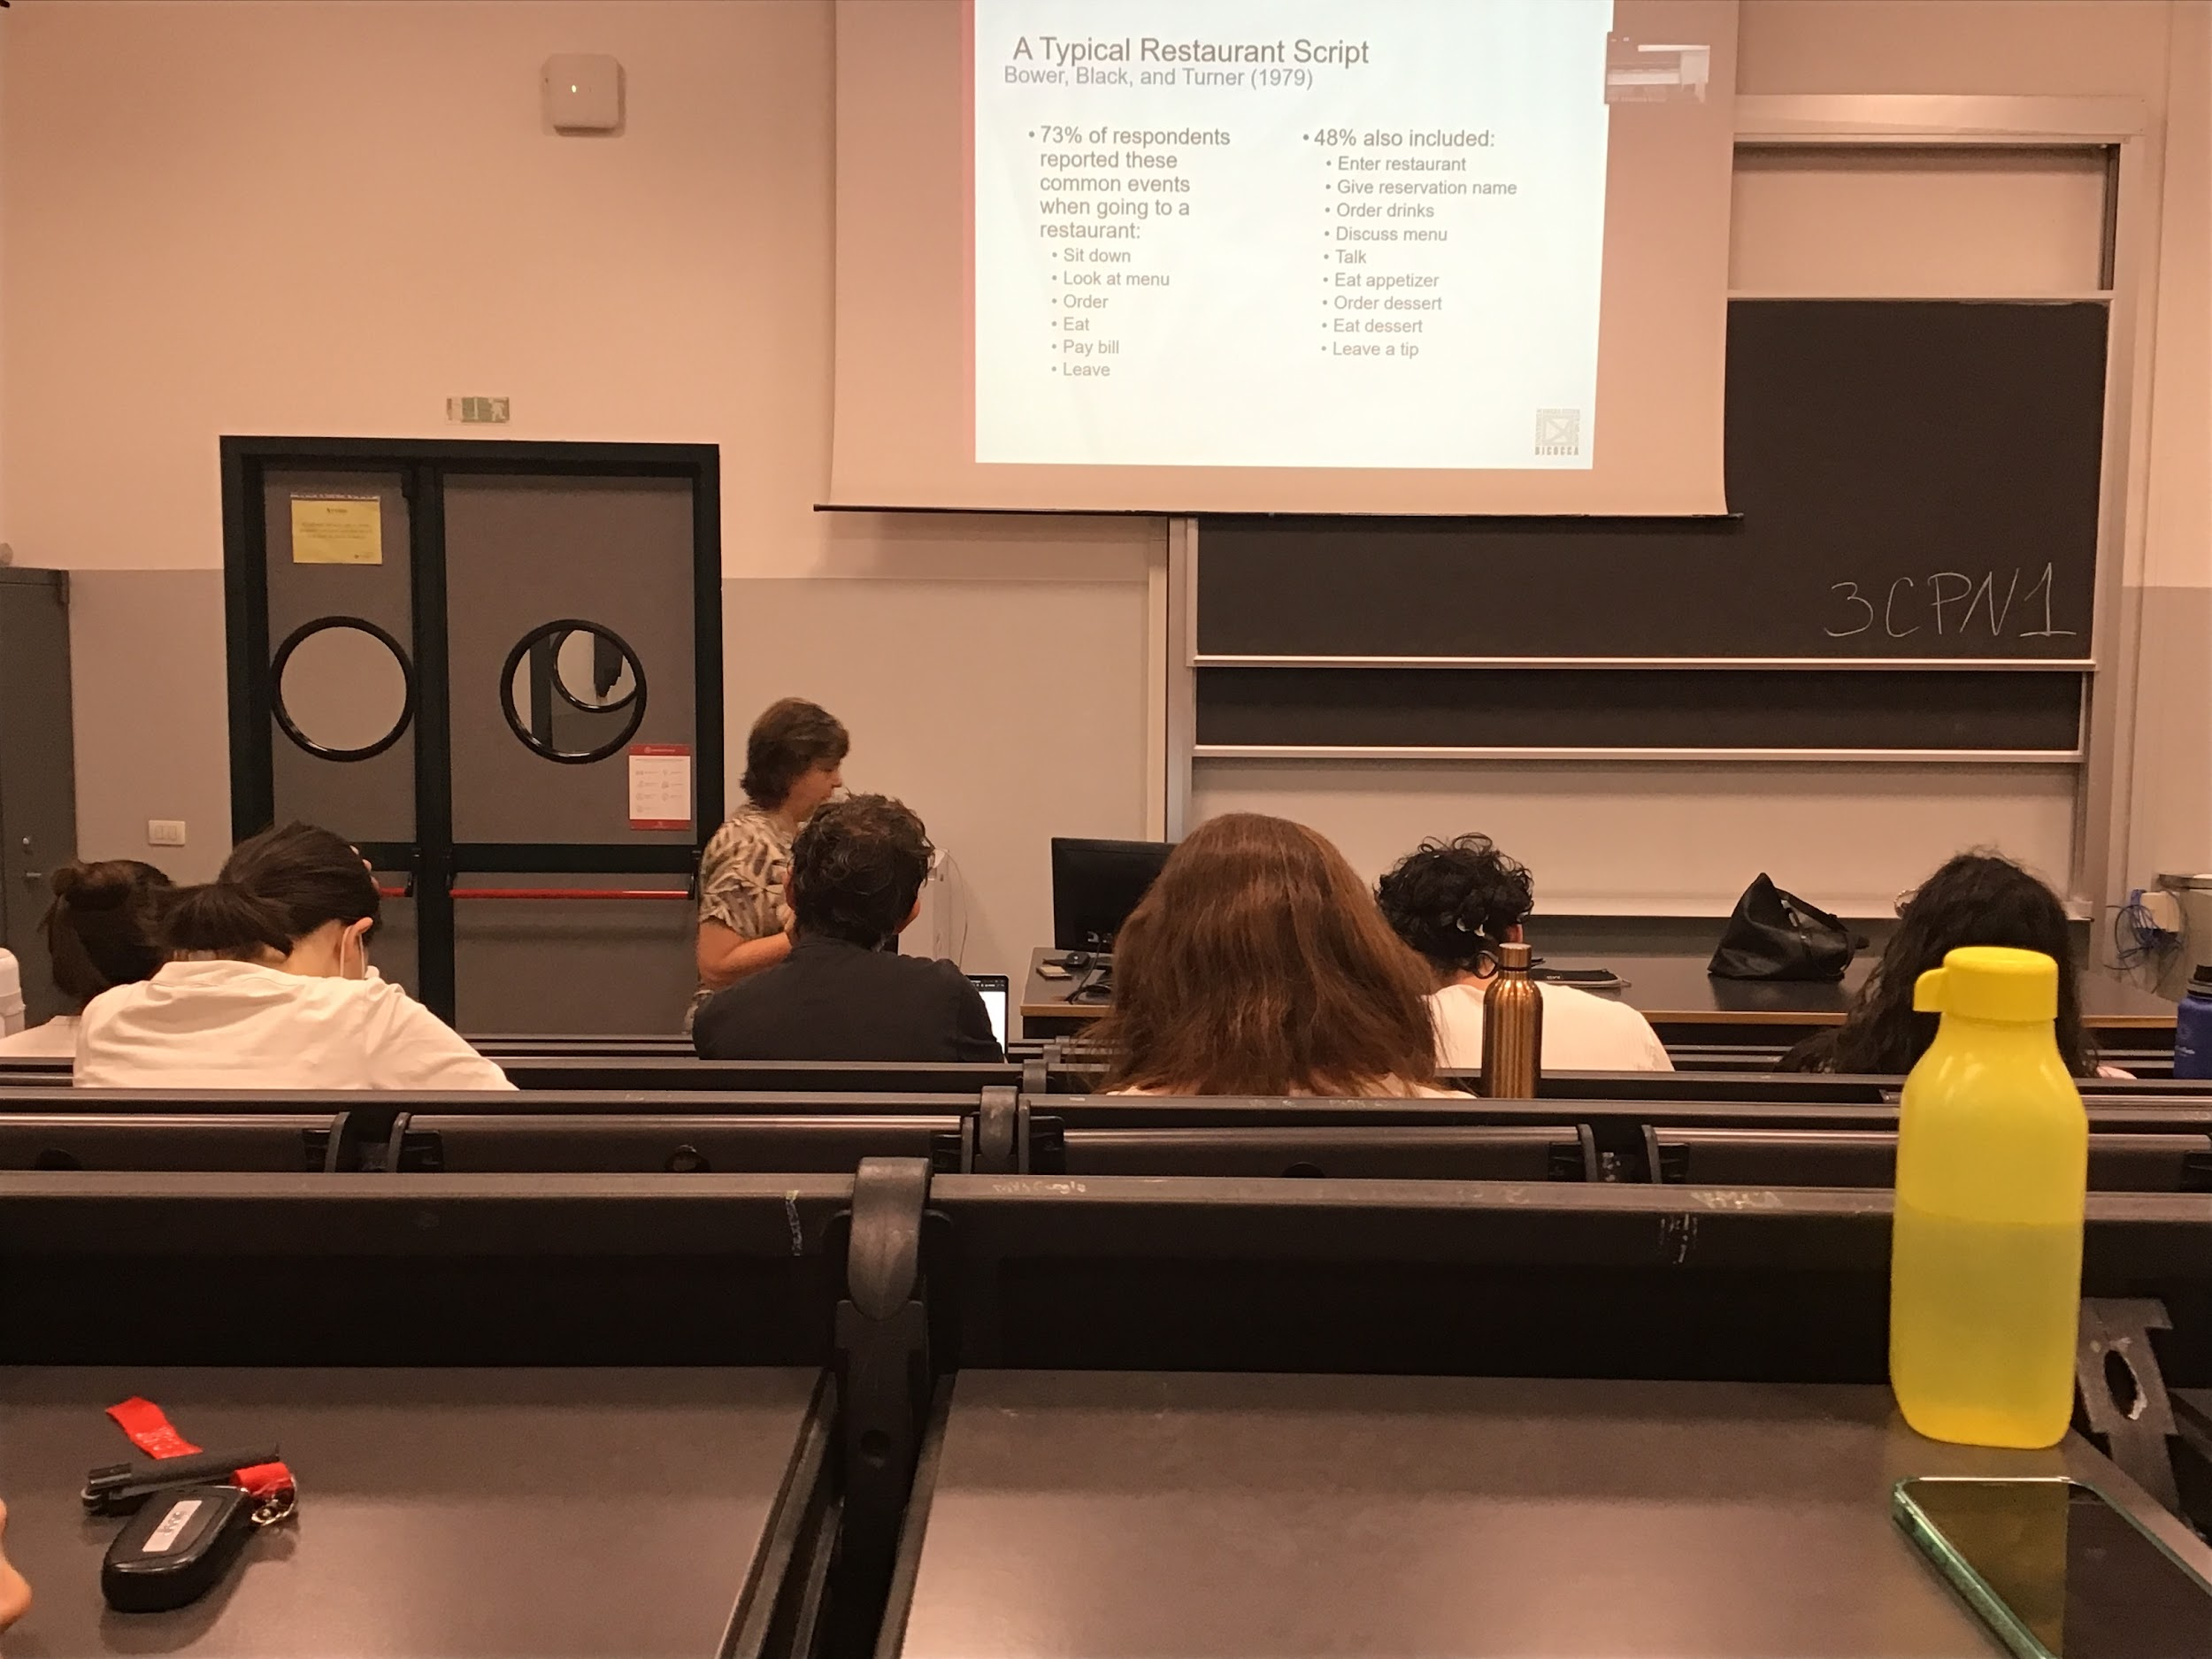

Typical result of scripts: when the autor ask you to describe any event that will happen when you go to a restaurant

There are very common items and less common items. Everyone of us has a different script, but the main components are the same

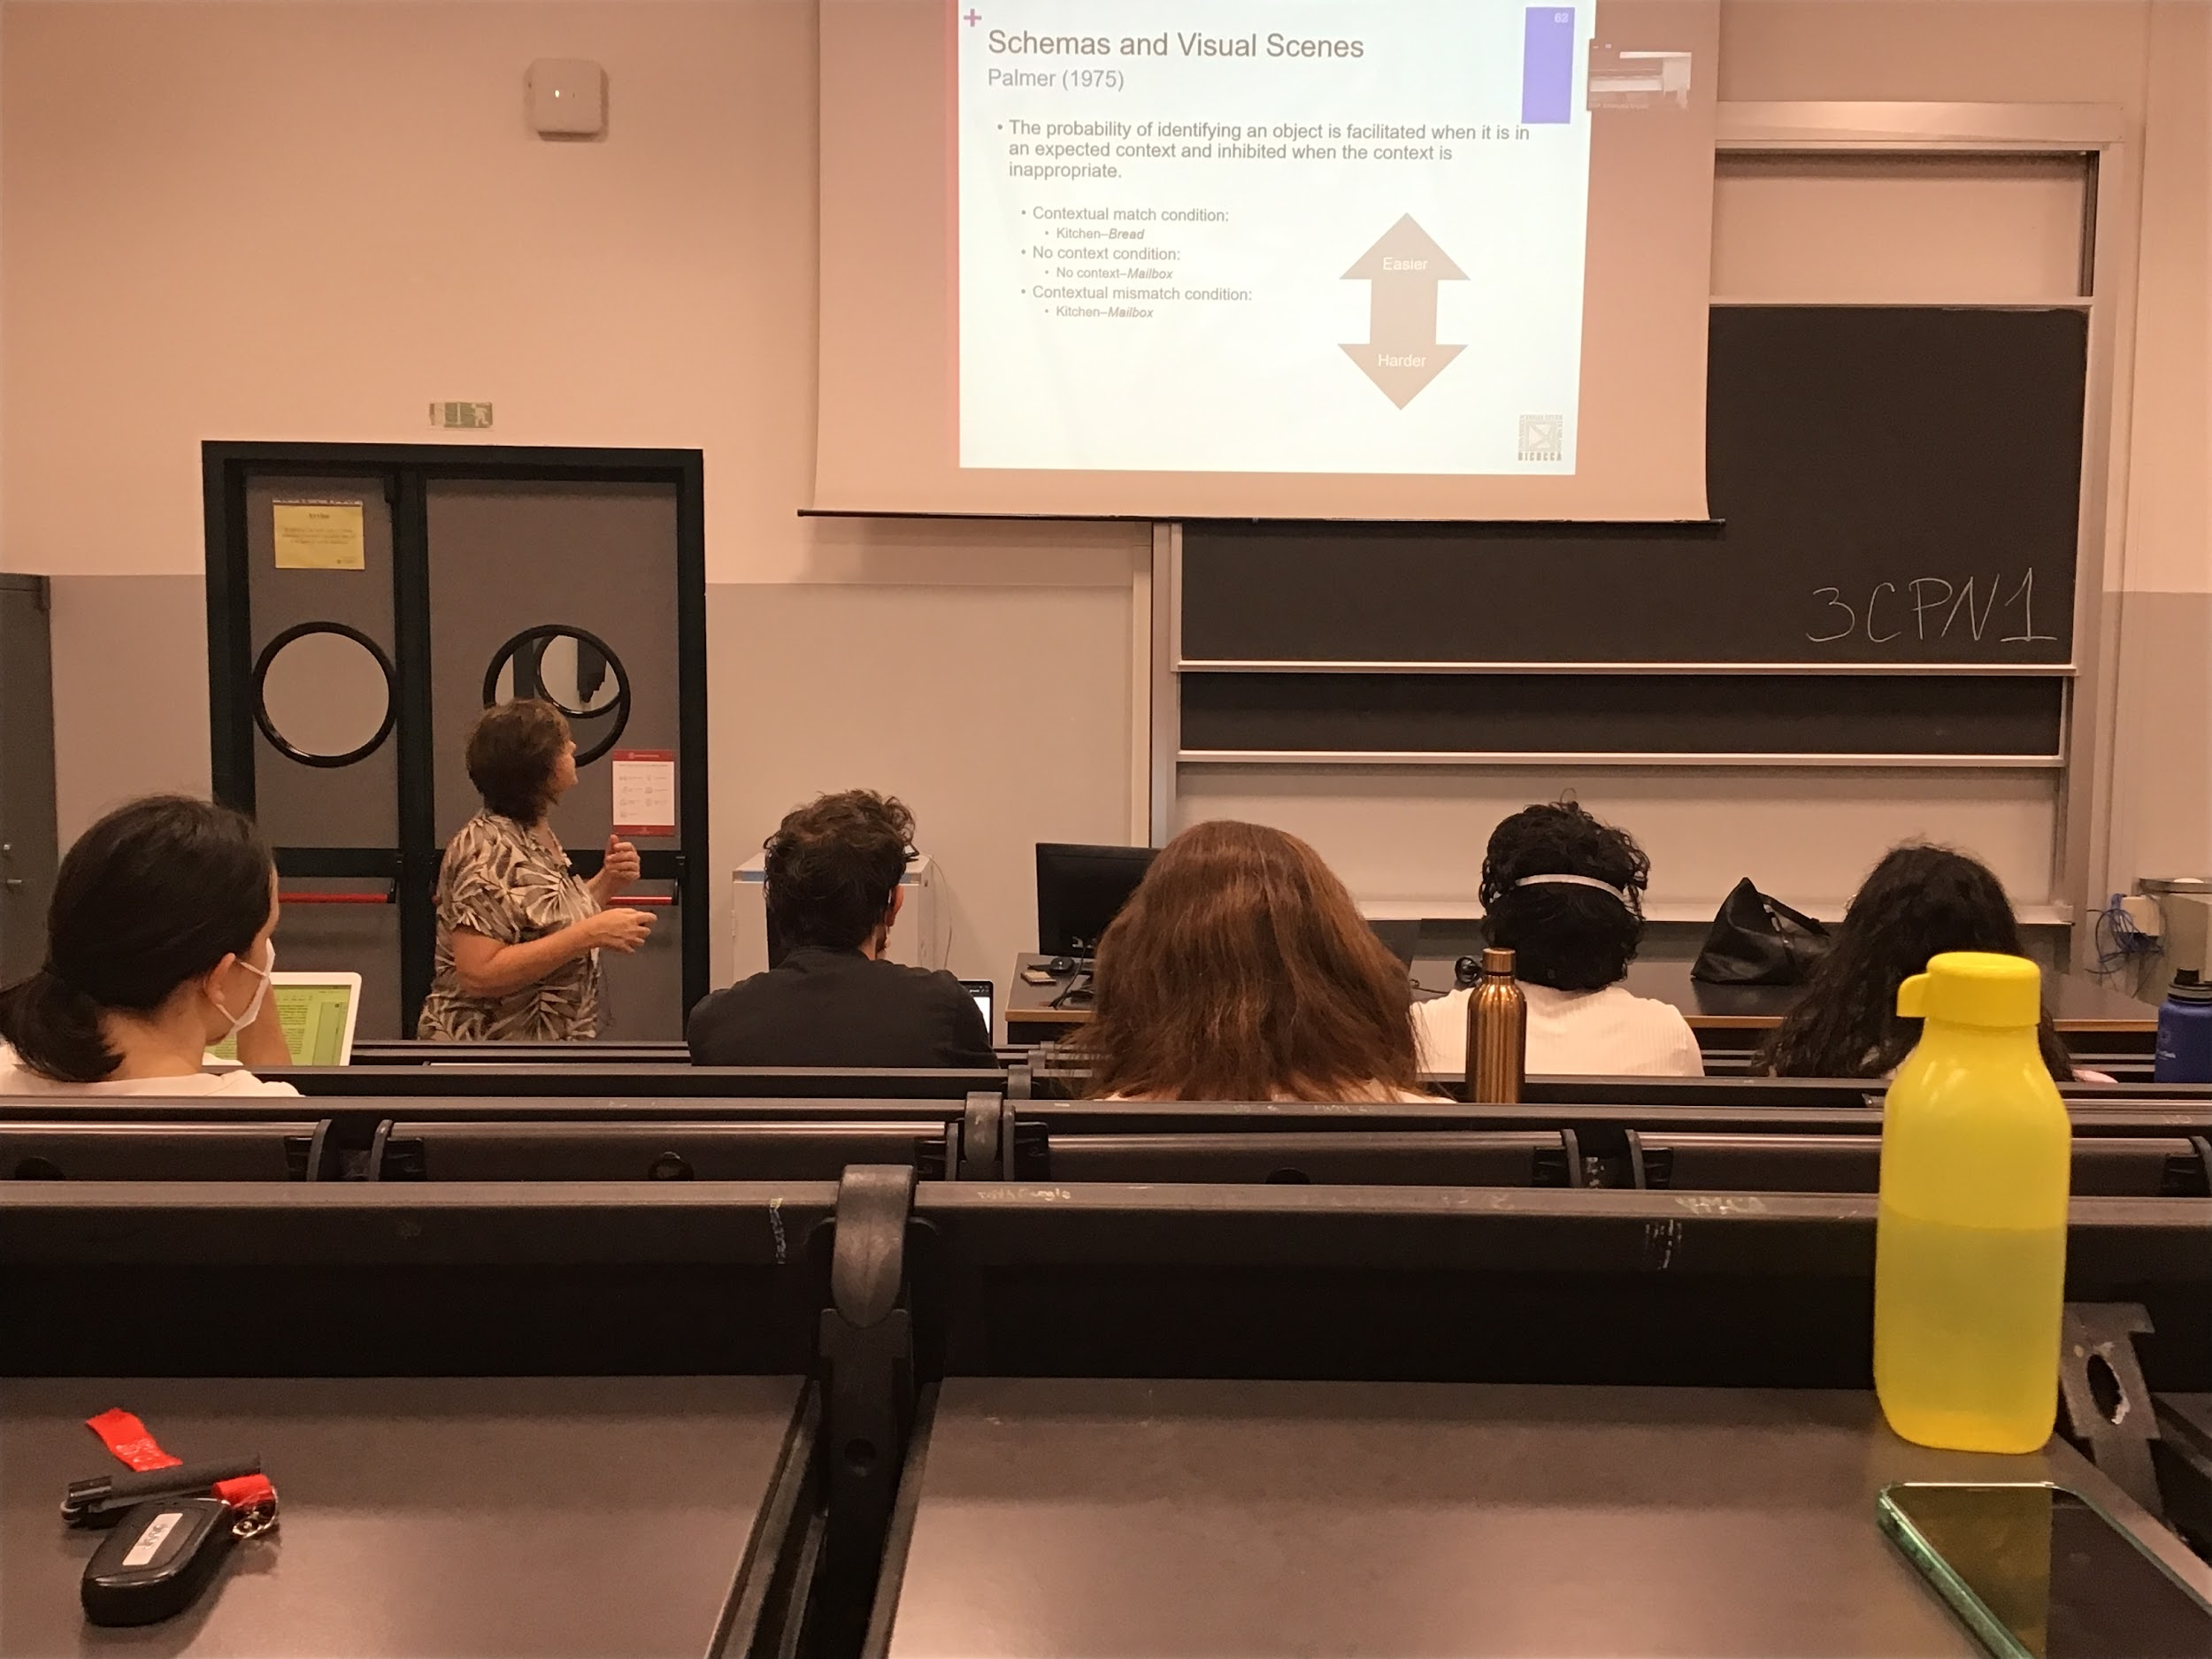

There a schema that contains visual information is supported by this type of experiment in which I ask you to find a given object

If I ask to find a loaf of bread in the kitchen you look on the counter and you find it very easily, in your schema objects like food are positioned on the counter

If I ask you to look for a mailbox in kitchen it takes longer to find it, in your script there is no mailbox

Data in favour that you have some kind of mental representation

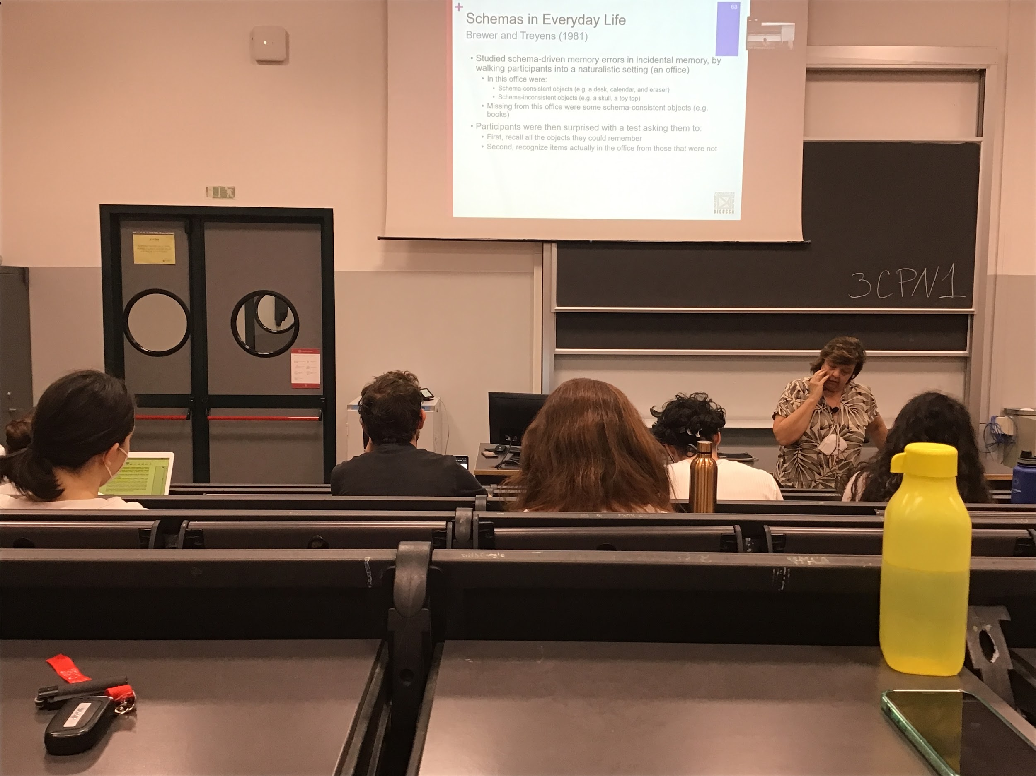

Schema representation is very important for witnesses in the court. The problem is that too many times when we try to remember some kind of event we rely a lot on our schema, reports some details that are not actually there

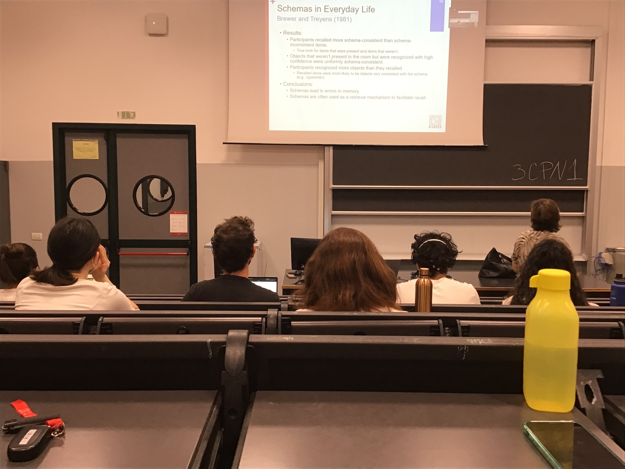

Experiment: aks people to go in an office, there are typical object office and some object that in our schema are not there and some object you usually expect in an office that were not there

People are asked to recall the object they saw, they found that you recall that are consistent with the schema and were not there and other reported objects that were unusual

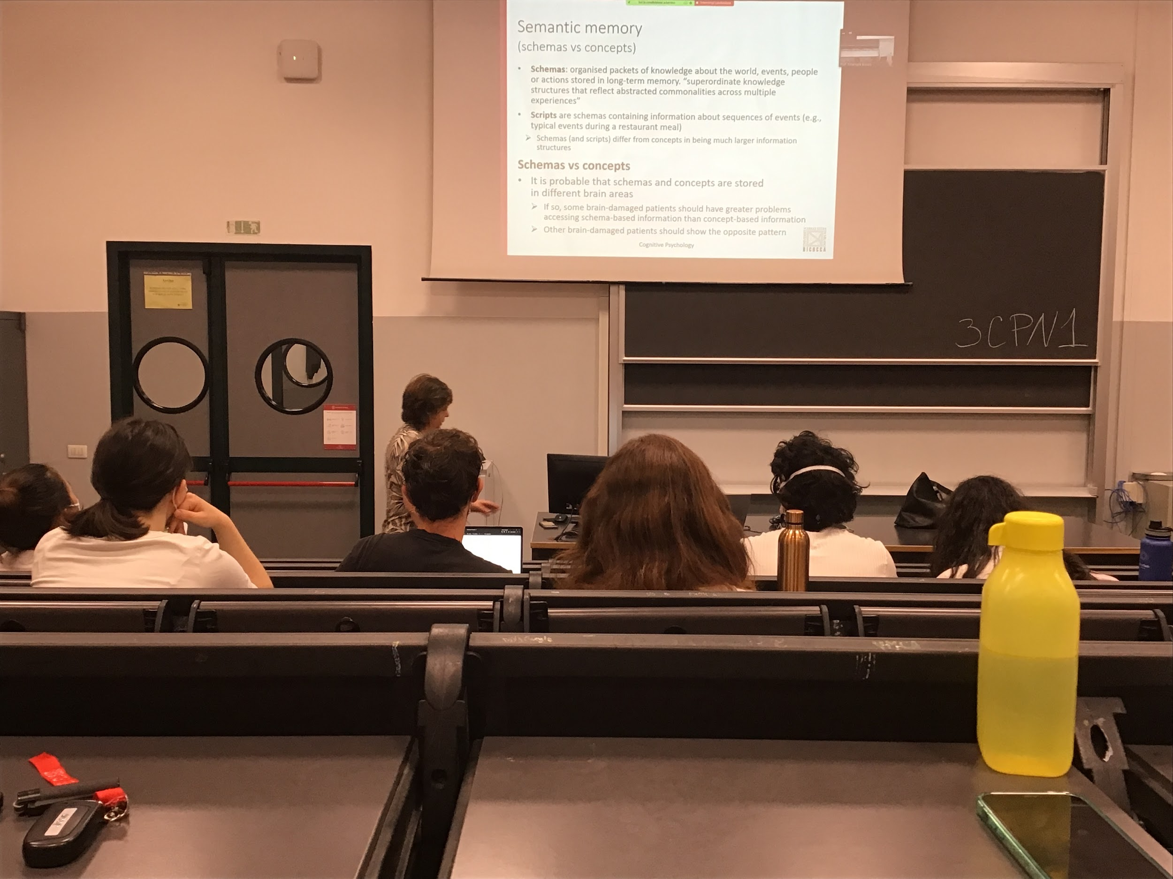

If concept and schemas are 2 different ways that semantic memory saves information we should find a double dissociation

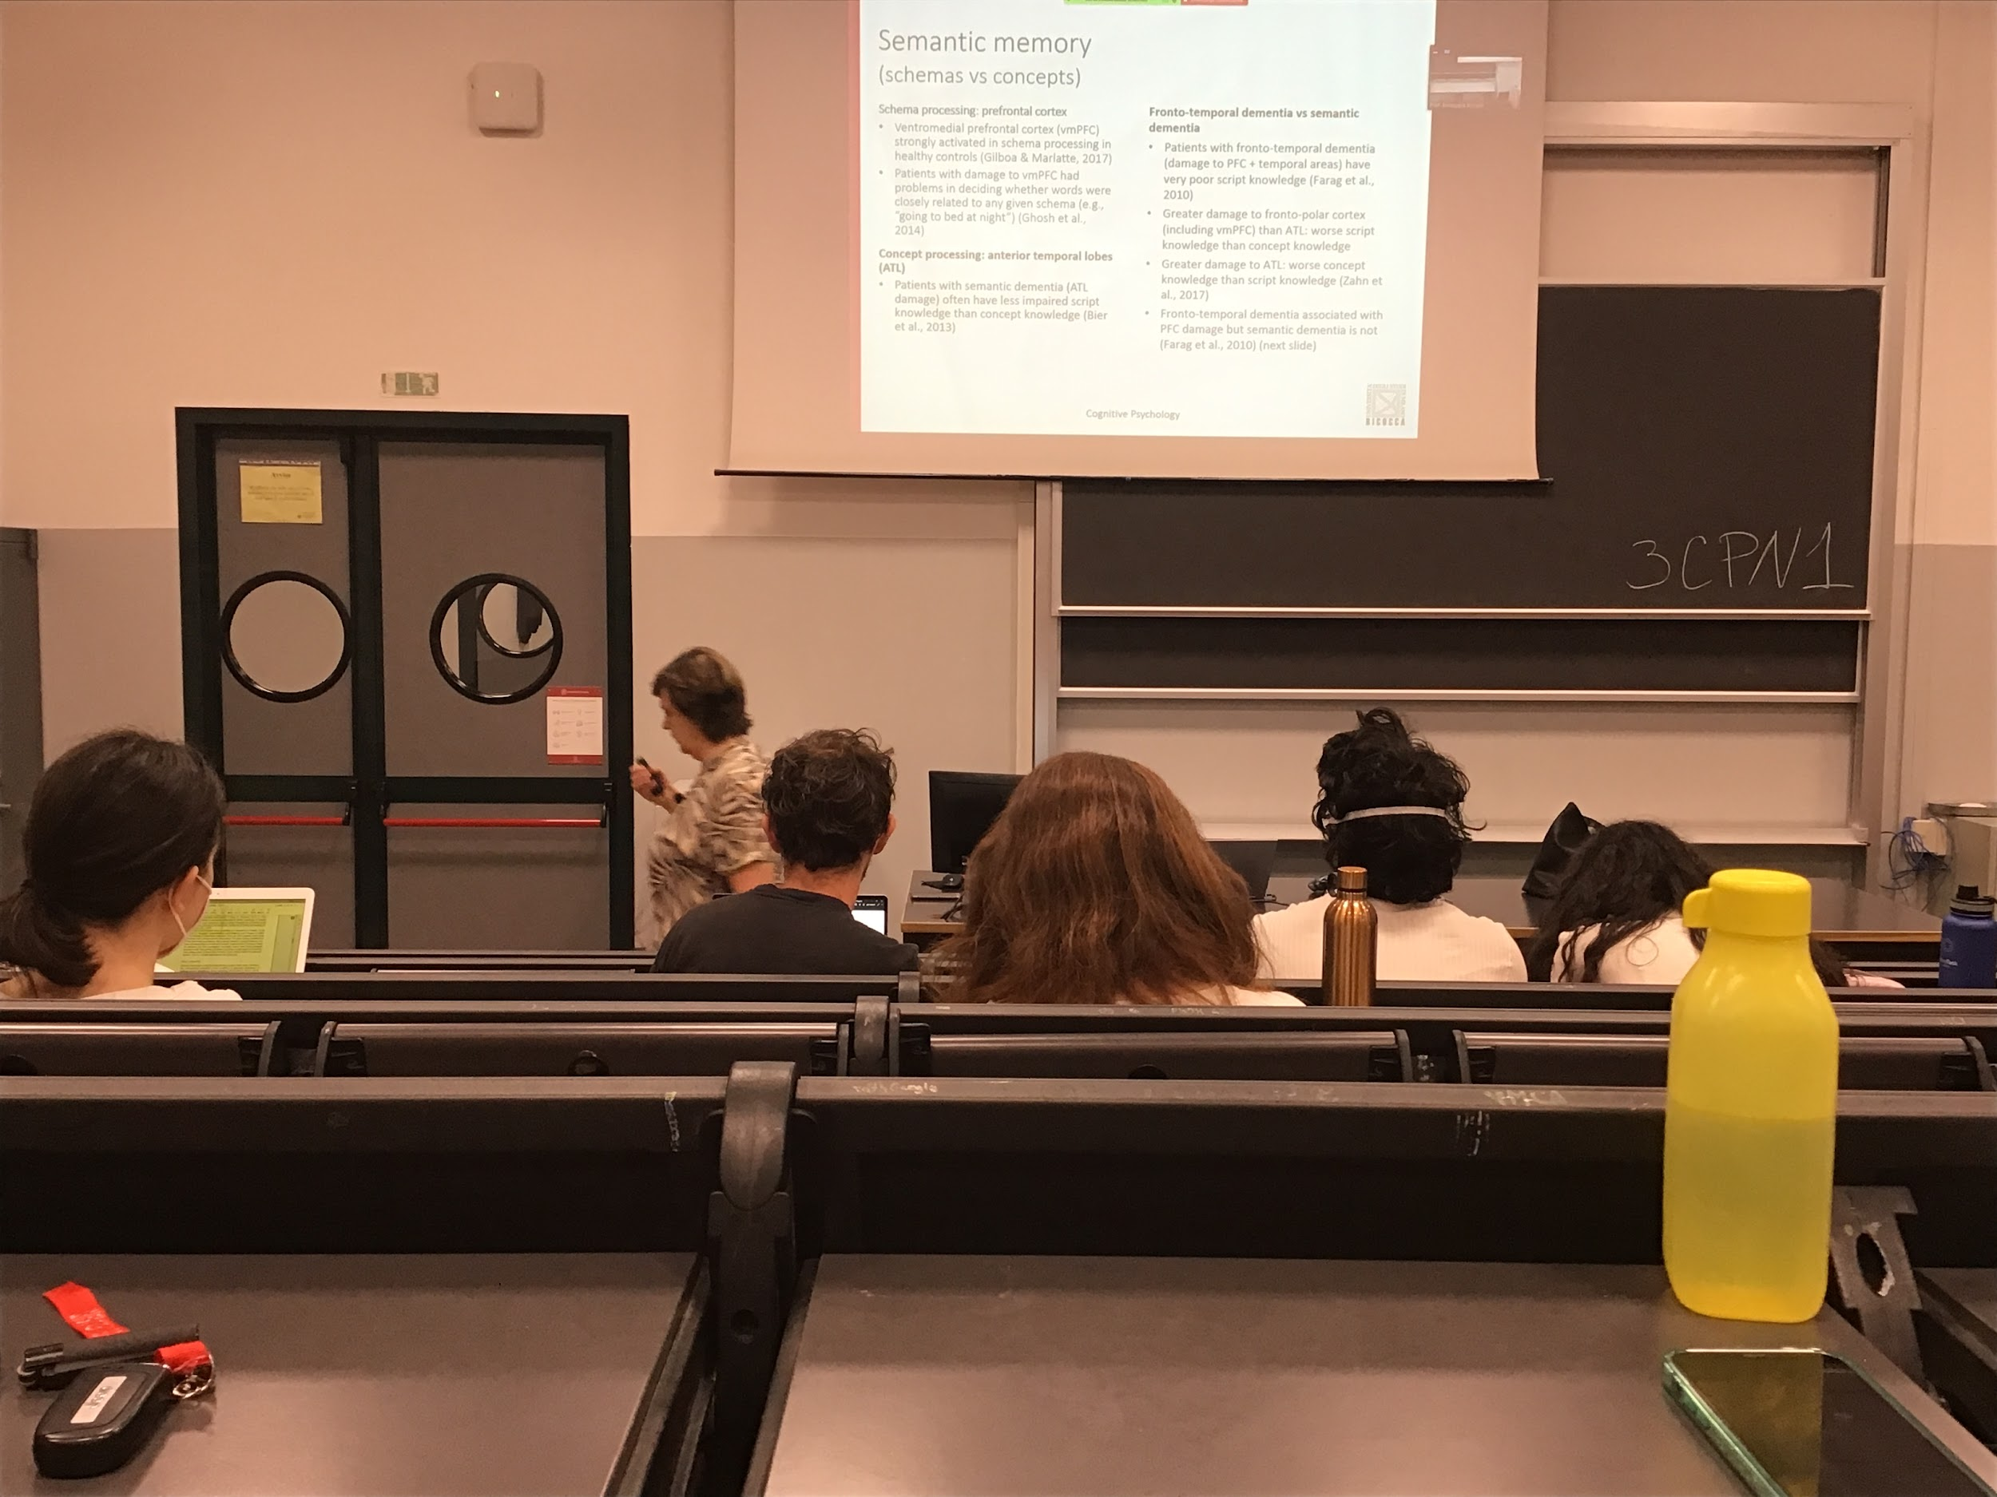

We do find different brain areas

Lesion is arterial temporal lobes area dedicated to concept, semantic dementia

There is a different group of areas in the prefrontal cortex that are active when we think about schema. People with frontotemporal dementia have the opposite problem. Difficult with schemas and not with concepts

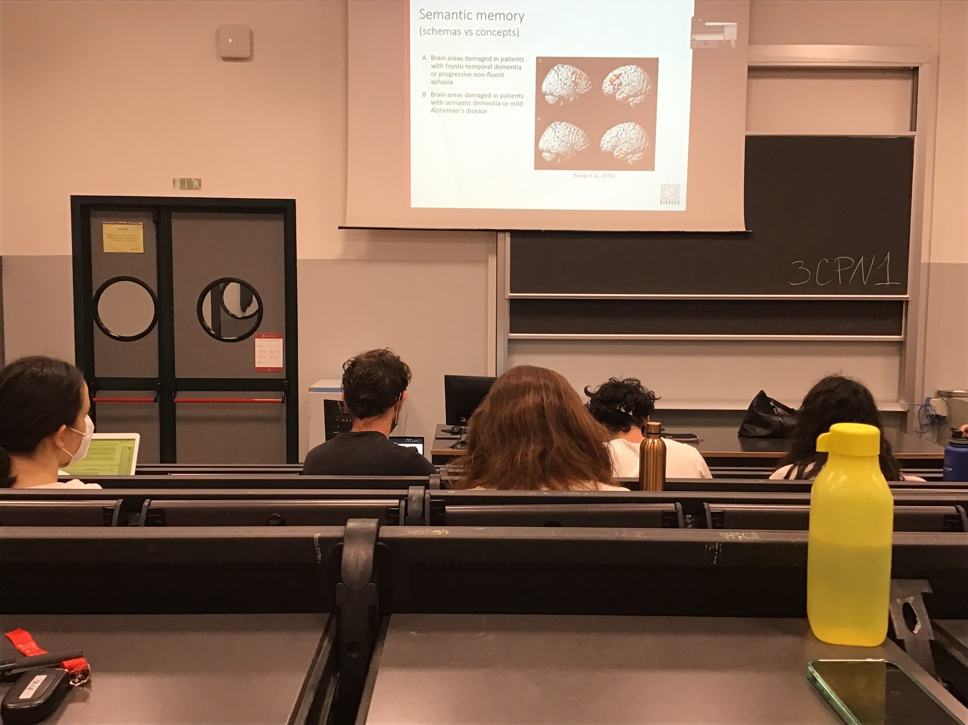

The areas are completely different

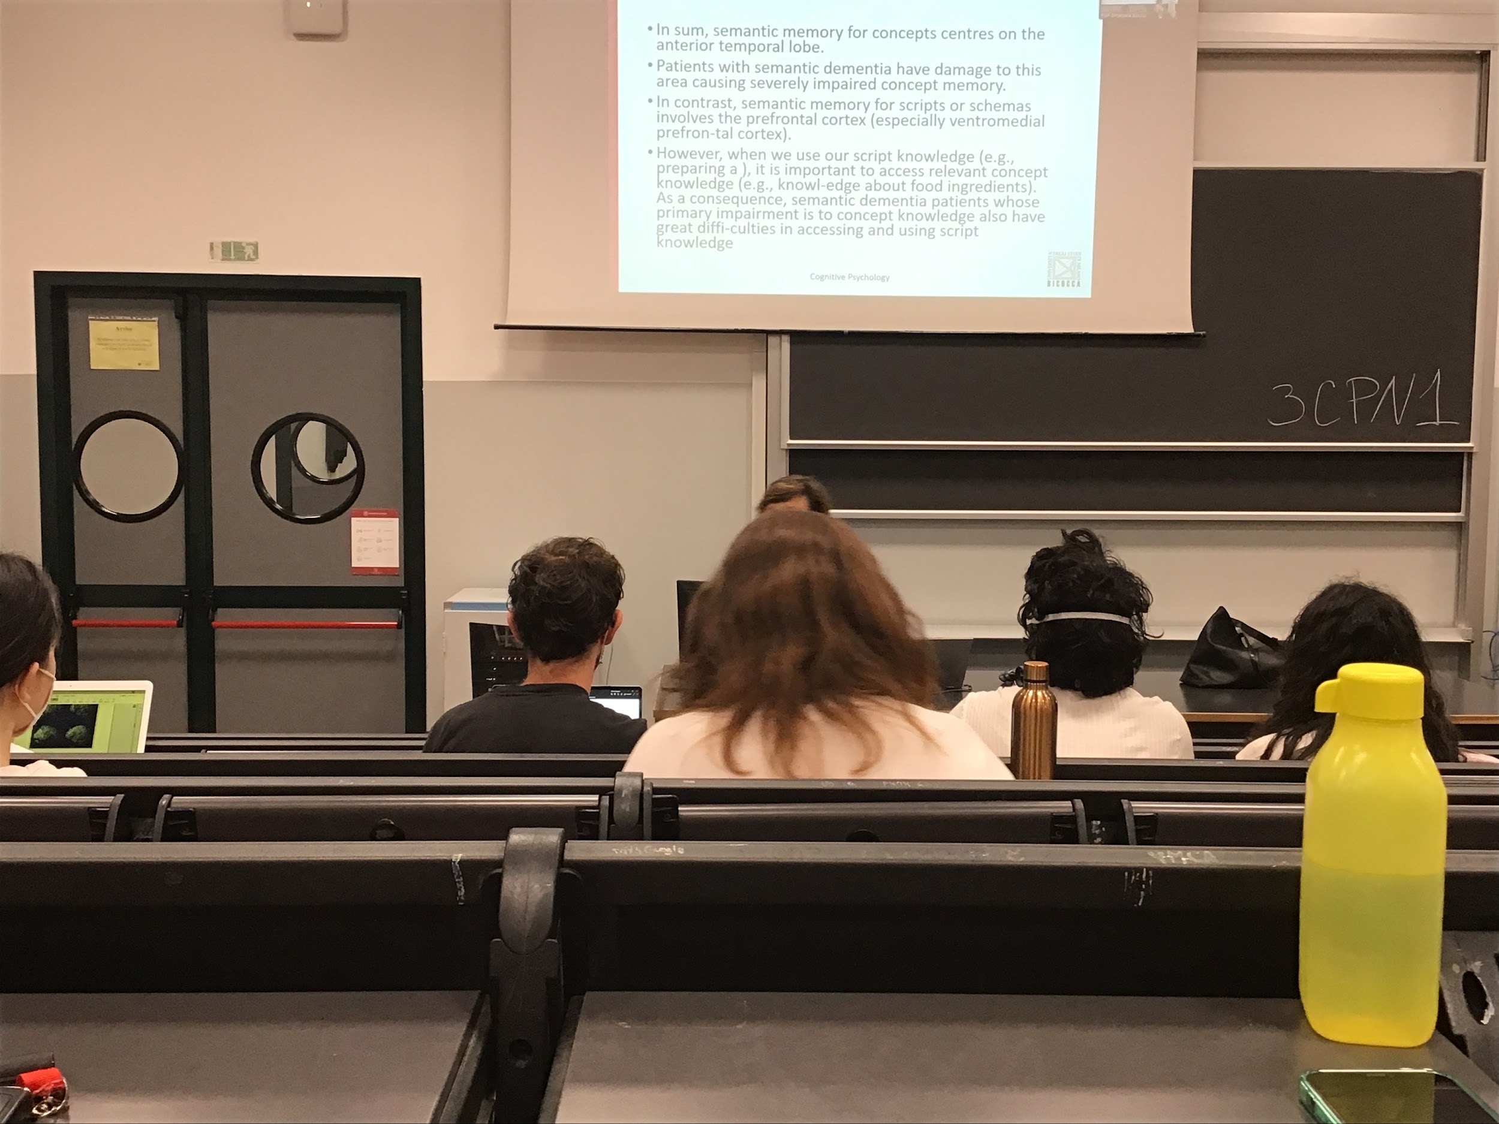

# Audio 2

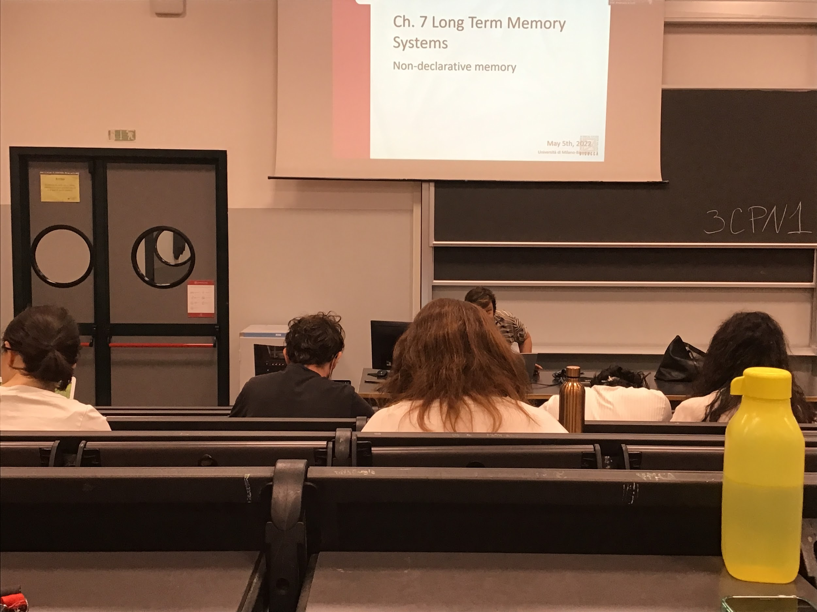

Declarative memory (AKA explicit memory) we can recall information explicitly

Non-declarative memory (AKA implicit memory). Our ability to learn and save information that we can no extract explicitly from memory

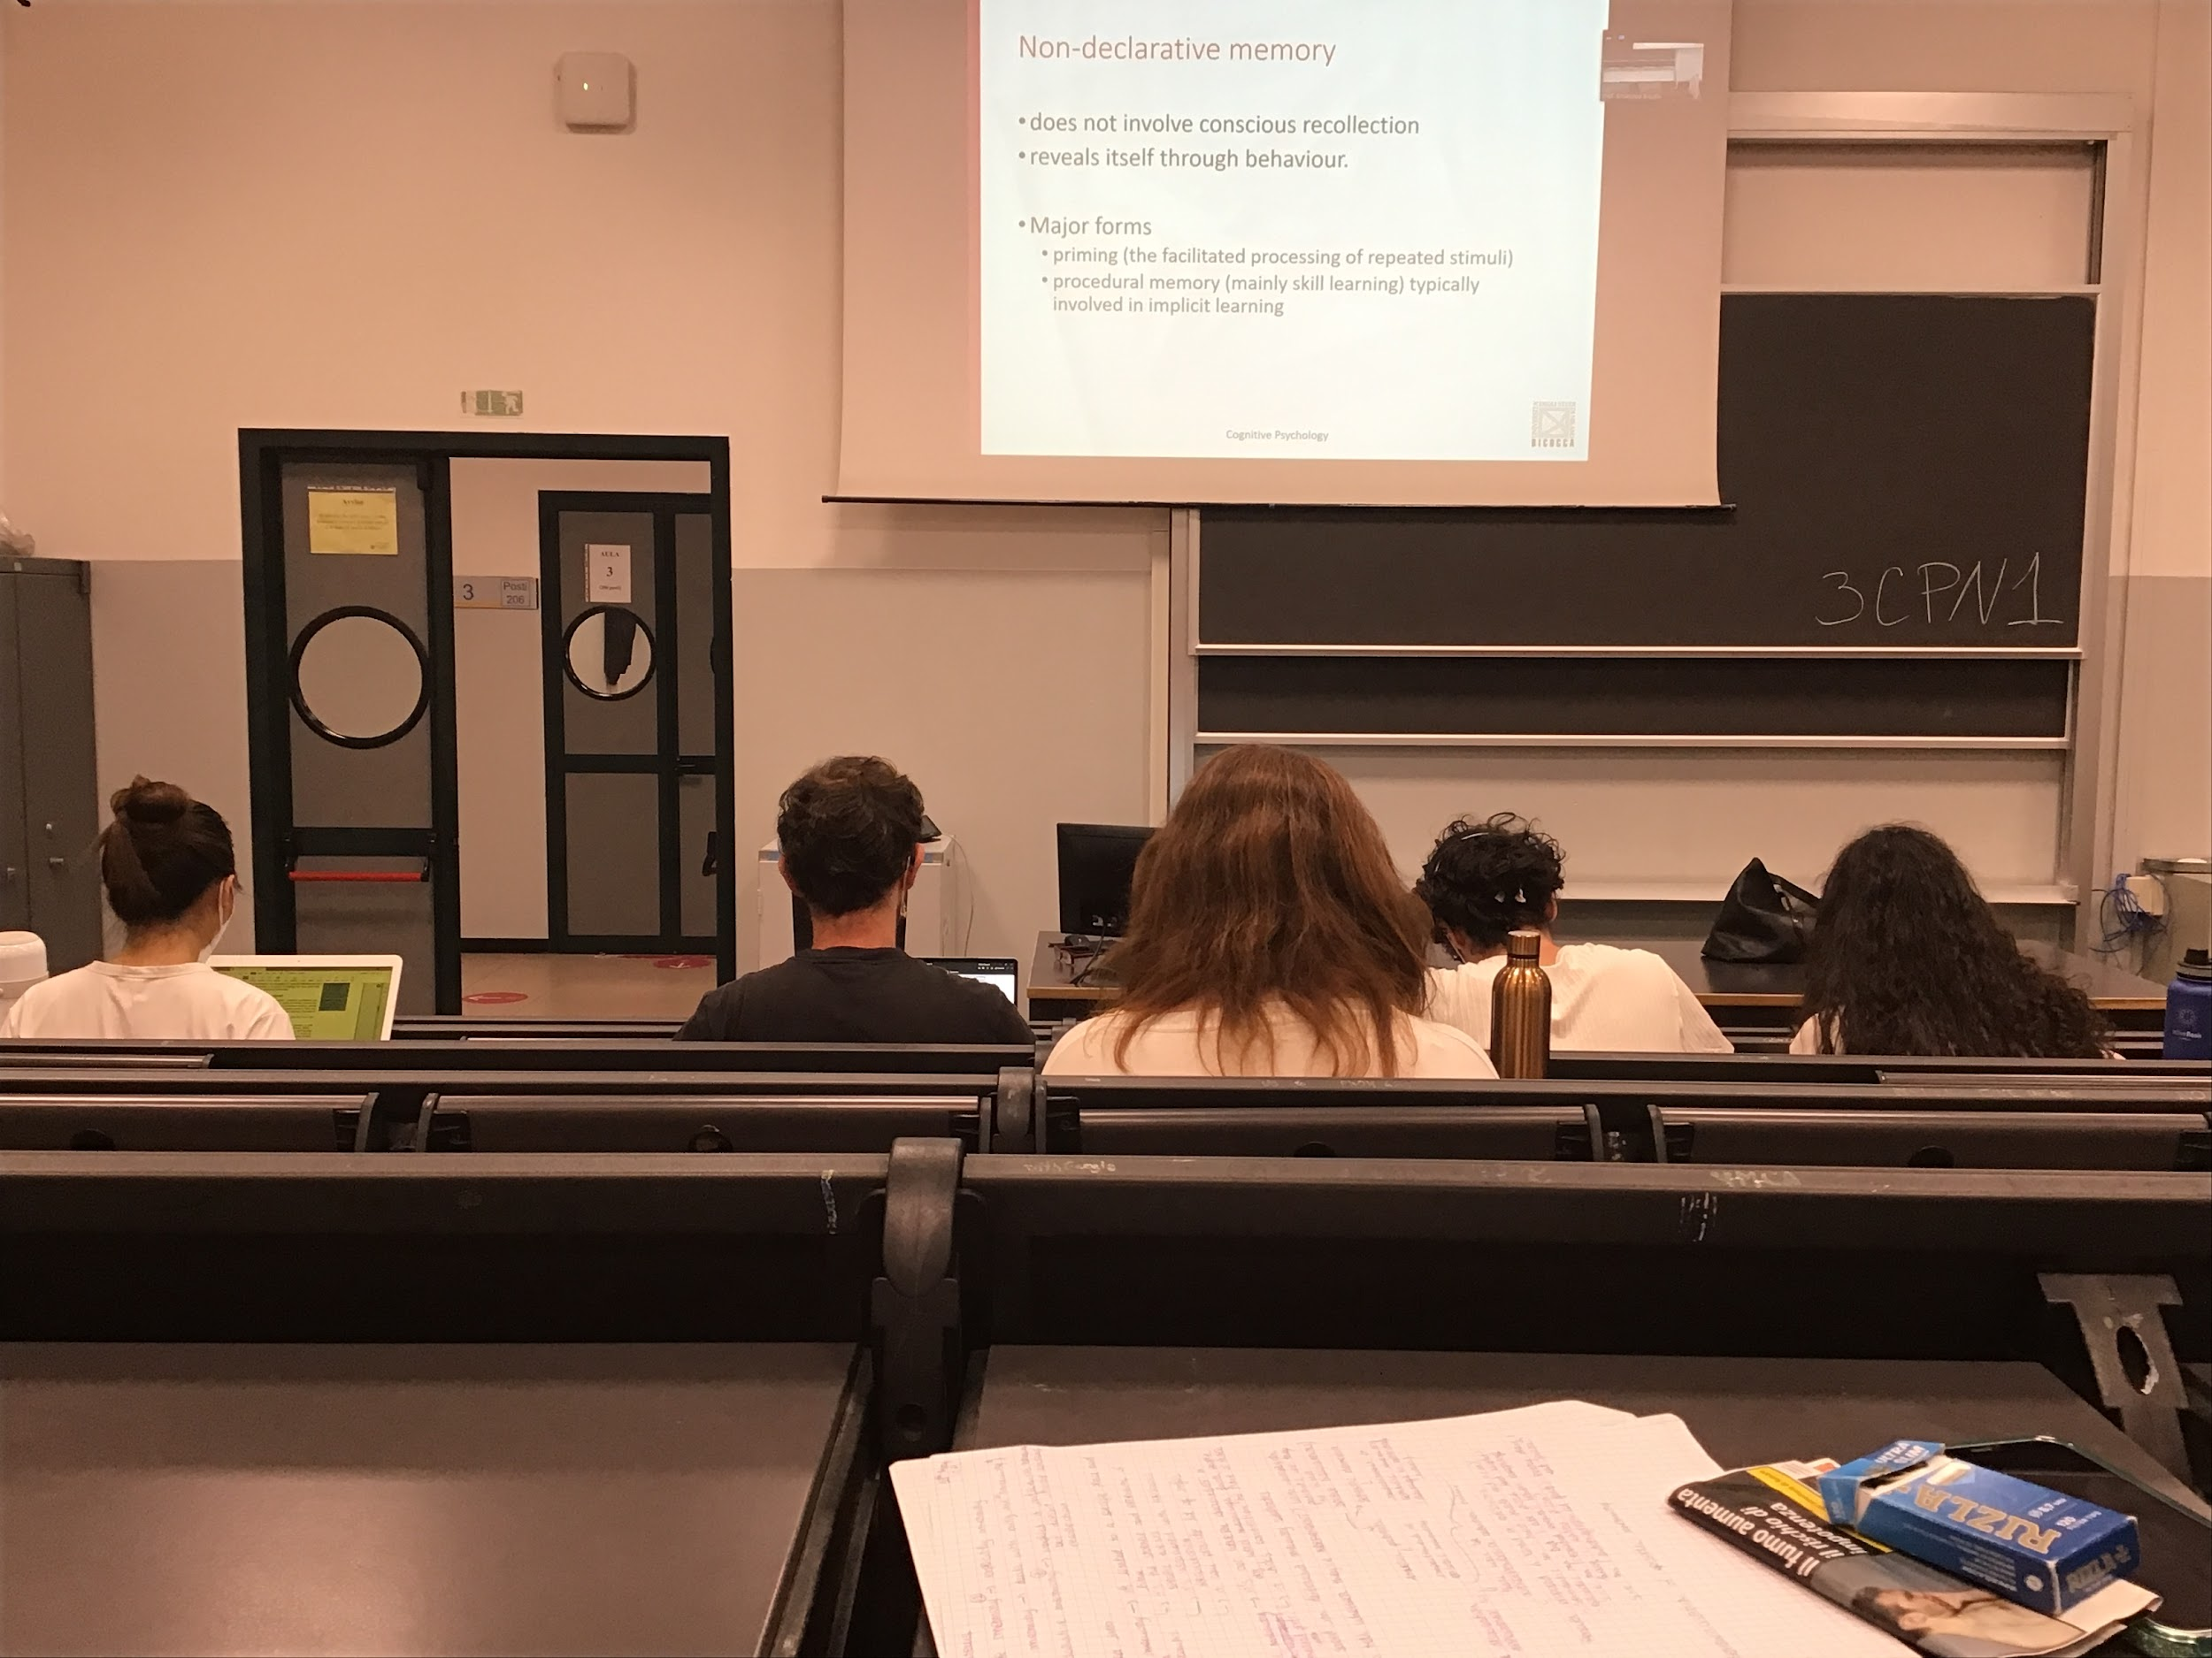

Non-declarative memory does not involve conscious recollection

Behaviour changes shows that someone learned something, like when you react in a different way

Two main distinction

* **Priming**: when I am present with some kind of stimulation, in presence of repeated stimuli what I see before influence what I see afterwards
* **Procedural memory**: ability to learn motor skill

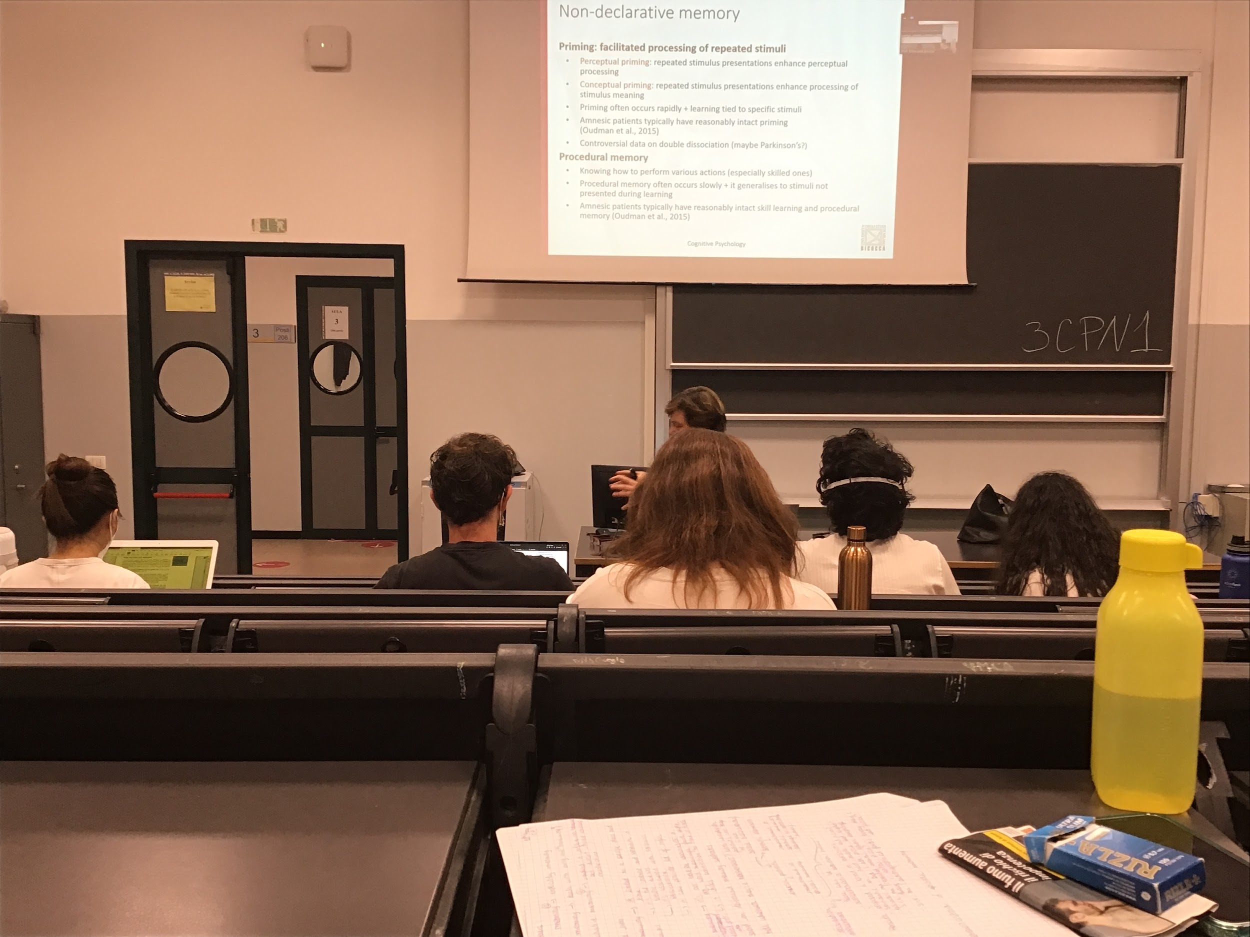

Non-declarative memory contains a lot of different tasks. What I have in common is that can not be extracted explicitly

The priming shows facilitated processes

2 type of priming

* **Perceptual priming**: what I hear (or some information that comes from the senses) activates some representation. The representations that are perceptually similar are processed faster and better. Very specific perceptually
* **Conceptual priming**: if I activate 1 concept in memory. Everything is completely different, it is a concept priming

Difference between priming and procedural memory:

* **Priming**: usually happens rapidly, immediately you have it right away, specific stimulus association
* **Procedural memory**: to learn a new skill you need practise, take time

It you learn to drive, you can apply your skill in different roads you have never been to before

For non declarative memory people with amnesia have deficit in this type of task (both priming and procedural memory)

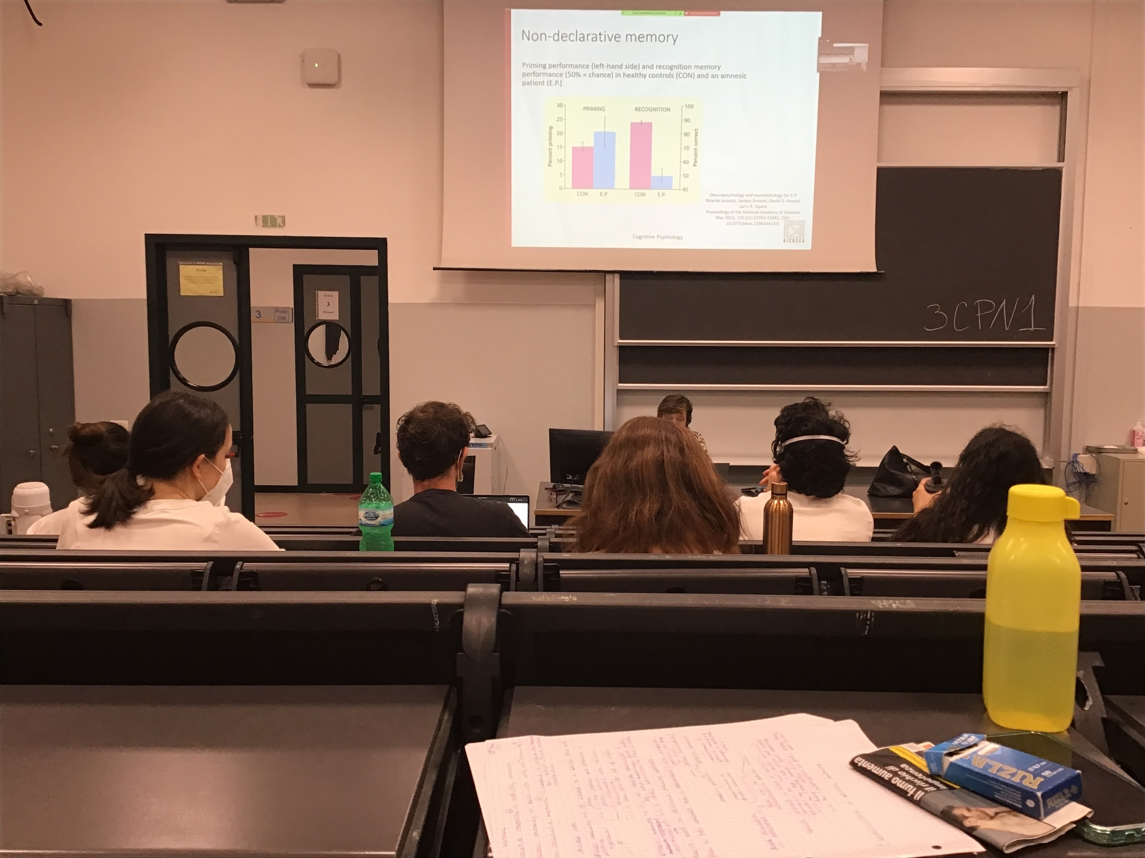

People with amnesic syndrome have a deficit in actual recognition memory (declarative memory) and not in non-declarative memory

E.P. Amnesic patient, his priming ability are similar to those of controls (a little better) but the recognition of explicitly memory is very low

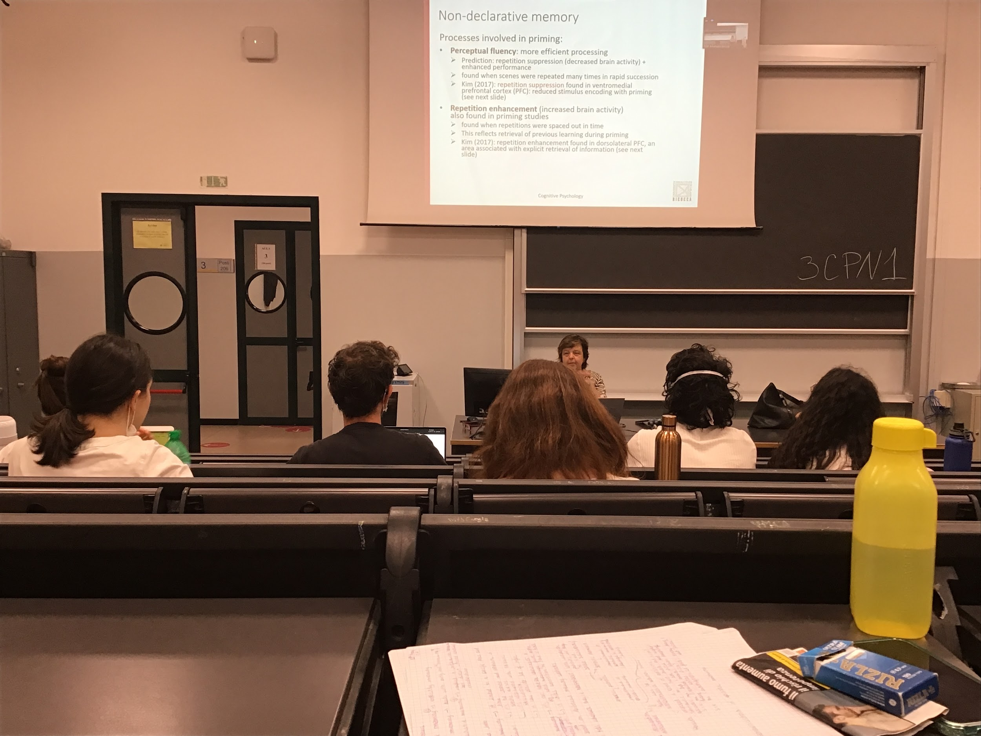

Priming can have different processes involved. In some case I can have a worst performance when there is repetition and in other cases better performance when we have repetition

When I repeat the same image or the same concept in rapid suppression what happens is that the brain reduces activity, repetition of always the same activation in time the brain (after a while) decide to separate energy and reduce activity

This reduce activation improves performance

On the other hand, when repetition are not so fast (one after the other) but are spaced in time there is increase brain activity when the second comes up and improves in performance

2 different brain activities are related to both improved in performance, completely different brain activity for repetition suppression (RS) and repetition enhancement (RE) and both bring improvement

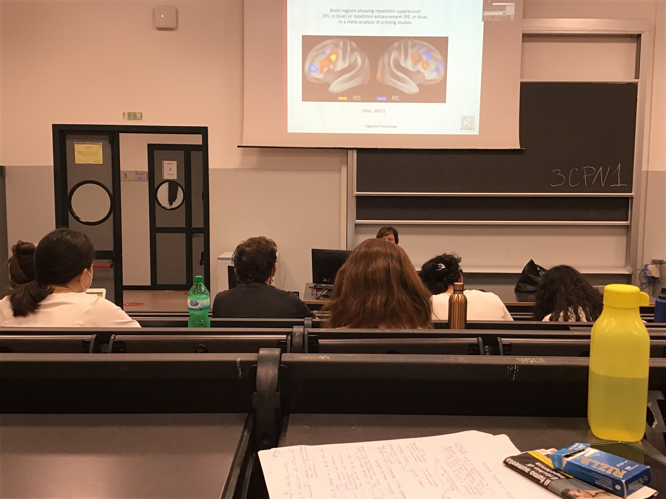

The network seems to be wild spread in the brain

Problem with priming: not clear that is a pure non declarative memory, sometime people can actually make explicit connections on what they been priming to

Is a mixture, while probably we can not actually find a double dissociation

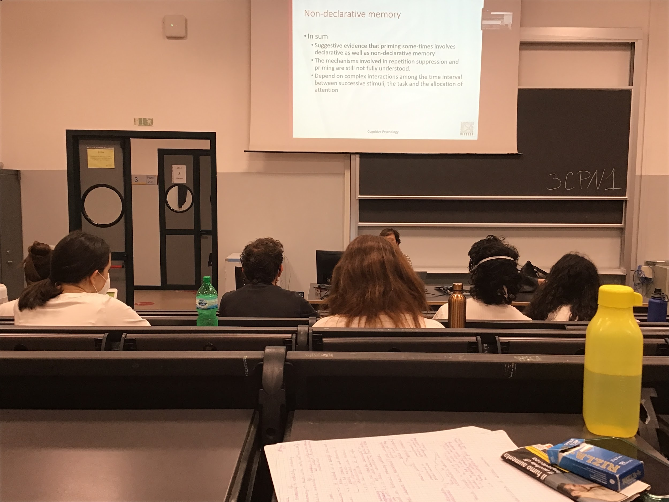

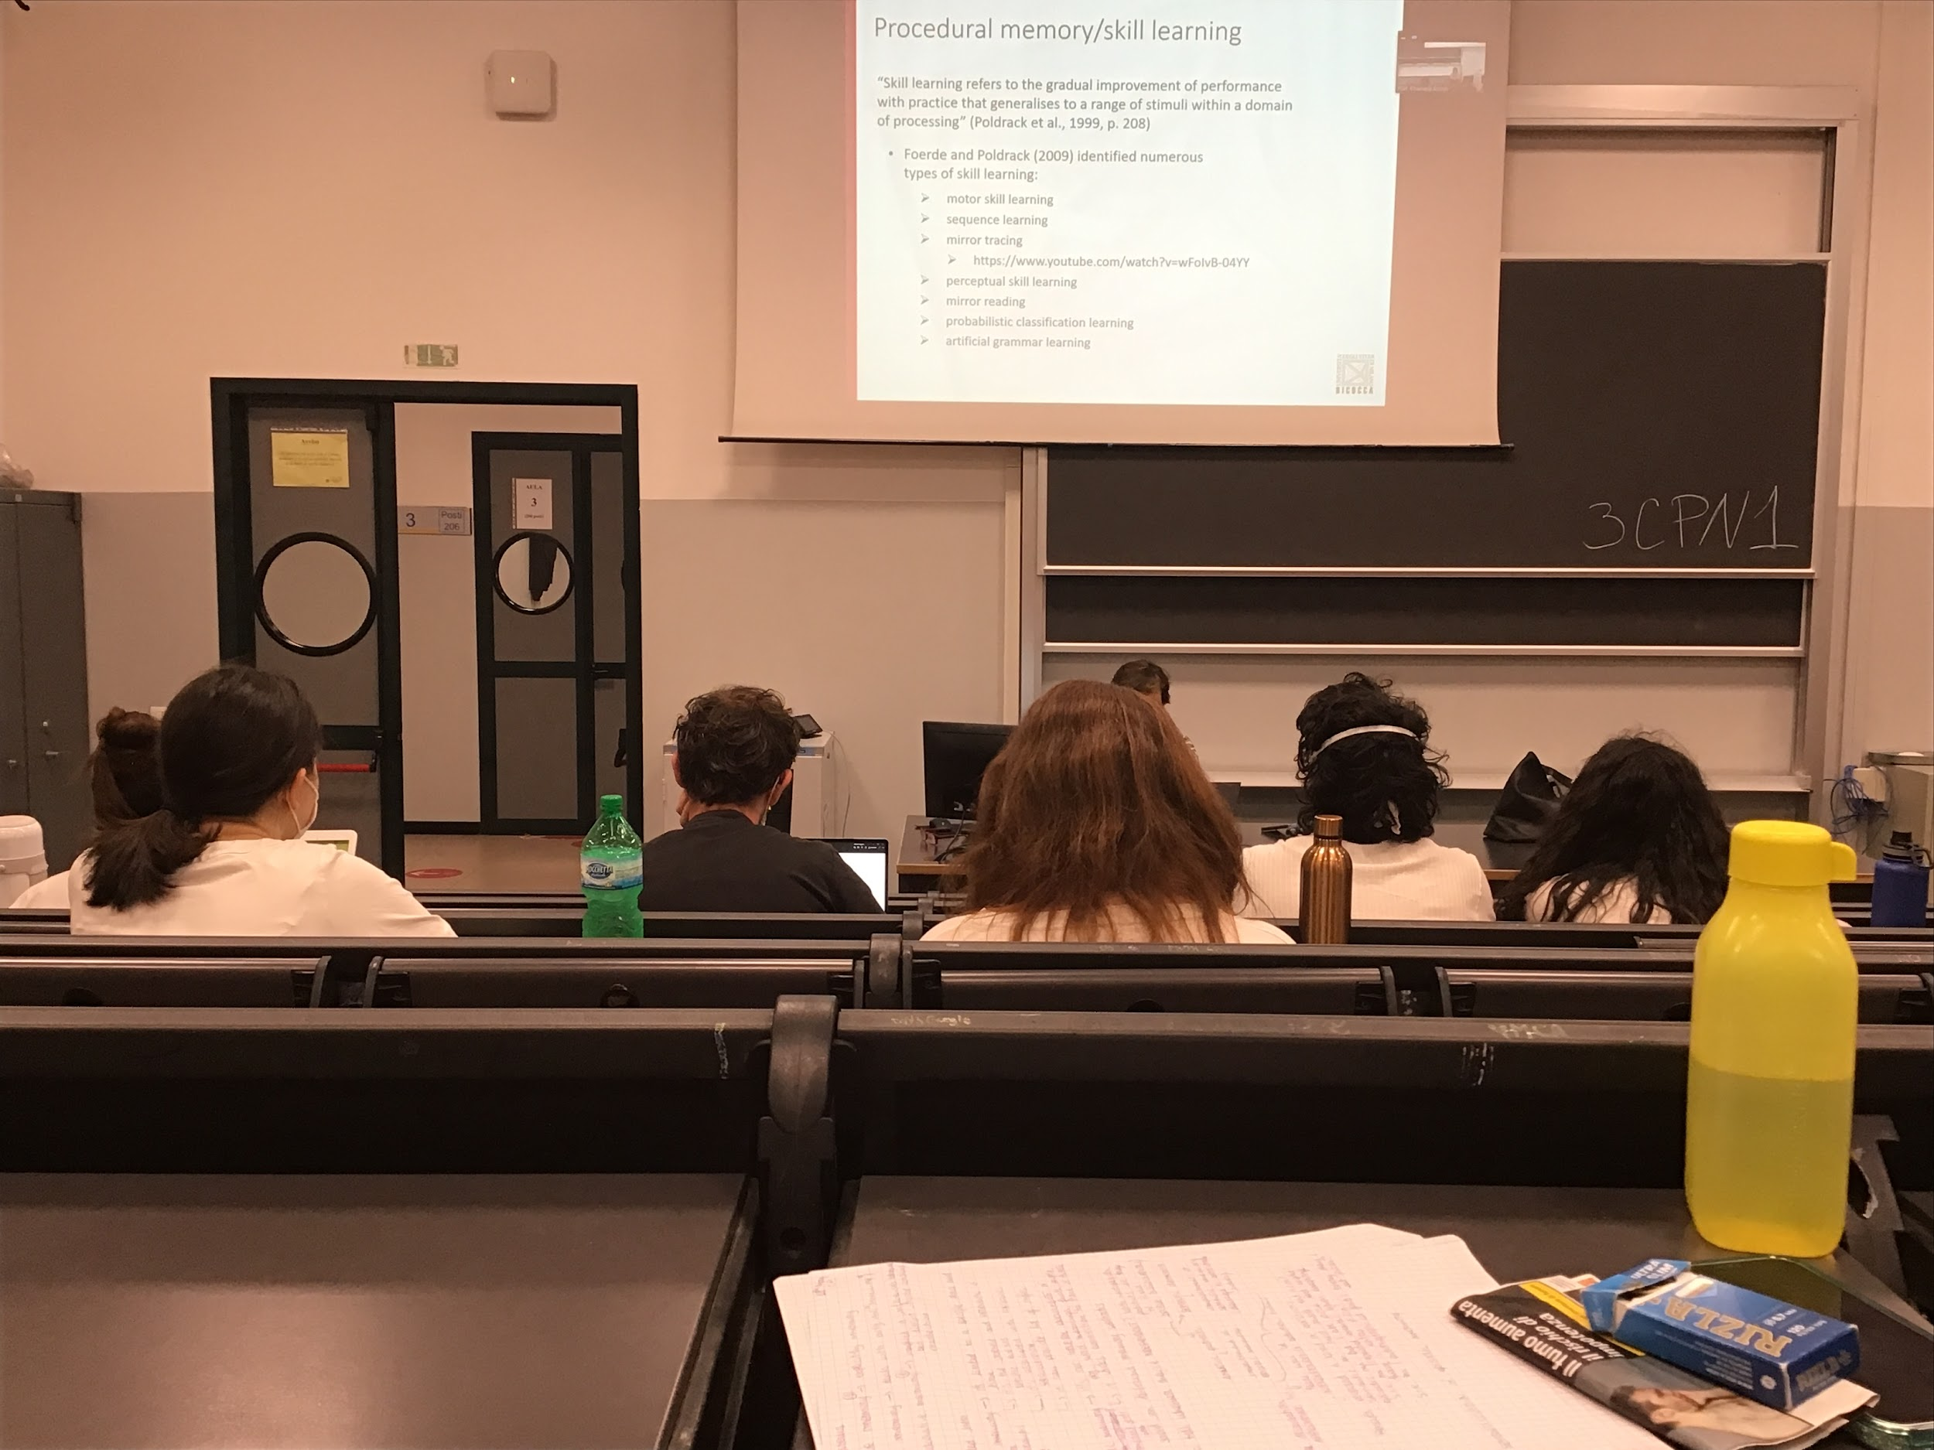

Another big pool is procedural memory (AKA skill learning)

Compared with prime, we need time and repetition to learn a specific task

Skill learning: gradually improve of performance with practice that generalises to a range of stimuli within a domain of processing

There are many example:

* Motor skill learning: ride a bike, play tennis…
* Sequence learning: learn specific sequences
* Mirror tracing: relativity difficult, have to stay between the two lines but what you see is mirrored, if you train over and over again you make less errors but you need time
* Artificial grammar learning

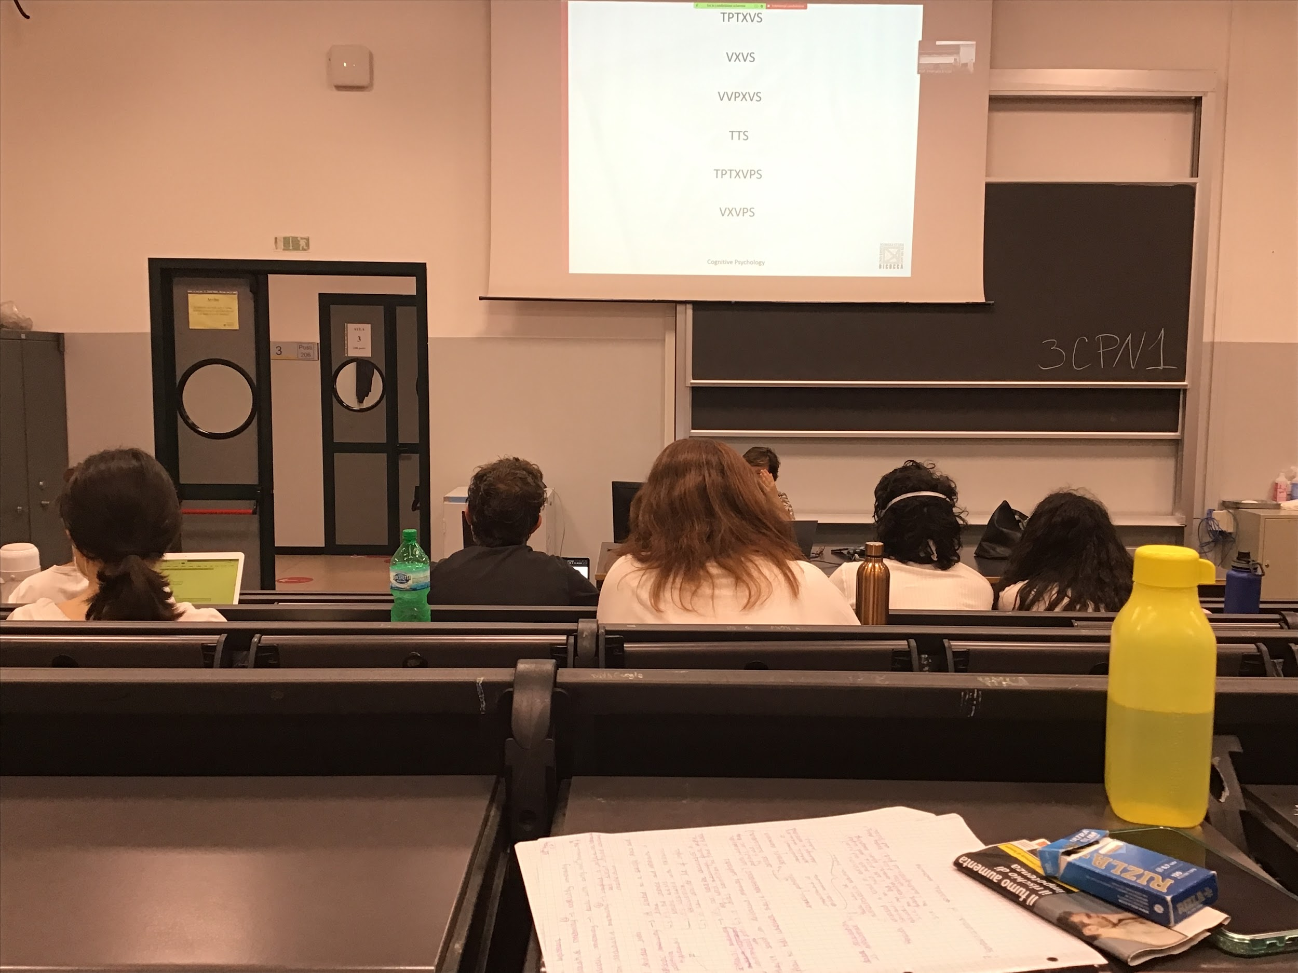

These words are words in a specific language and you need to learn the language. After having shown people a series of words I made them perform a task (nothing to do with letters) and then **gave two words and which of the two following words have the same rules as before?**

* TTXVS
* TPXPS

People try to guess, higher % if the time get the right answer, but most of these people are not able to tell what the rules are

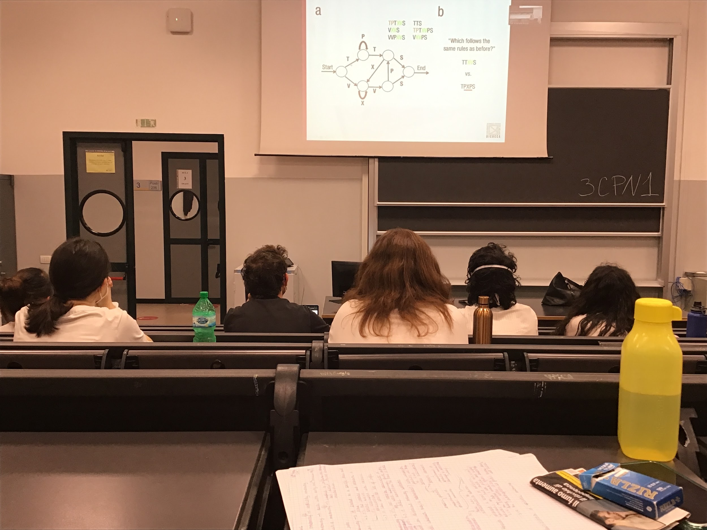

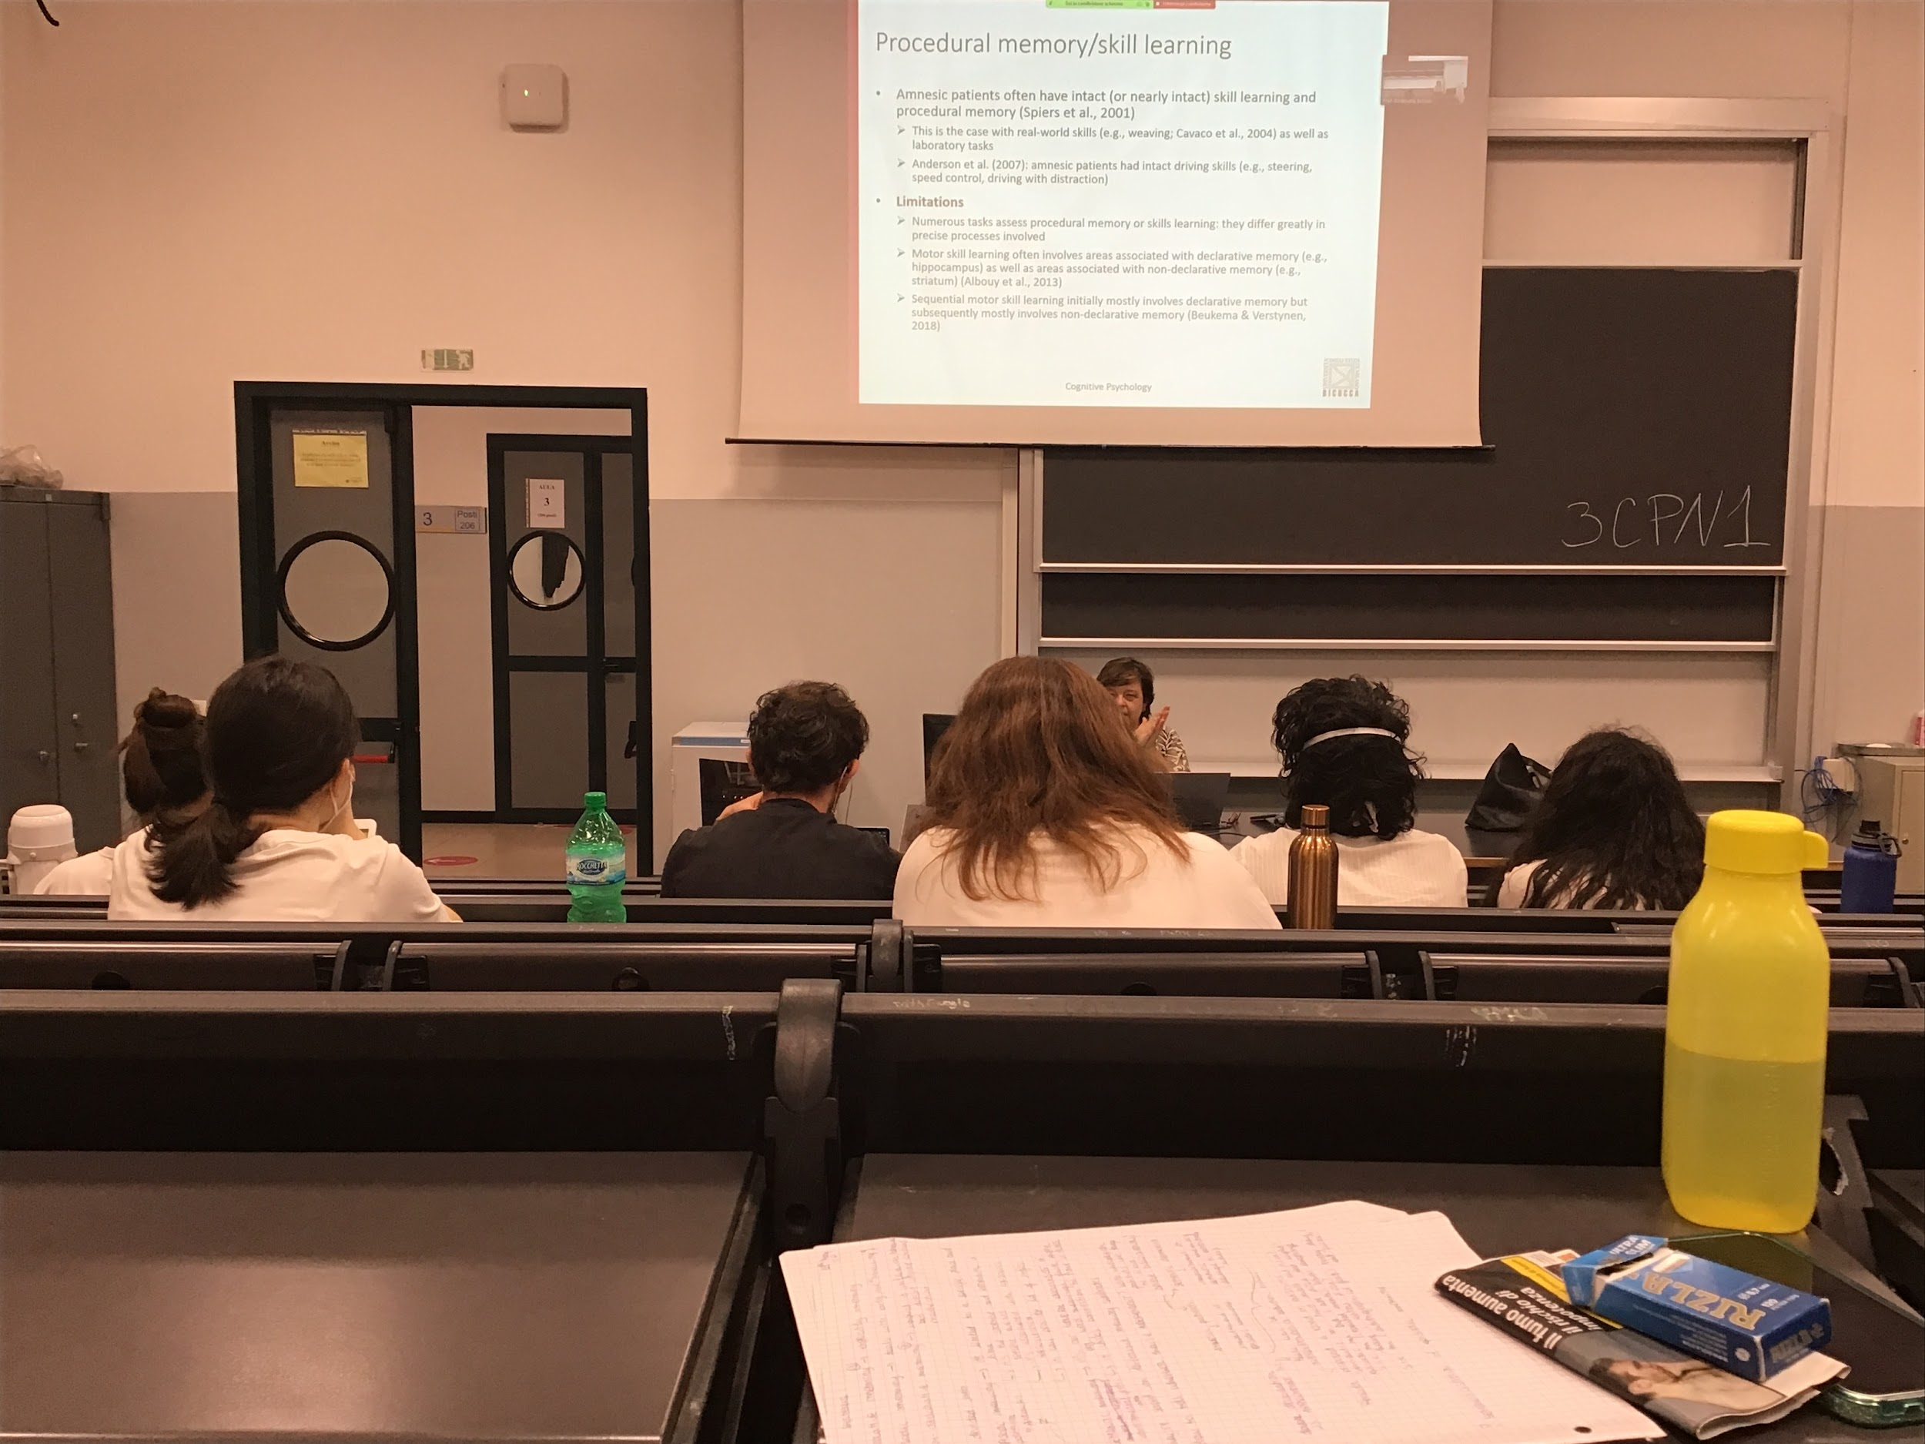

Non declarative memory is specific, doing all these tasks. Even people with amnesic syndrome can learn the grammar of artificial grammar (may take a little longer but they do it)

Intact skill learning. Not only with mirror tracing and can actually improve without actually remembering they already practise.

Amnesiac can do skill learning and can drive, can do the correct tasks

There are many different types of tasks that we use to study non declarative memory, and must have some different underlying processes involved (artificial grammar and driving don’t have much in common) . It is difficult to understand what actually connects everything. Also most of the task are not purely declarative

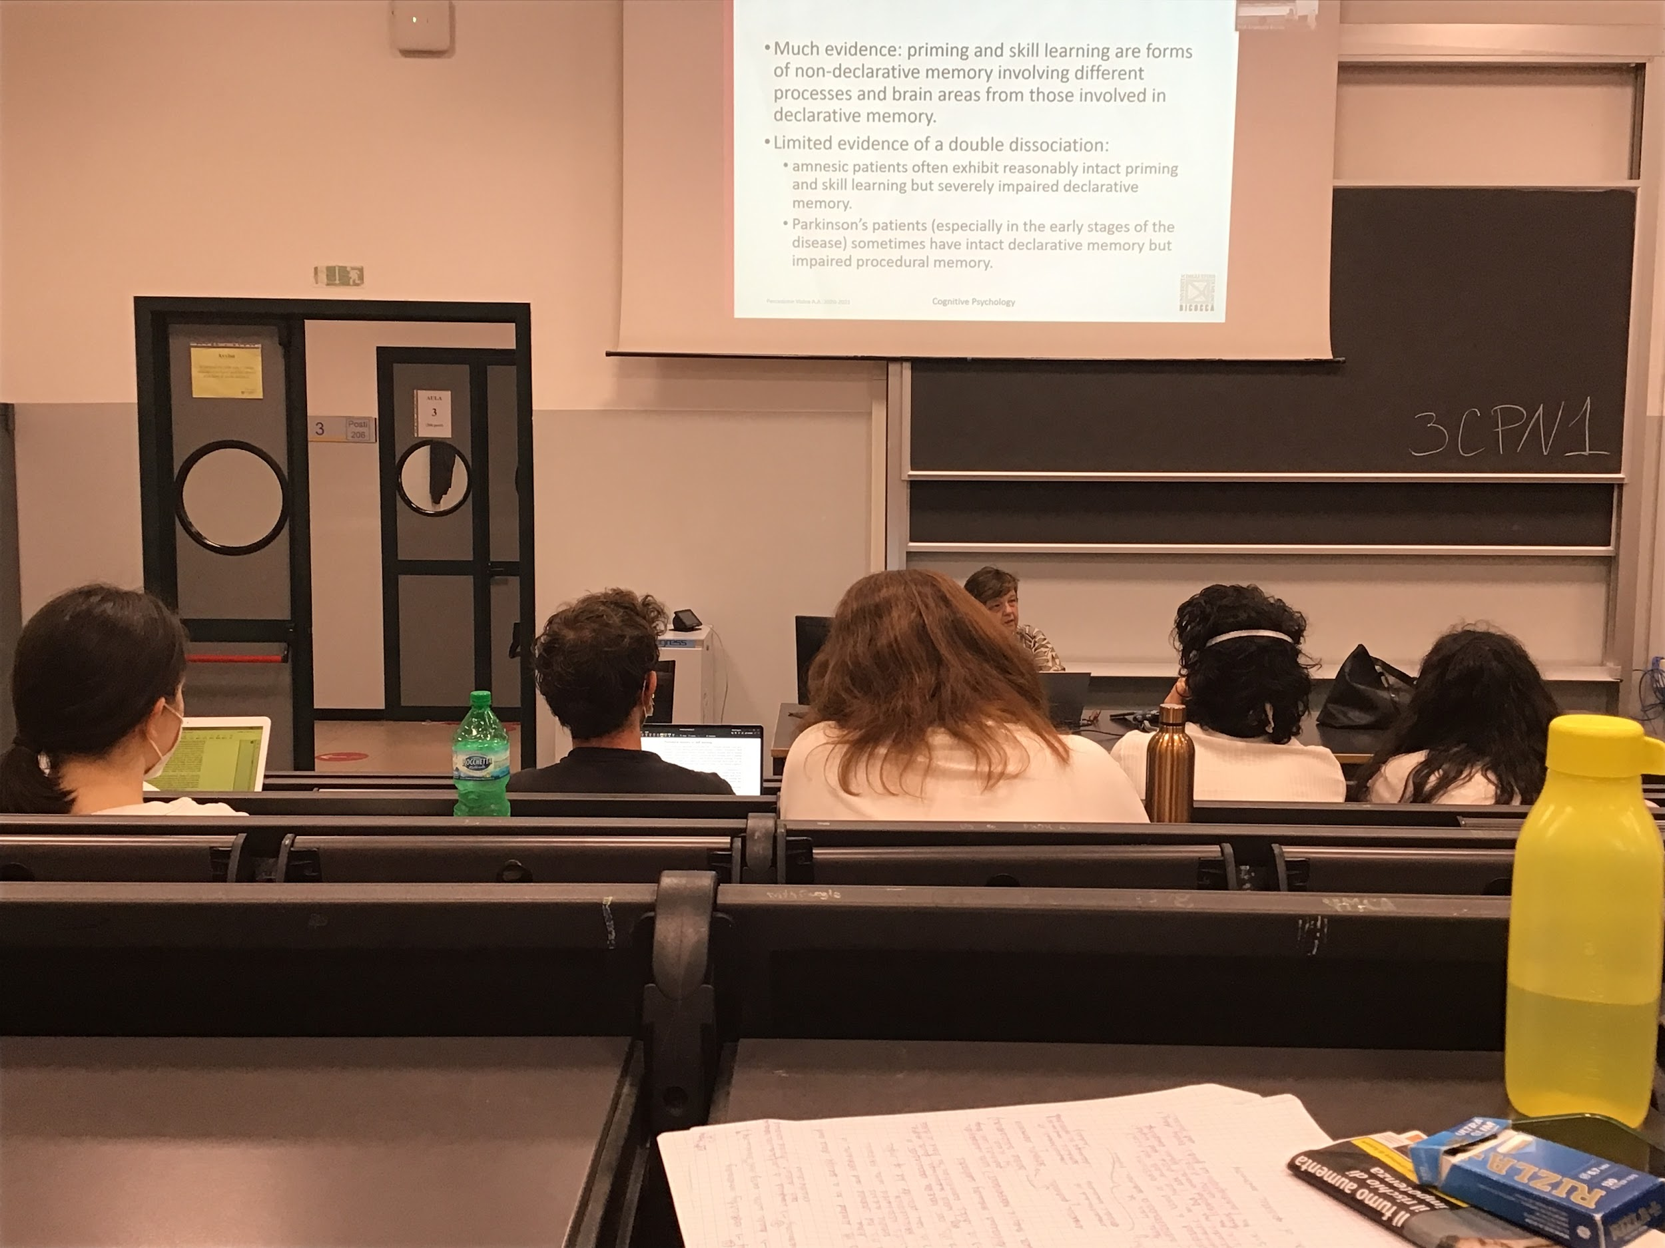

There must be something that puts everything in common (even if we don’t know exactly what it is)

Different networks of brain areas involved, many areas active, can not identity a single area

Problem with declarative and nondeclarative memory: double dissociation not found yet. Some data can support double dissociation, but very few data

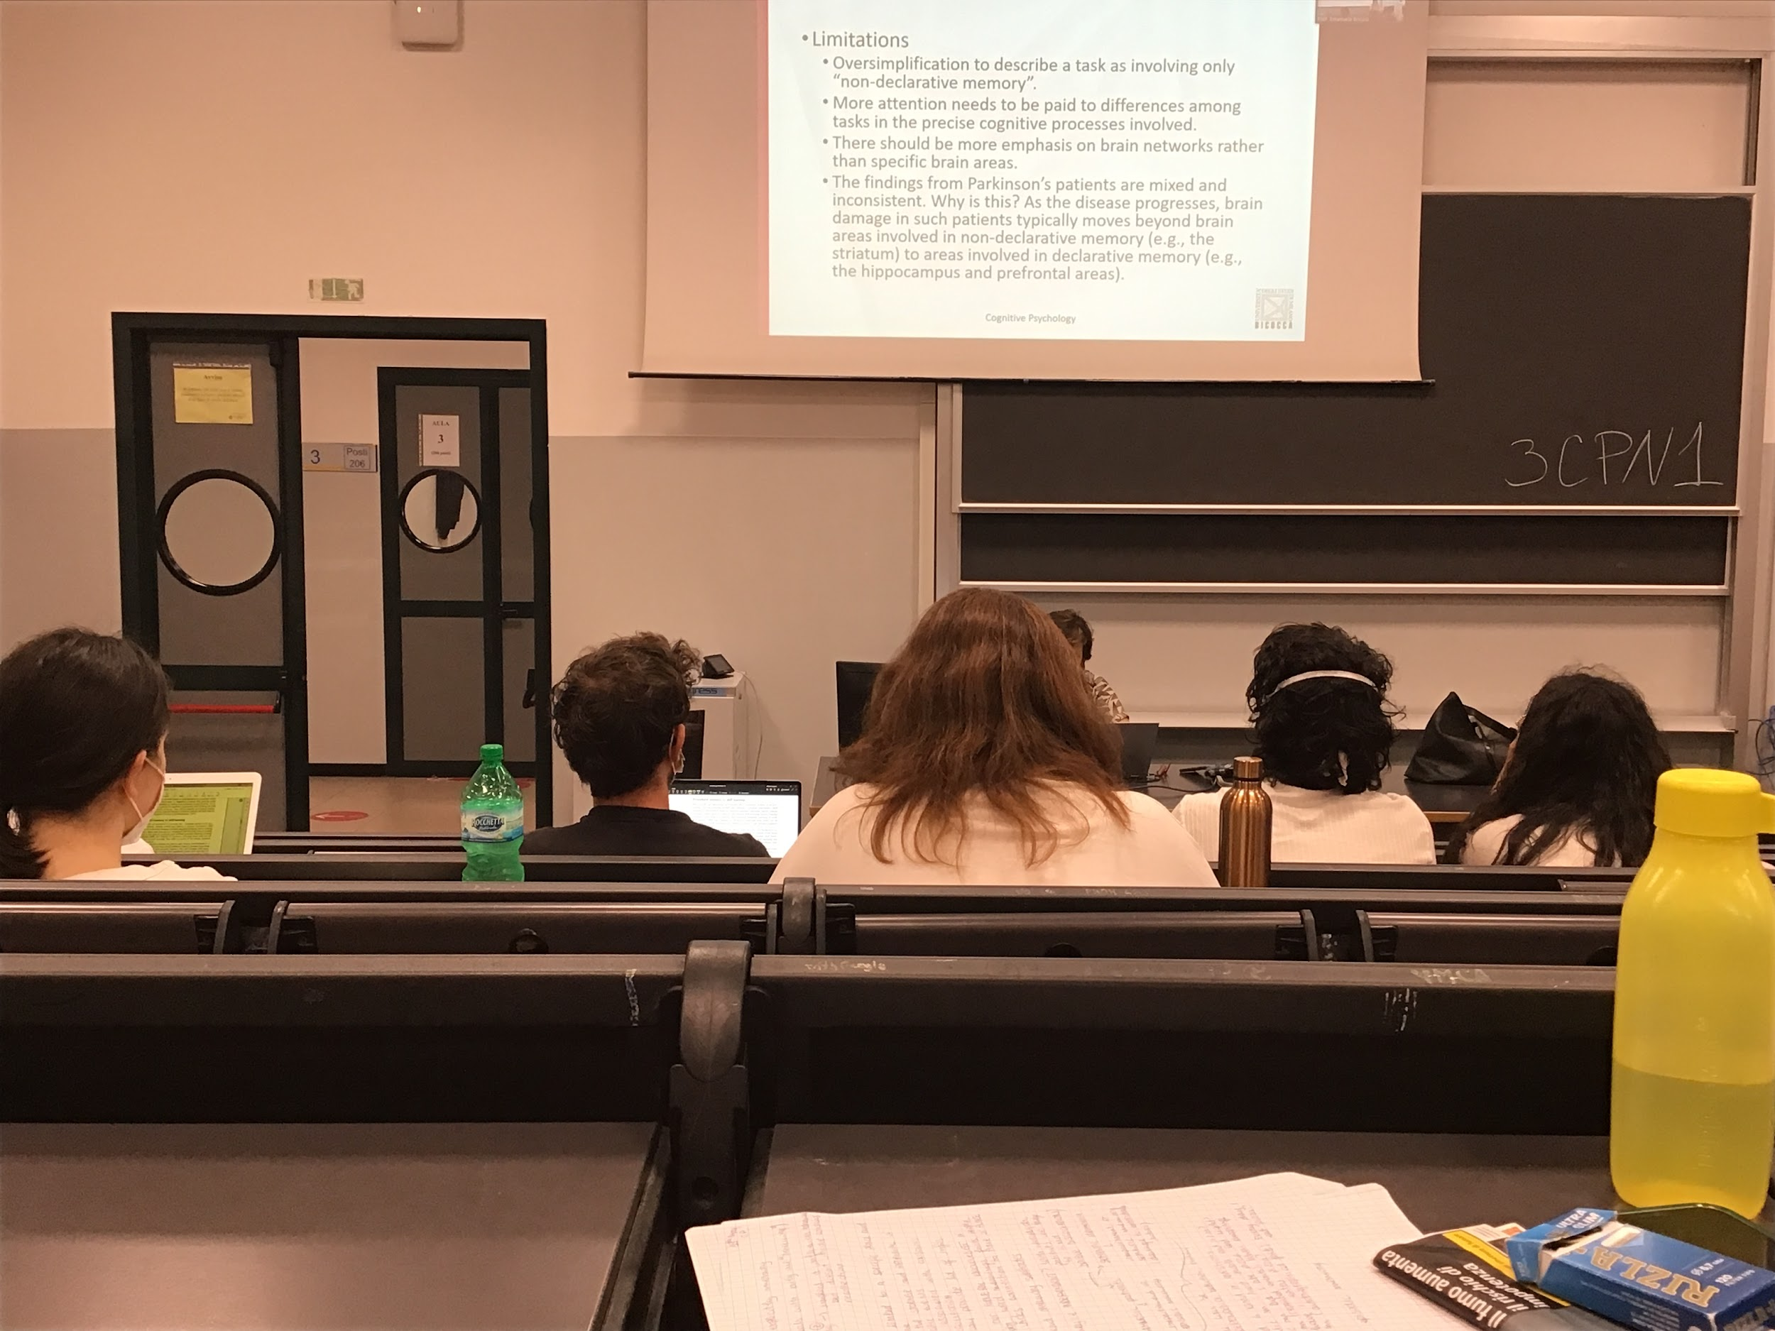

There is some support for non declarative memory. We should focus much more on networks, we should try to understand better what are the different implications of the different tasks.

There is not clear identification on what nondeclarative memory is and what it involves, later year it has been proposed no distinction between the declarative and nondeclarative memory system

Implicit is something that becomes easy for you in some ways, but you don’t know the rules. Even if are able to tell me the rules in artificial grammar is no anymore implicit learning and it has become explicit learning

## Beyond memory system

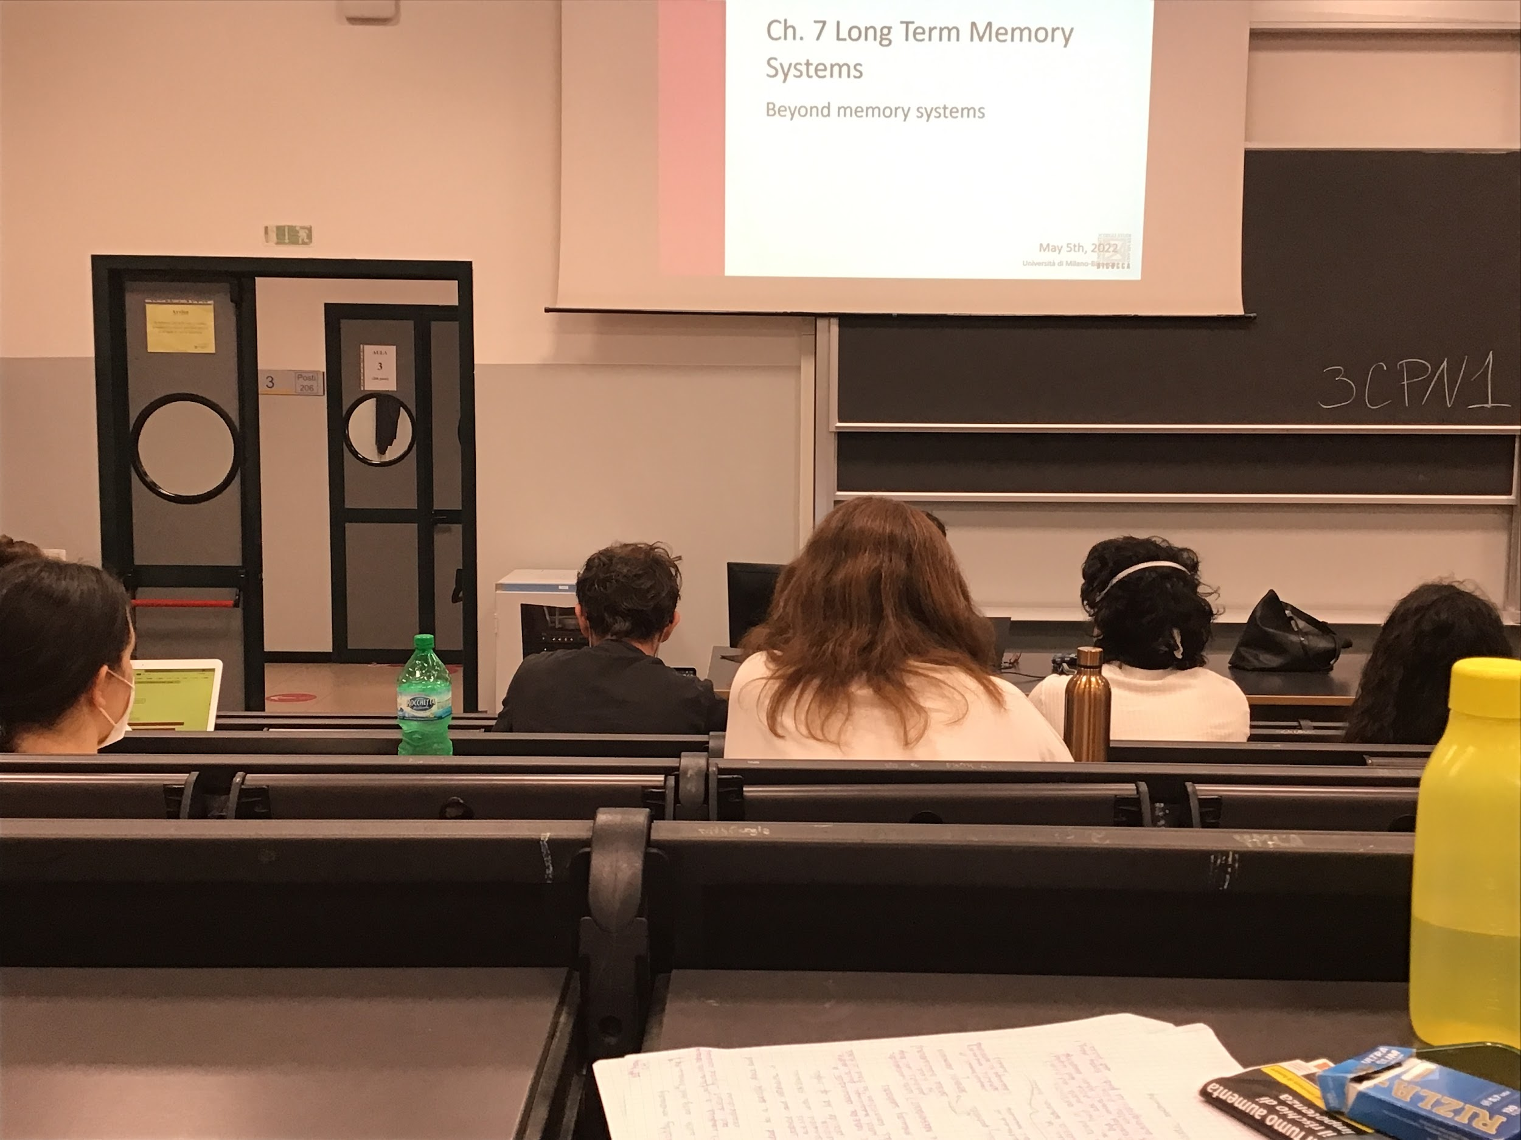

The problem with the memory system is that it is difficult to find double dissociation between declarative and nondeclarative memory. Maybe declarative memory is build up on nondeclarative memory

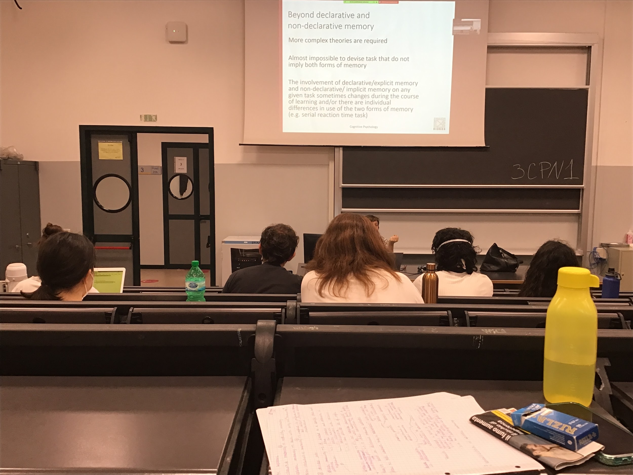

You try to find some declarative rule

Almost impossible to find a task that does not imply a little bit the other form of memory

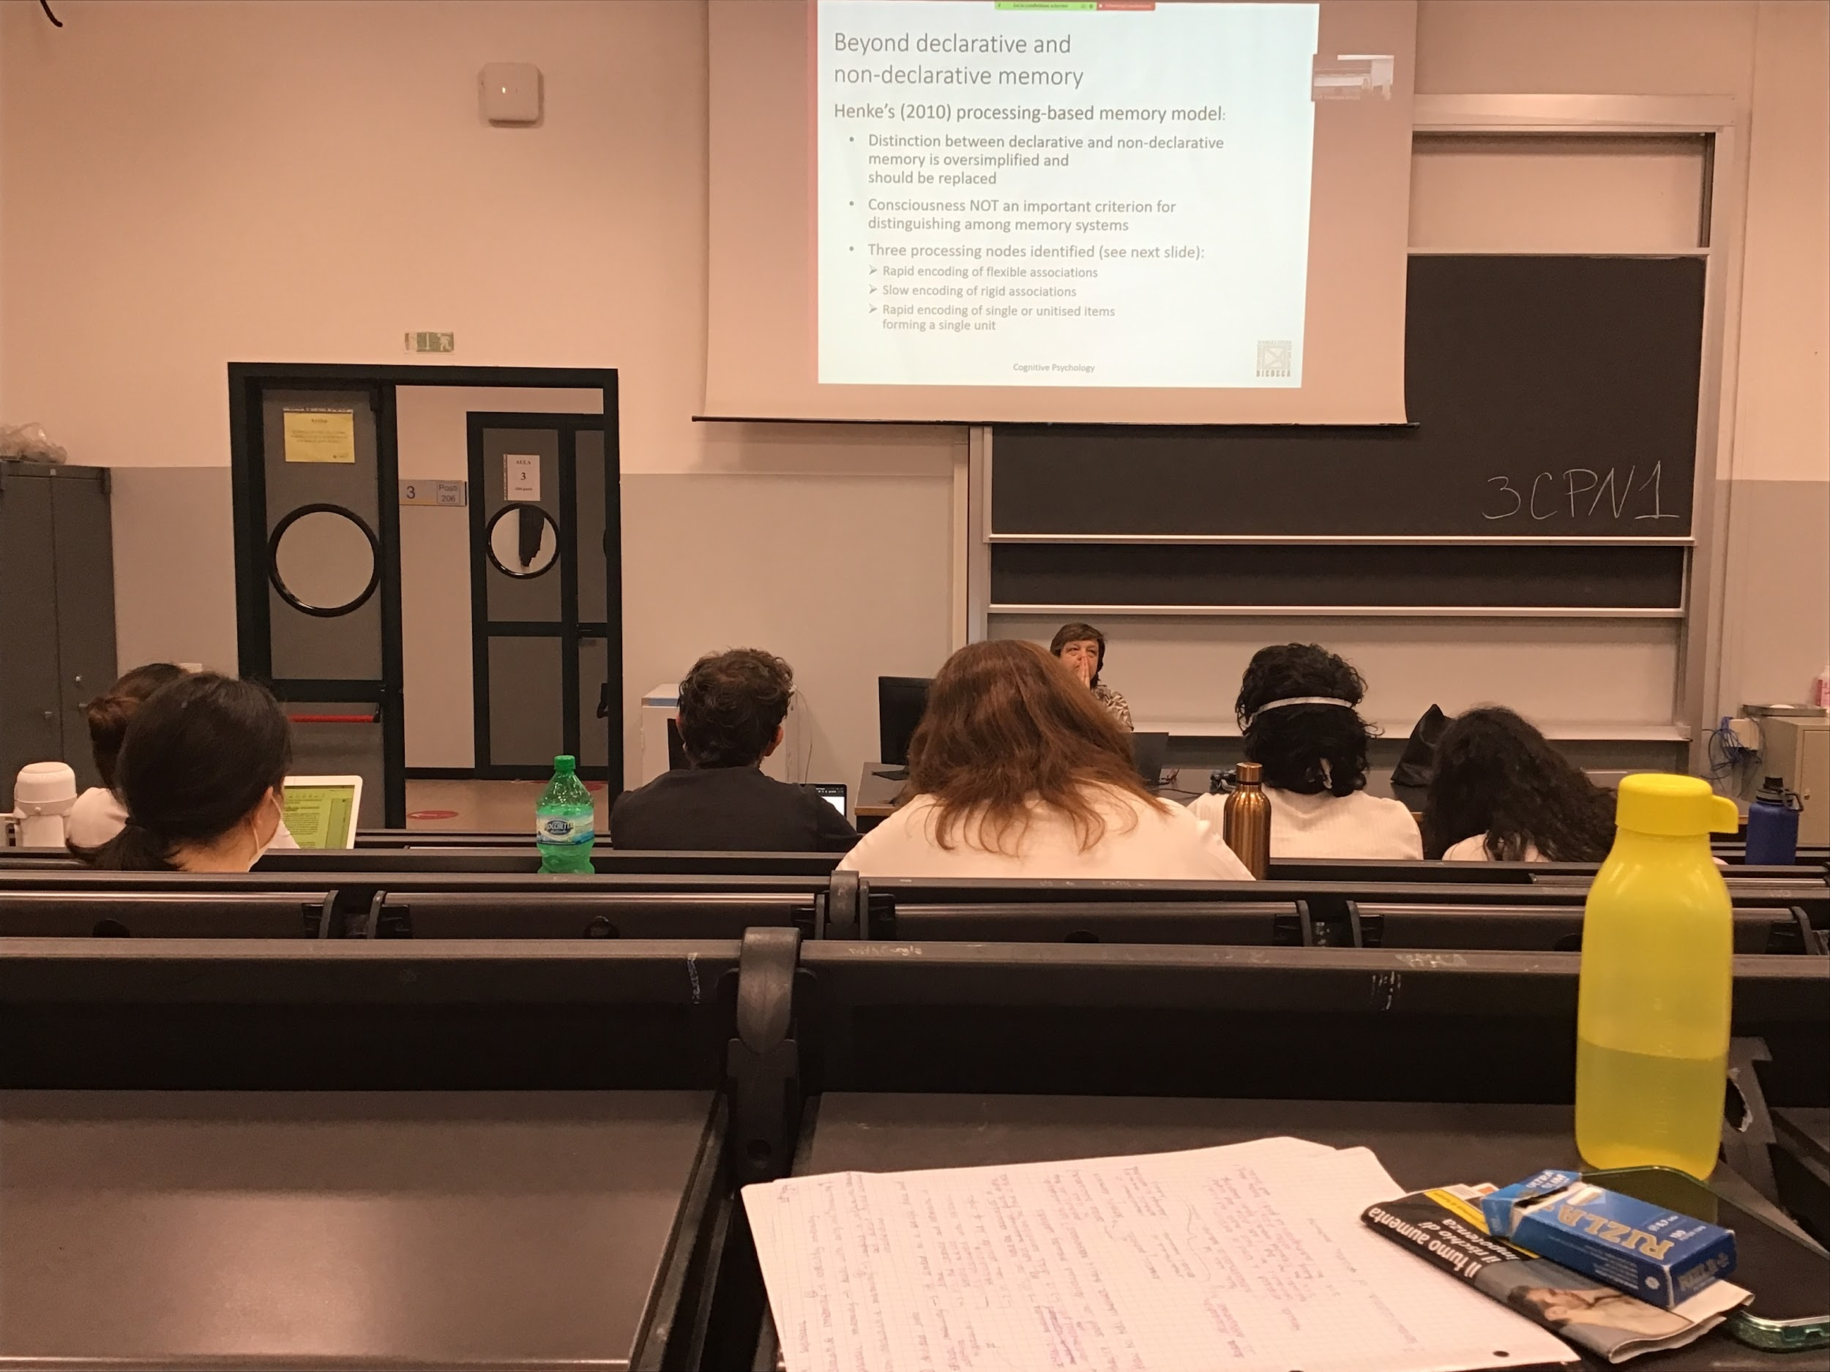

Very difficult to study the two memory together, maybe they are not really different

We should be able to shift the gear and propose a different model

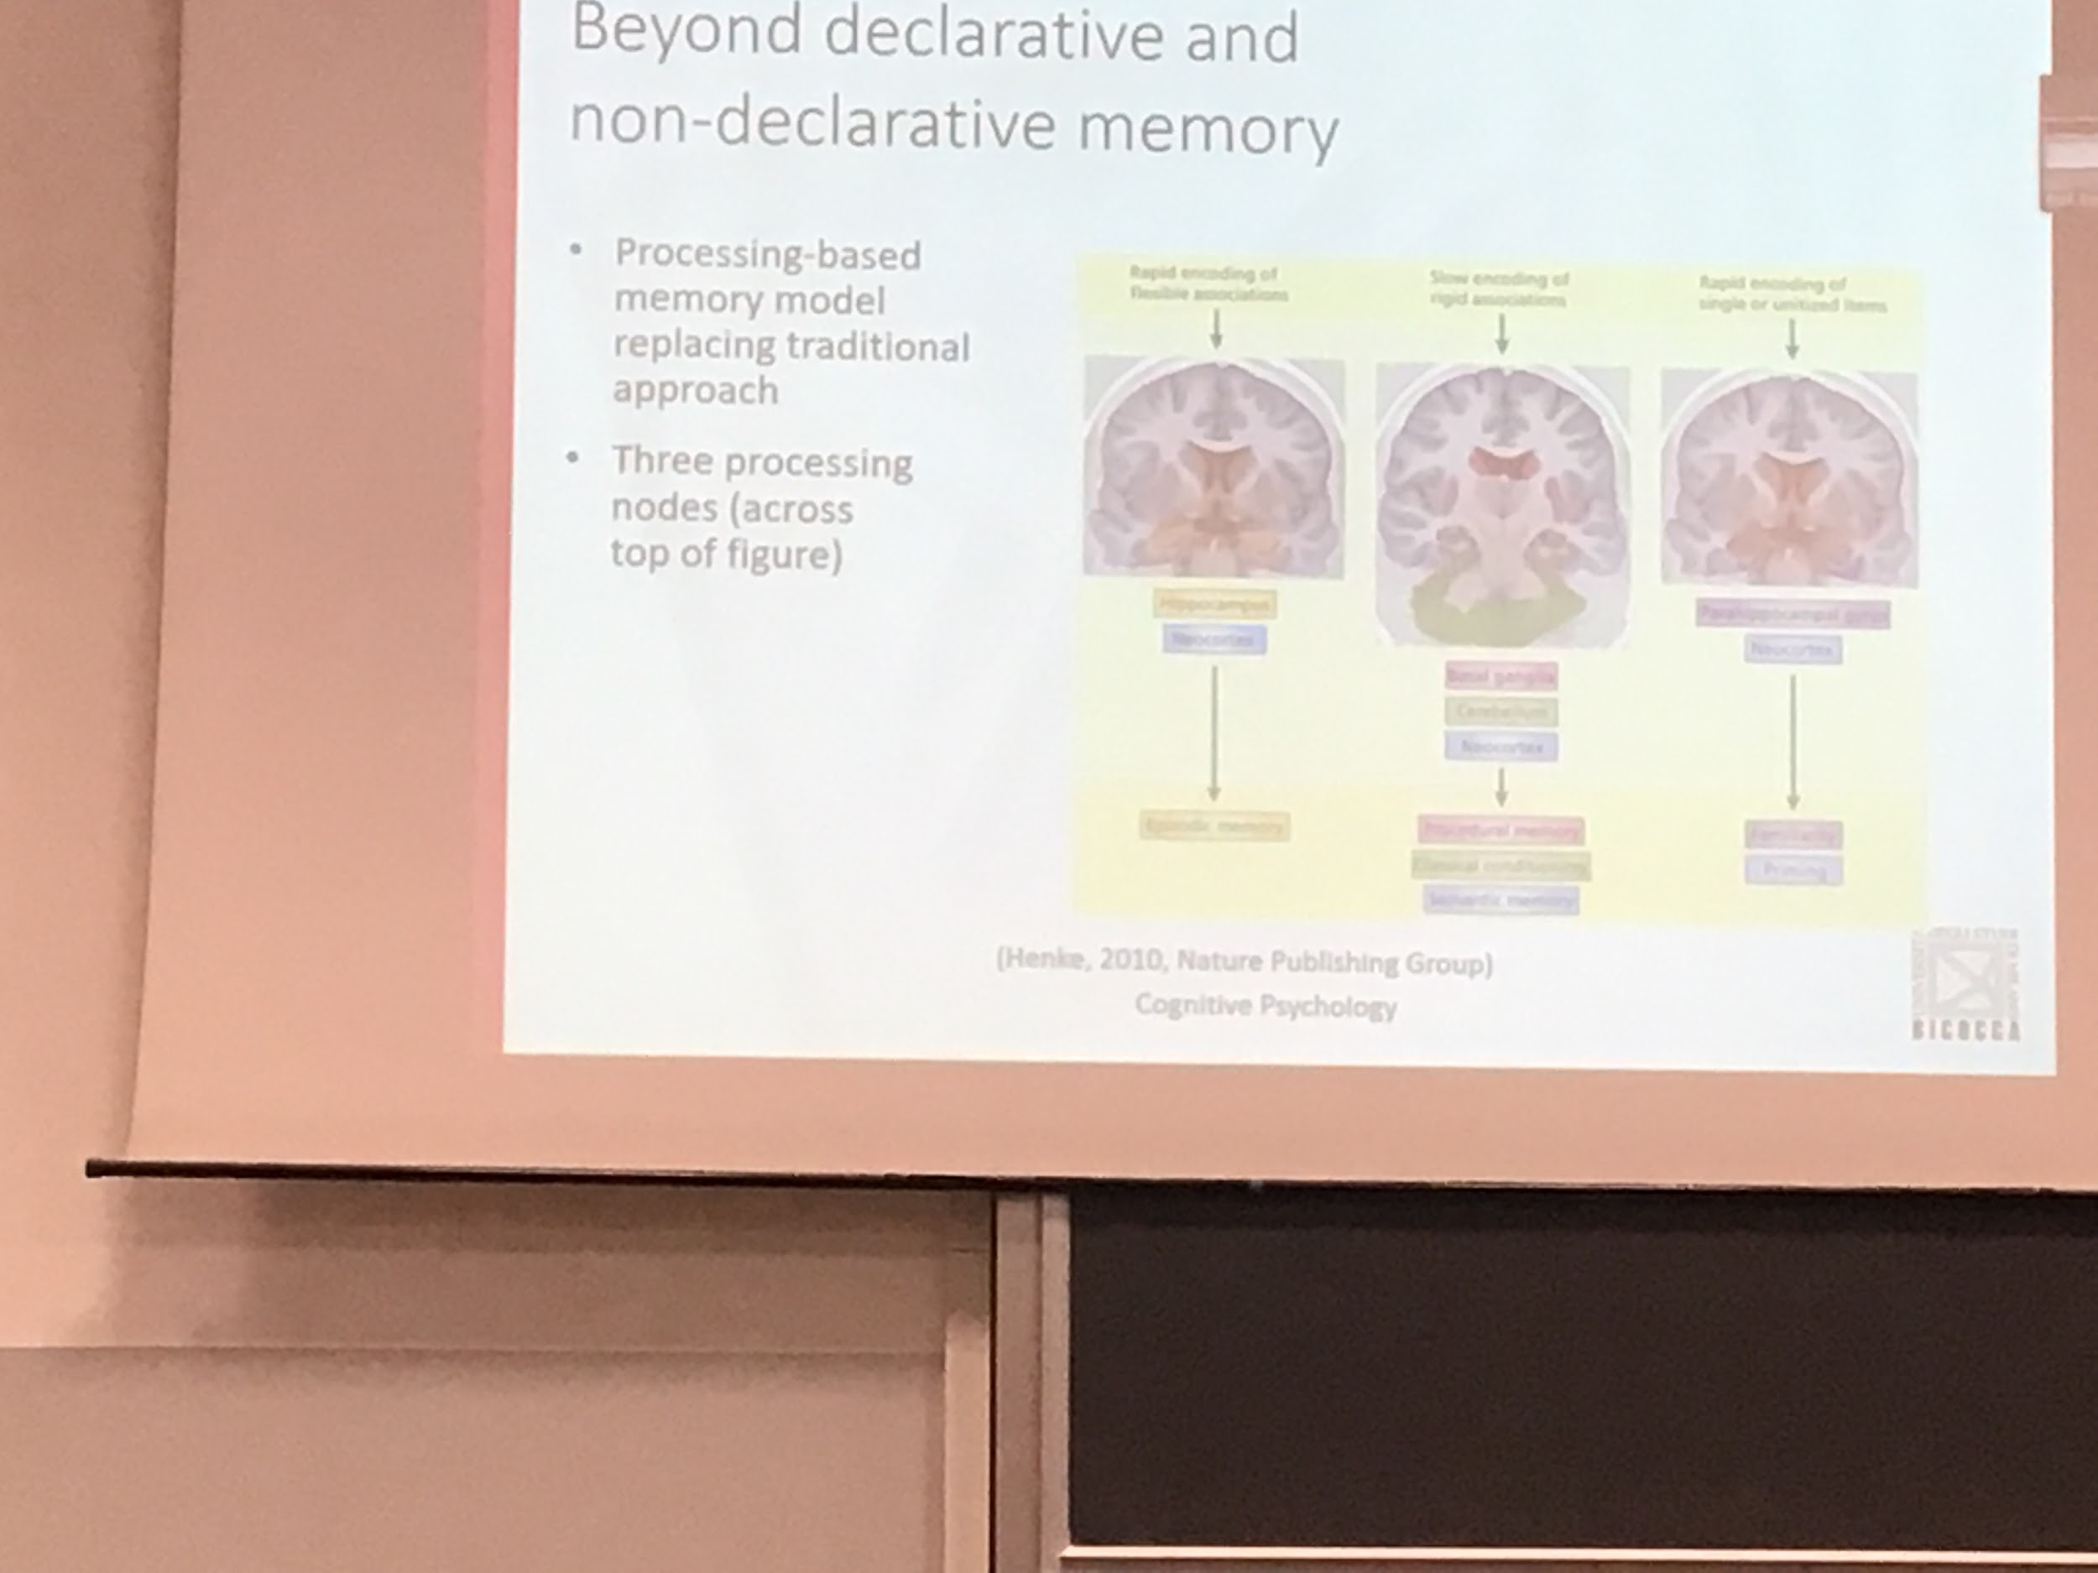

**New hypothesis beyond declarative and nondeclarative memory (Henke)**: memory is model dependent on processing, different types of processing happen to different types of events. Consciousness is not important

3 different processing node

* **Rapid encoding of file associations**: for when I have to do something fast (like priming) use the hippocampus and neocortex
* **Slow encoding of rigid associations**: use cerebellum and neocortex, put together procedural memory, classical conditions and semantic memory. Mixes the different situations
* **Rapid encoding of single or unitised items**: parahippocampal gyms,neocortex. Familiarity and priming

To be able to explain all the data that we collected we have to go further and focus on specific processes that we use to do specific tasks. Emphasis switched from the system to the process. What kind of analysis we have to do in a specific task. Different types of processes require different brain parts. Even if this processes are common in declarative and nondeclarative we have to accept that

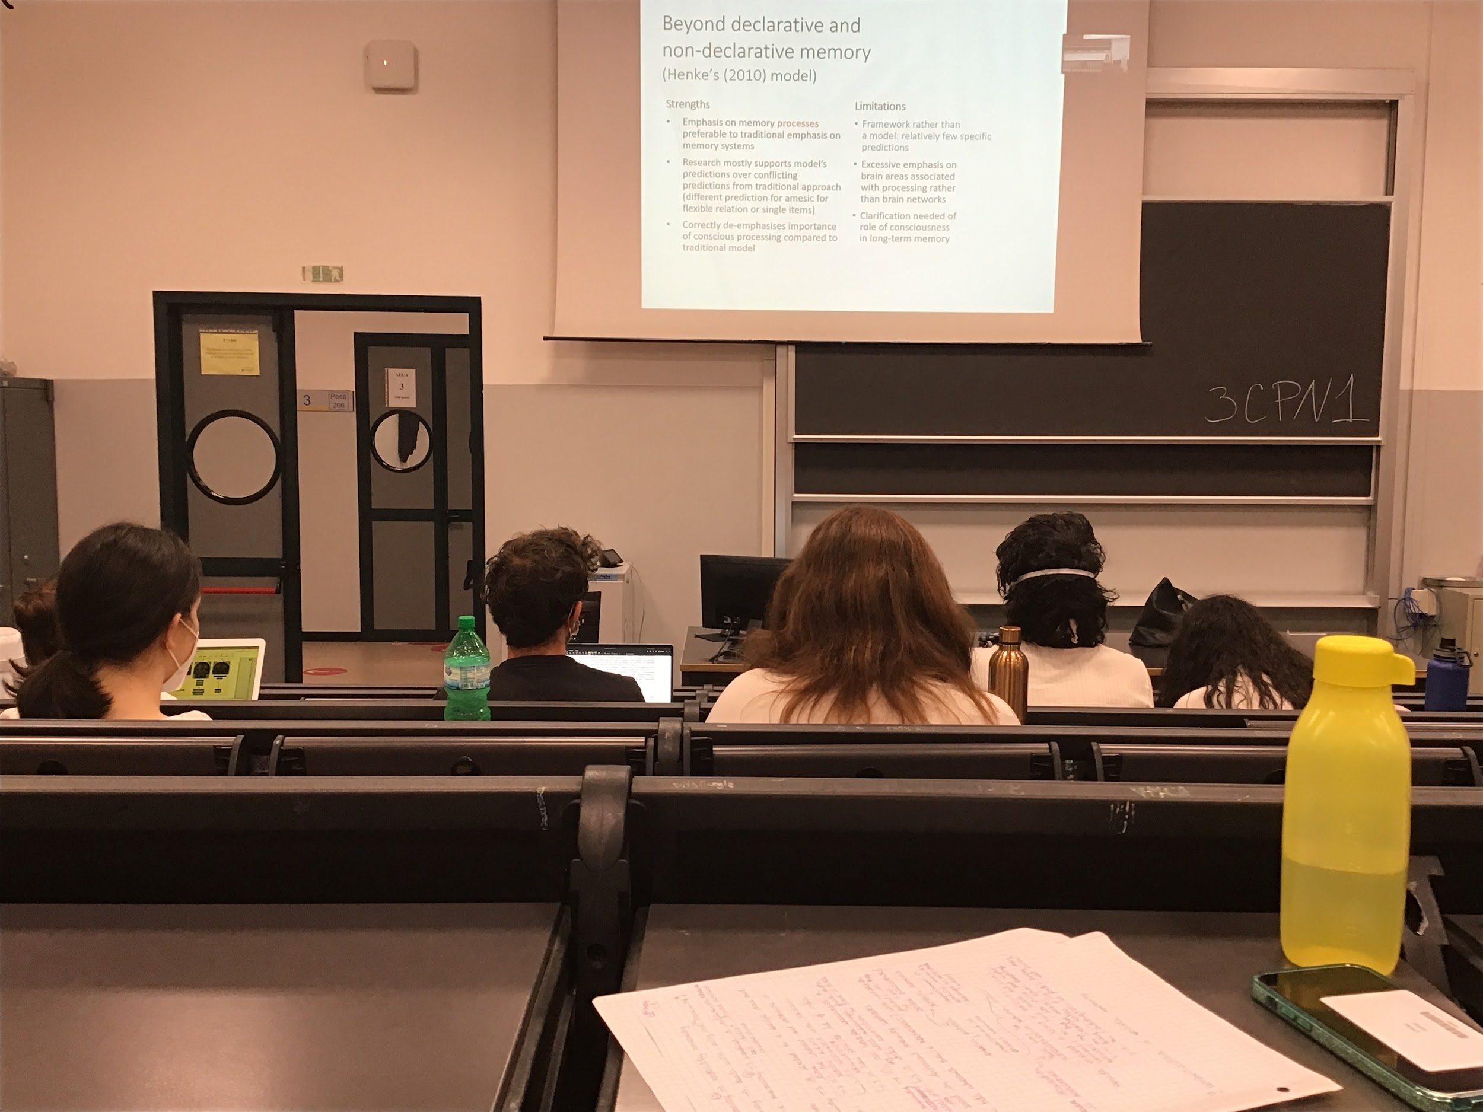

This approach split up in 3 processes is able to explain a lot of data than the two original thesis. Lot of research that show that there wa sno clear distinction between declarative and nondeclarative memory

Is a step forward to compared to the other models

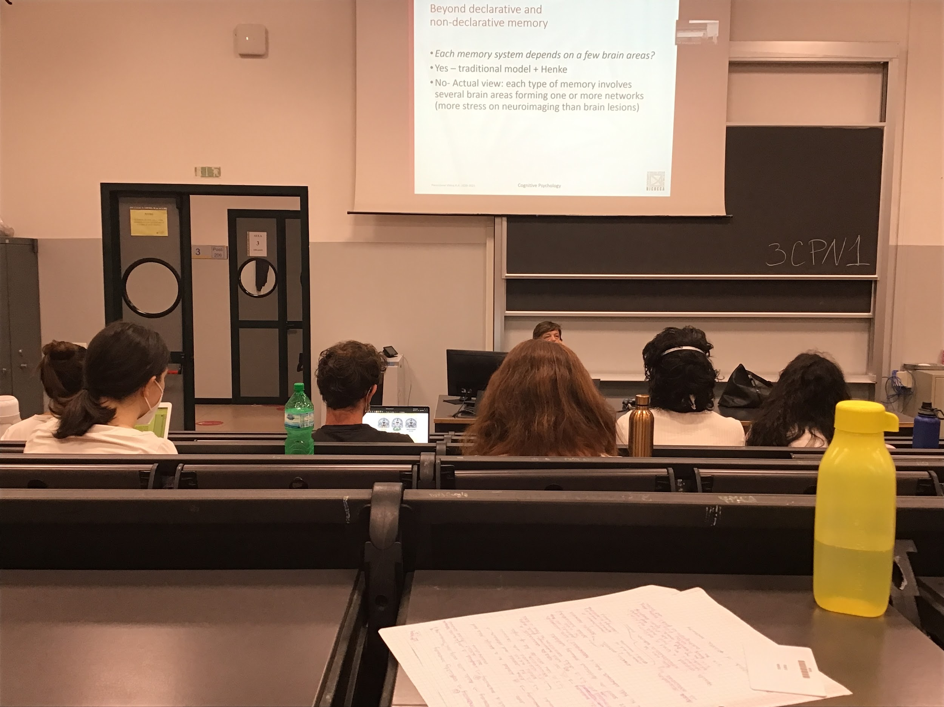

Differences when answering explicitly or implicity, this model does not enable us to understand the two differences

Henke models advance to go over between the distinction in declarative and nondeclarative memory. But still focuses on the idea that few brain areas are connected to each memory process, in reality **specific areas interact**

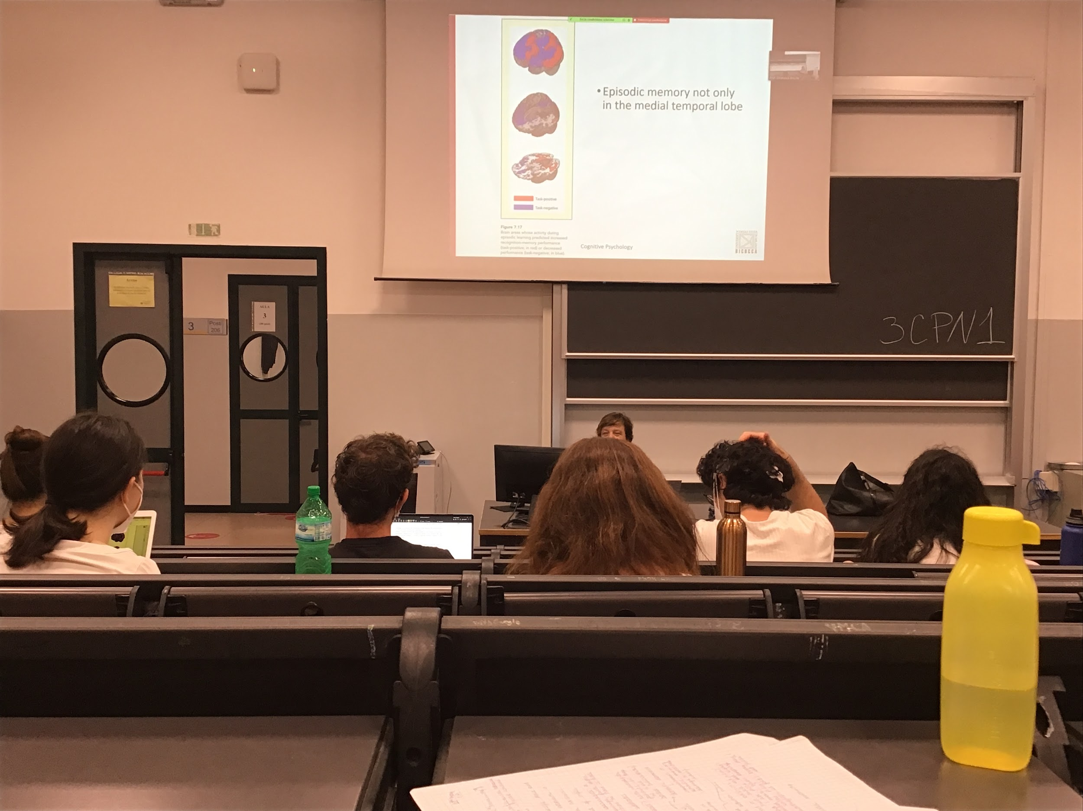

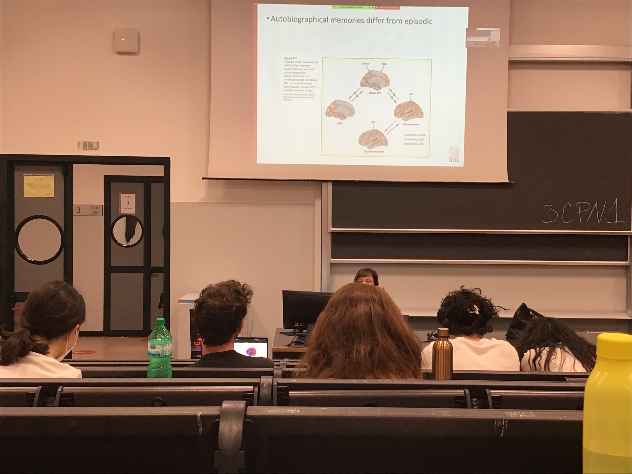

**Original hypothesis: same brain areas are active for autobiographical memory and episodic memory, but actually there are different areas**

There is a lot that still need to know about network activation

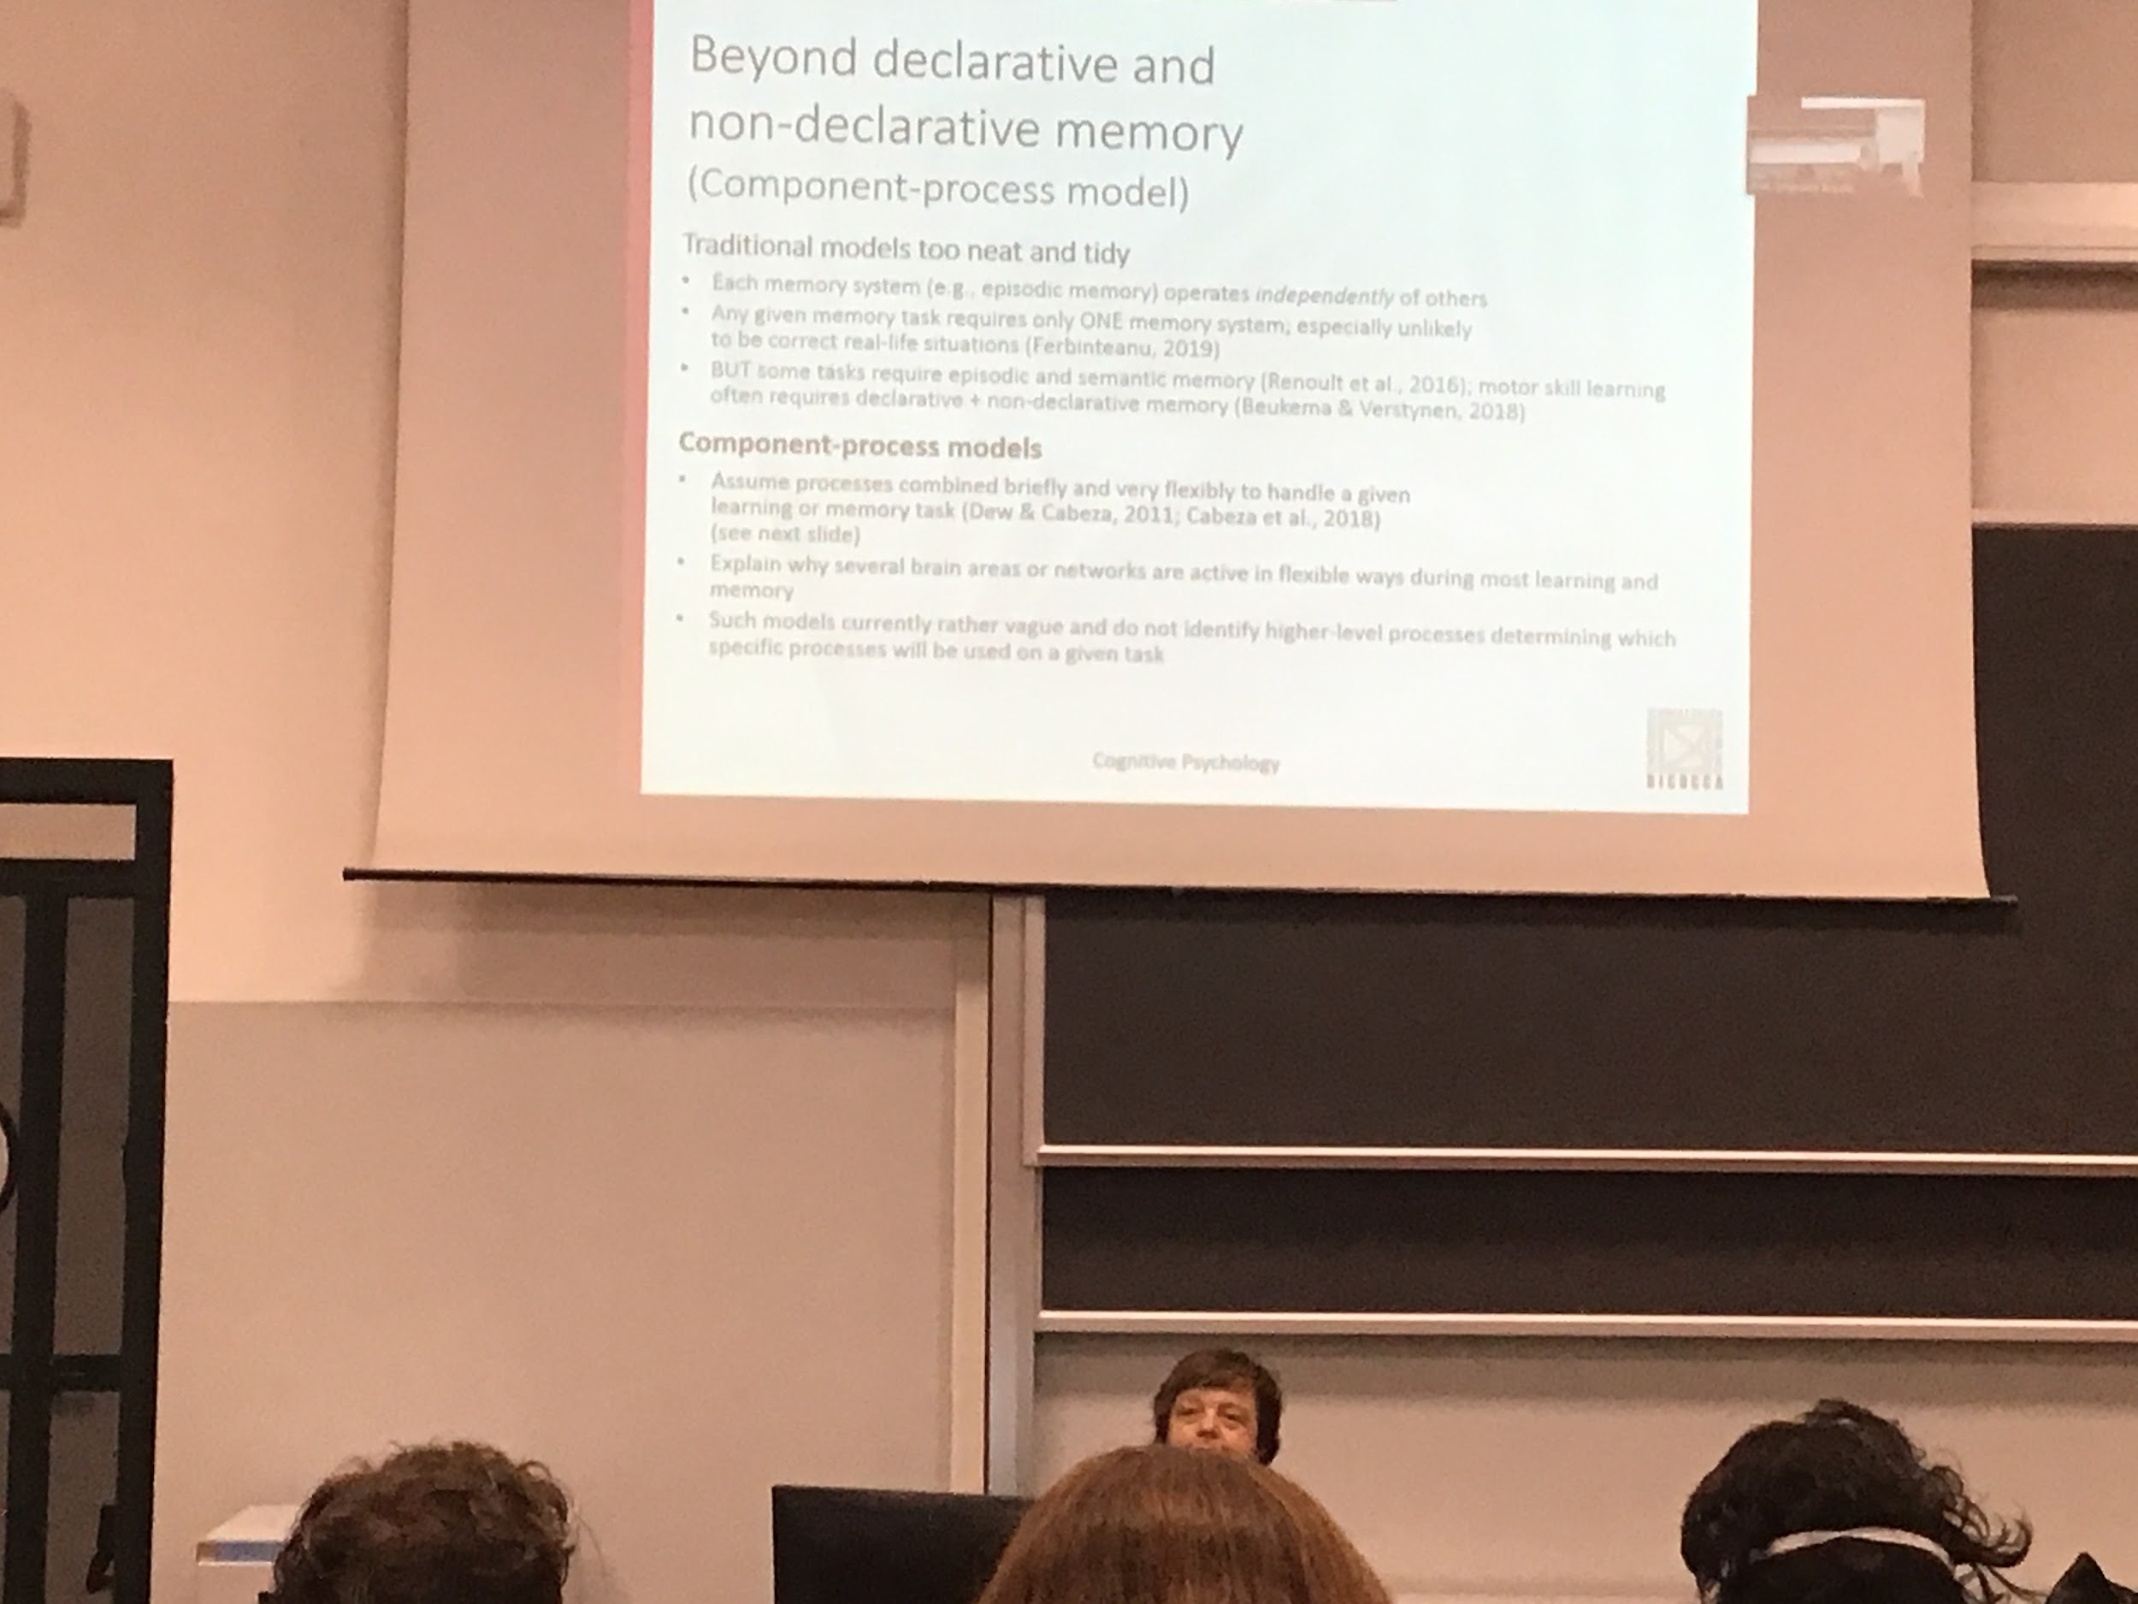

Component process model:

Model that tries to explain this complex aspect of memory and how it is organised

Idea that the original models were too clean and study separately the different types of memory (one model for episodic memory, one for semantic memory…)

Basic: any task would require one memory system. In reality there is a mixture, we can mix and match different parts of memory to perform a different task

Several network can be activite in any given movement depending on what we try to do

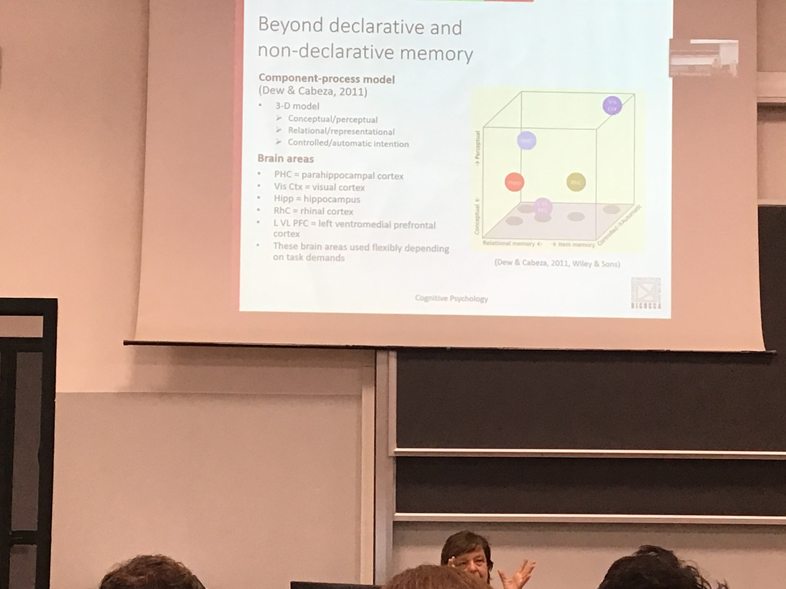

3 different direction that can characterise our memory task

* conceptual/perceptual
* relational/reprentional
* controlled/automatic intention

Each given task fits in the cube. Each task characterised by a specific level of activation. Depending where it is it activates different brain areas

There are different areas that are important for that specific characteristic

AUDIO 3

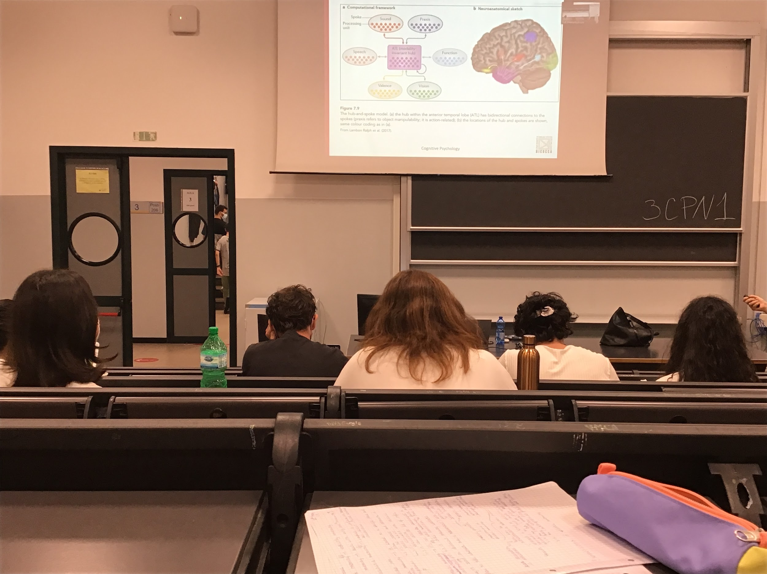

Each concept is represented in multiple places, each having a hub in ATL. Each concept has a connection with a different representation of the same concept that has specific characteristics (related to speech, sound, motion, function…)

In ATL all concept interact with each other

# CHAPTER 12

Problem solving and expertise

Focuses on different types of problem solving, **expertise influences our ability to solve some of the problems**

3 main topics

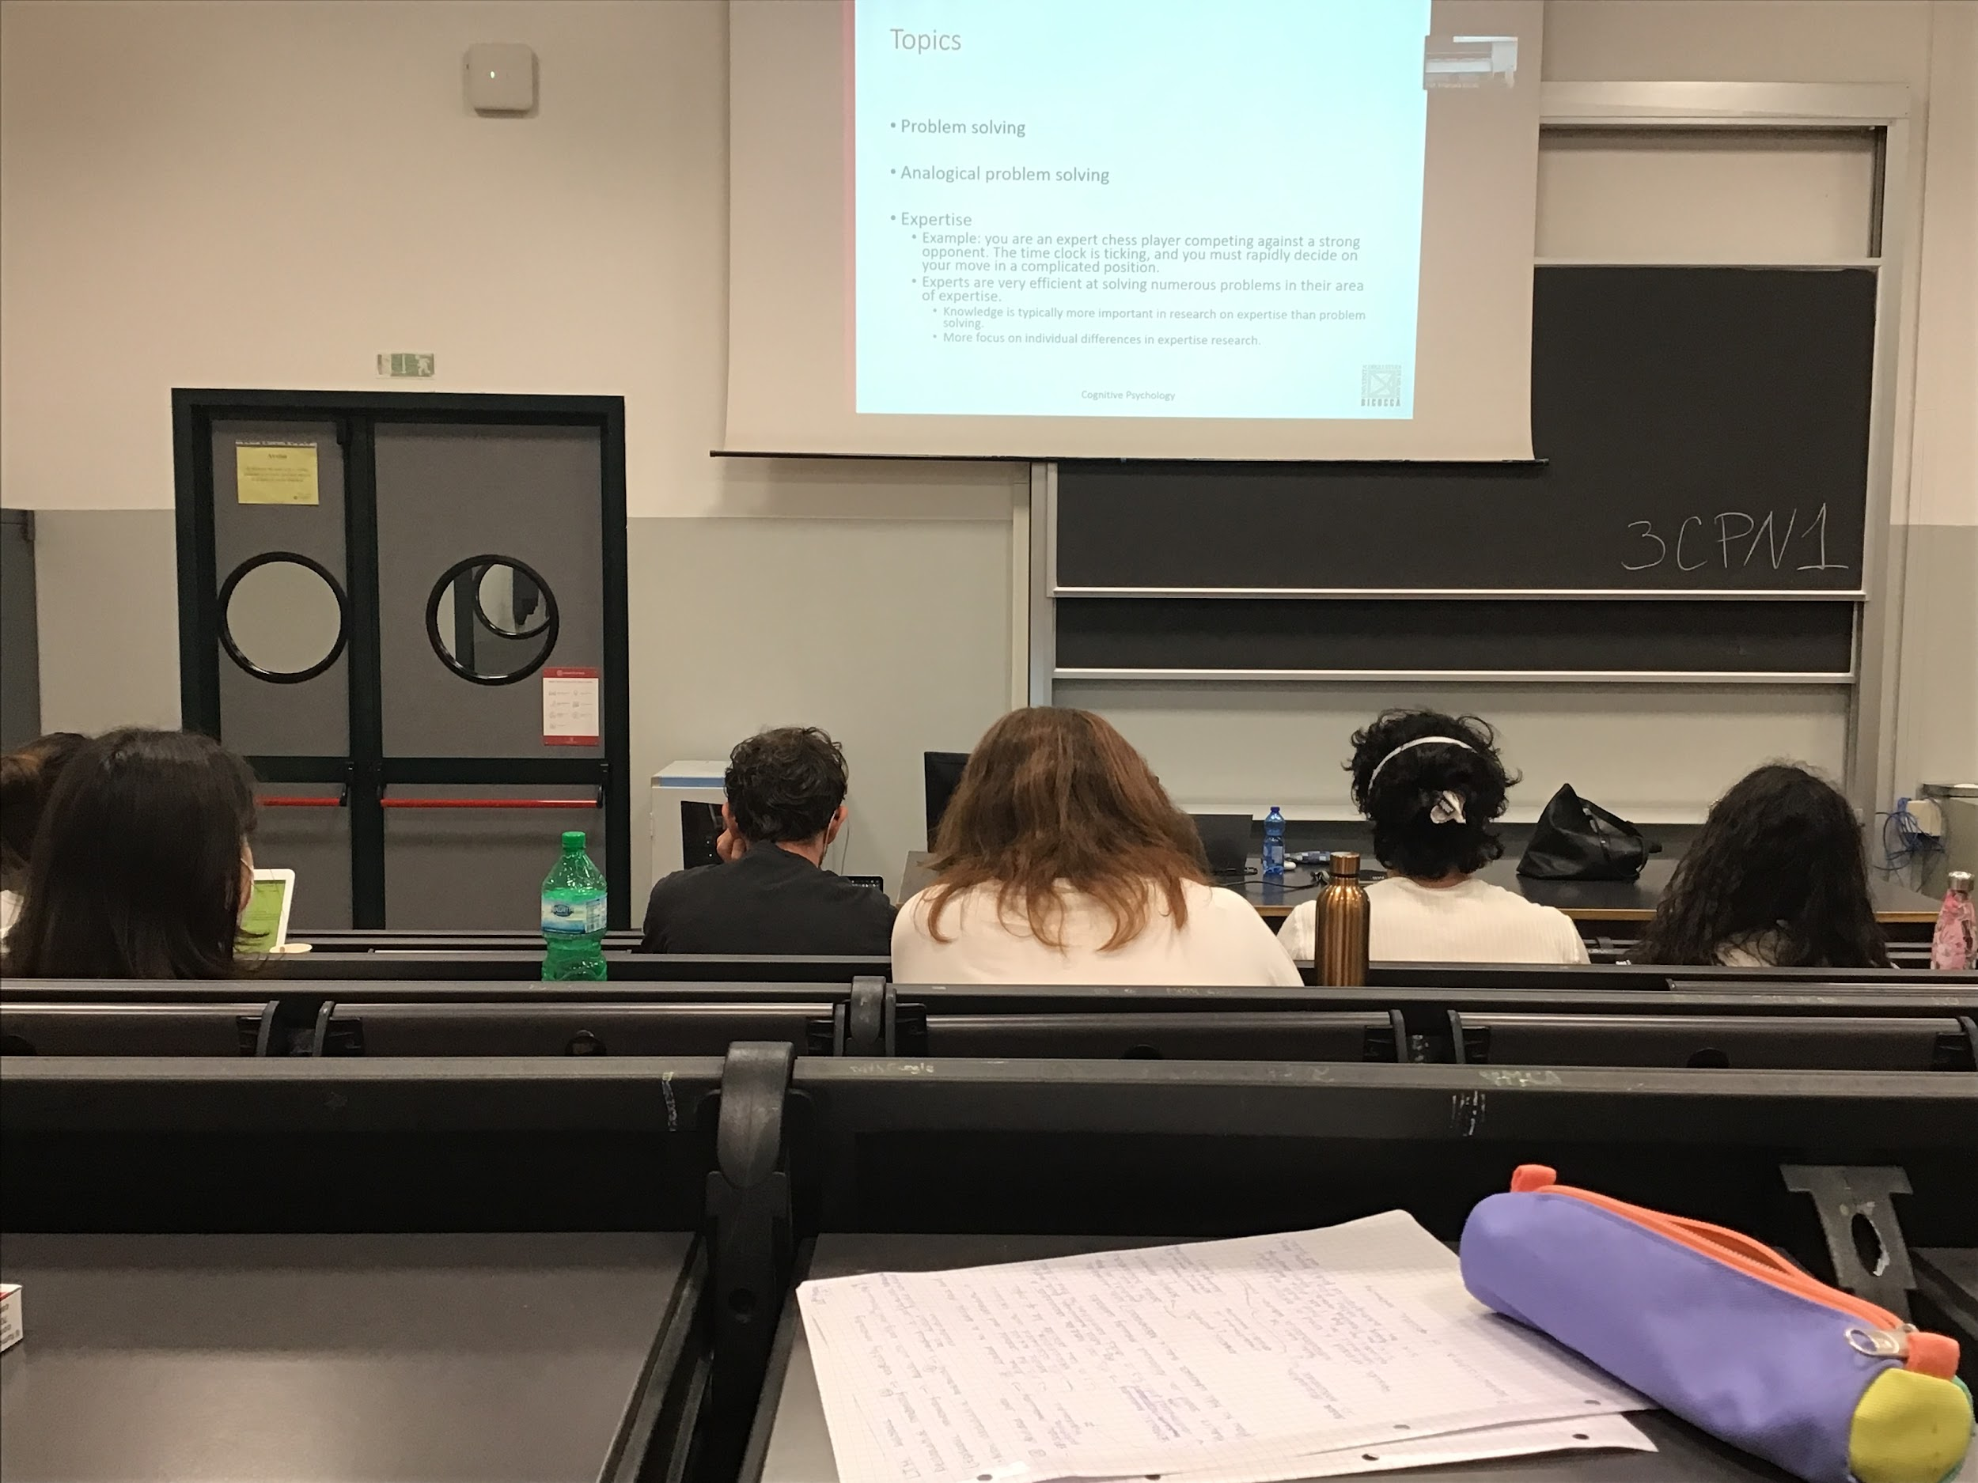

**Problem solving**: a situation in which there are two different situations. Have to reach a place X but trains are late and you can not reach X by car. We need to solve this kind of problem very often

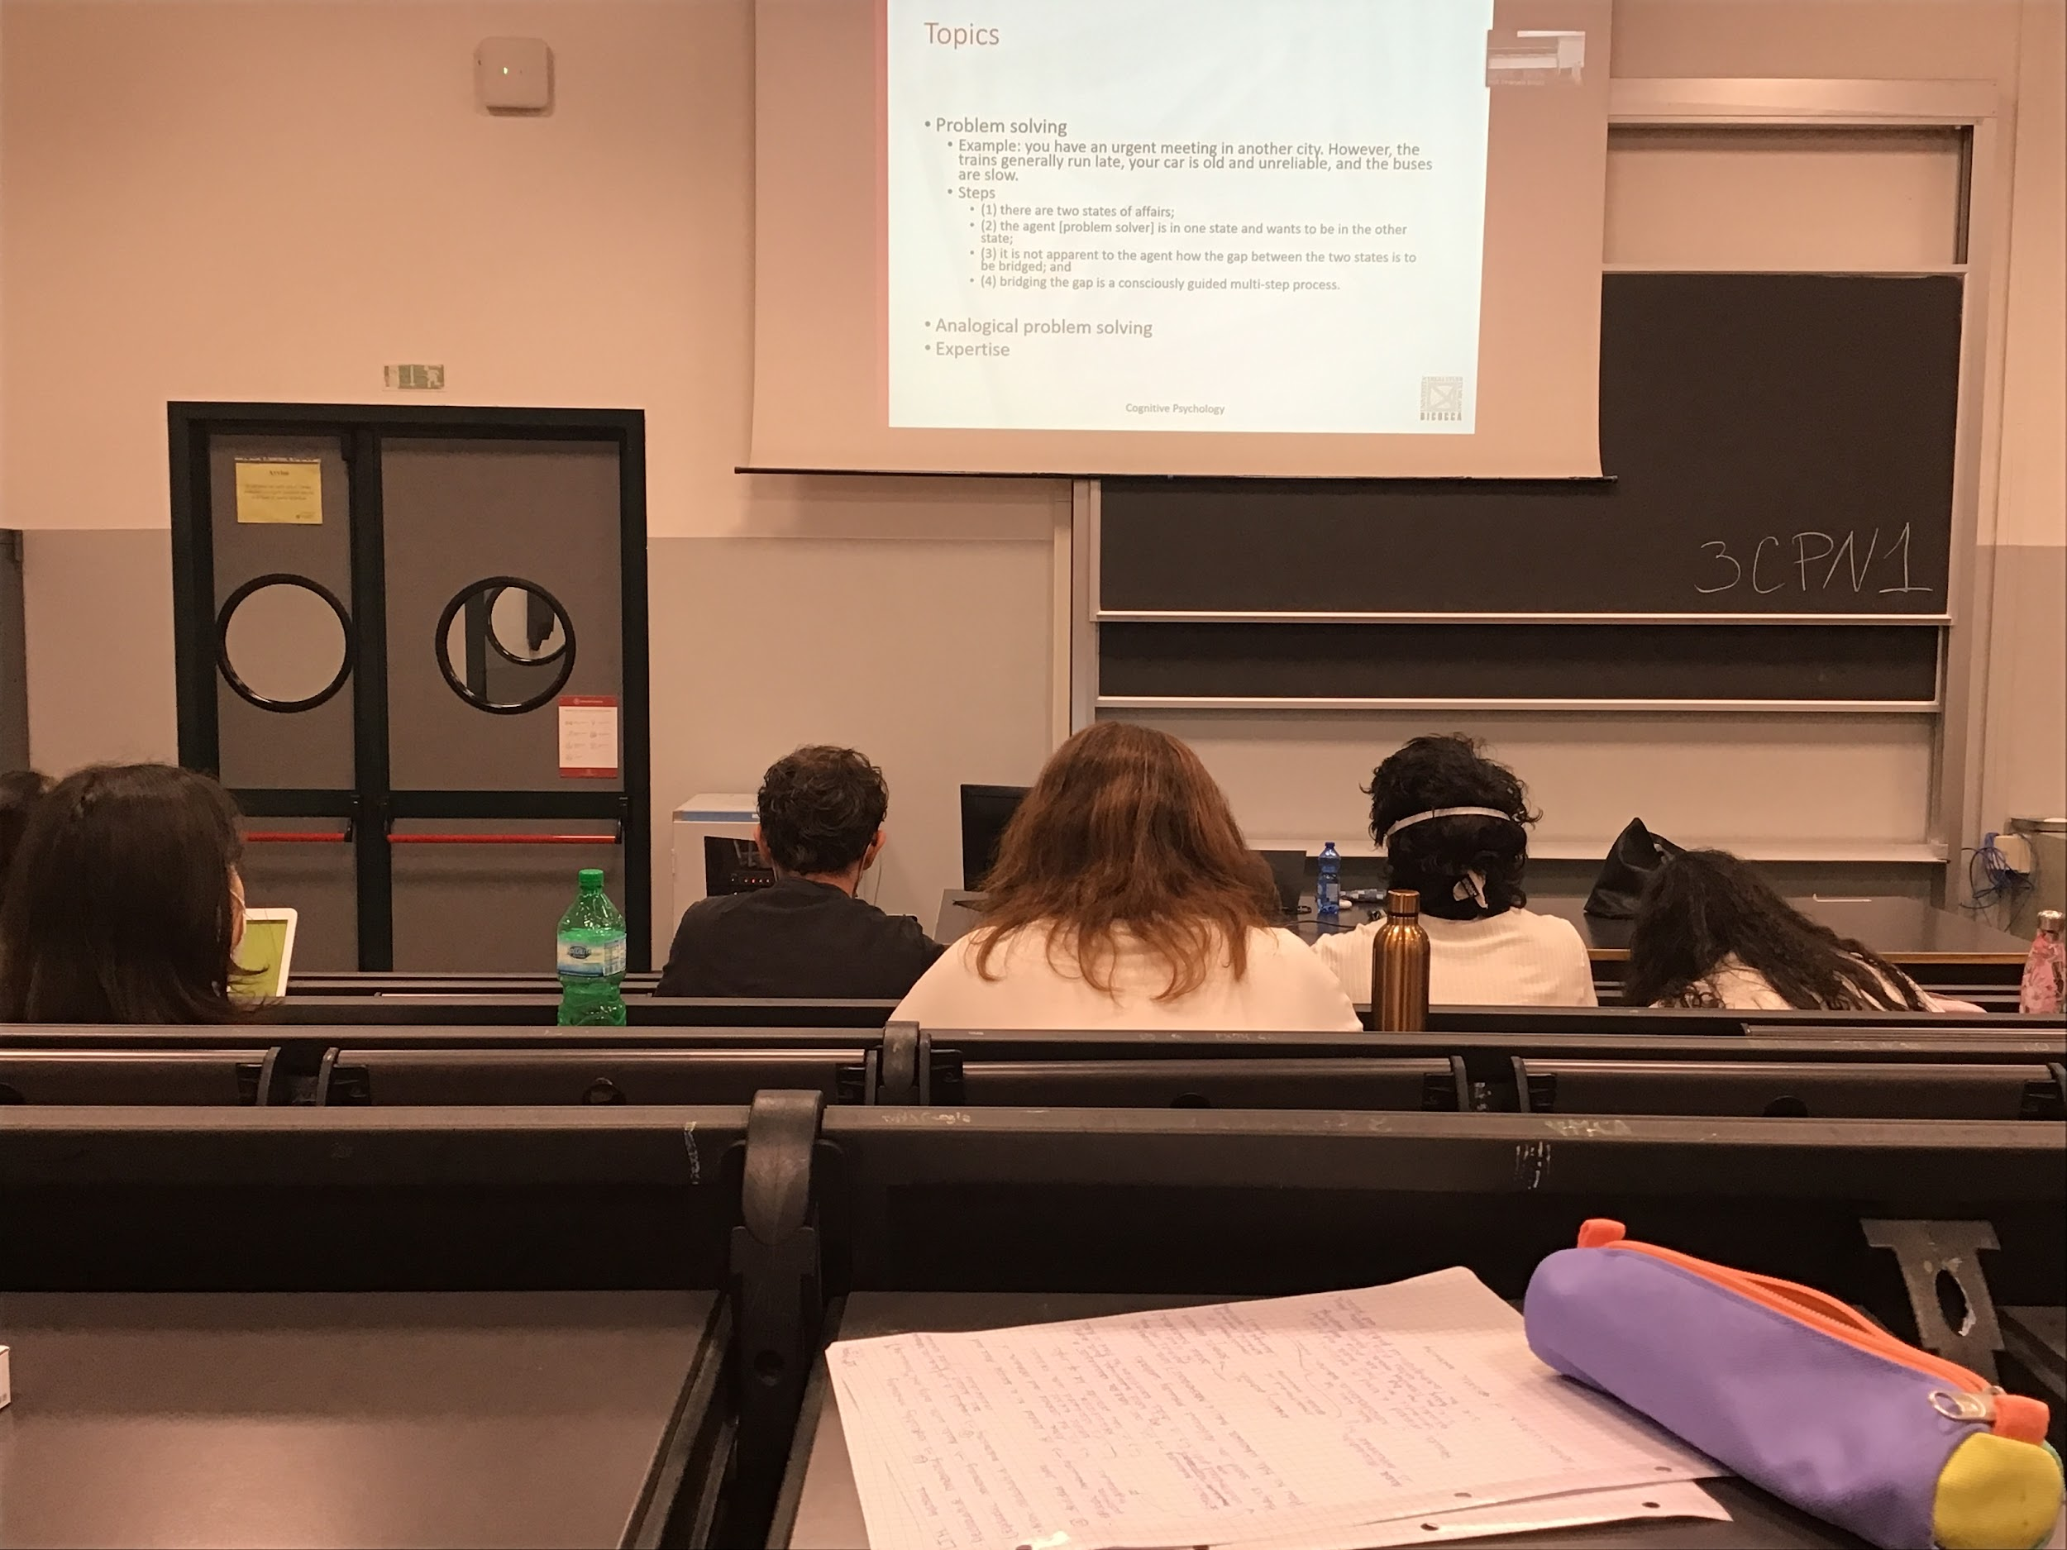

Evaluate different options and find the faster way to go from my position to X. I have knowledge about different situations but I don’t have the solution given from past experiences

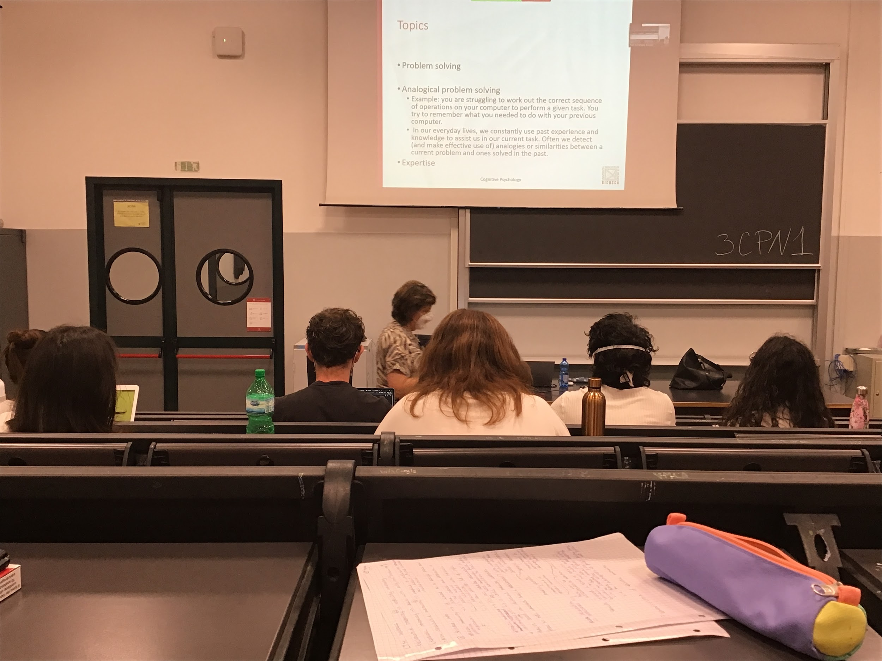

Analogically problem solving subset of problem solving

**Analogic**: have to do something on the computer, we know we have to do different steps and activate different programs in a precise order. The fastest way to solve this problem is going in our memory and see what we have done in the past, find how did we solve the problem earlier

We are using past experiences to solve the current task, try to make

analogies and use our experience to solve the problem

We do not need to be expert in a certain task to be able to perform it

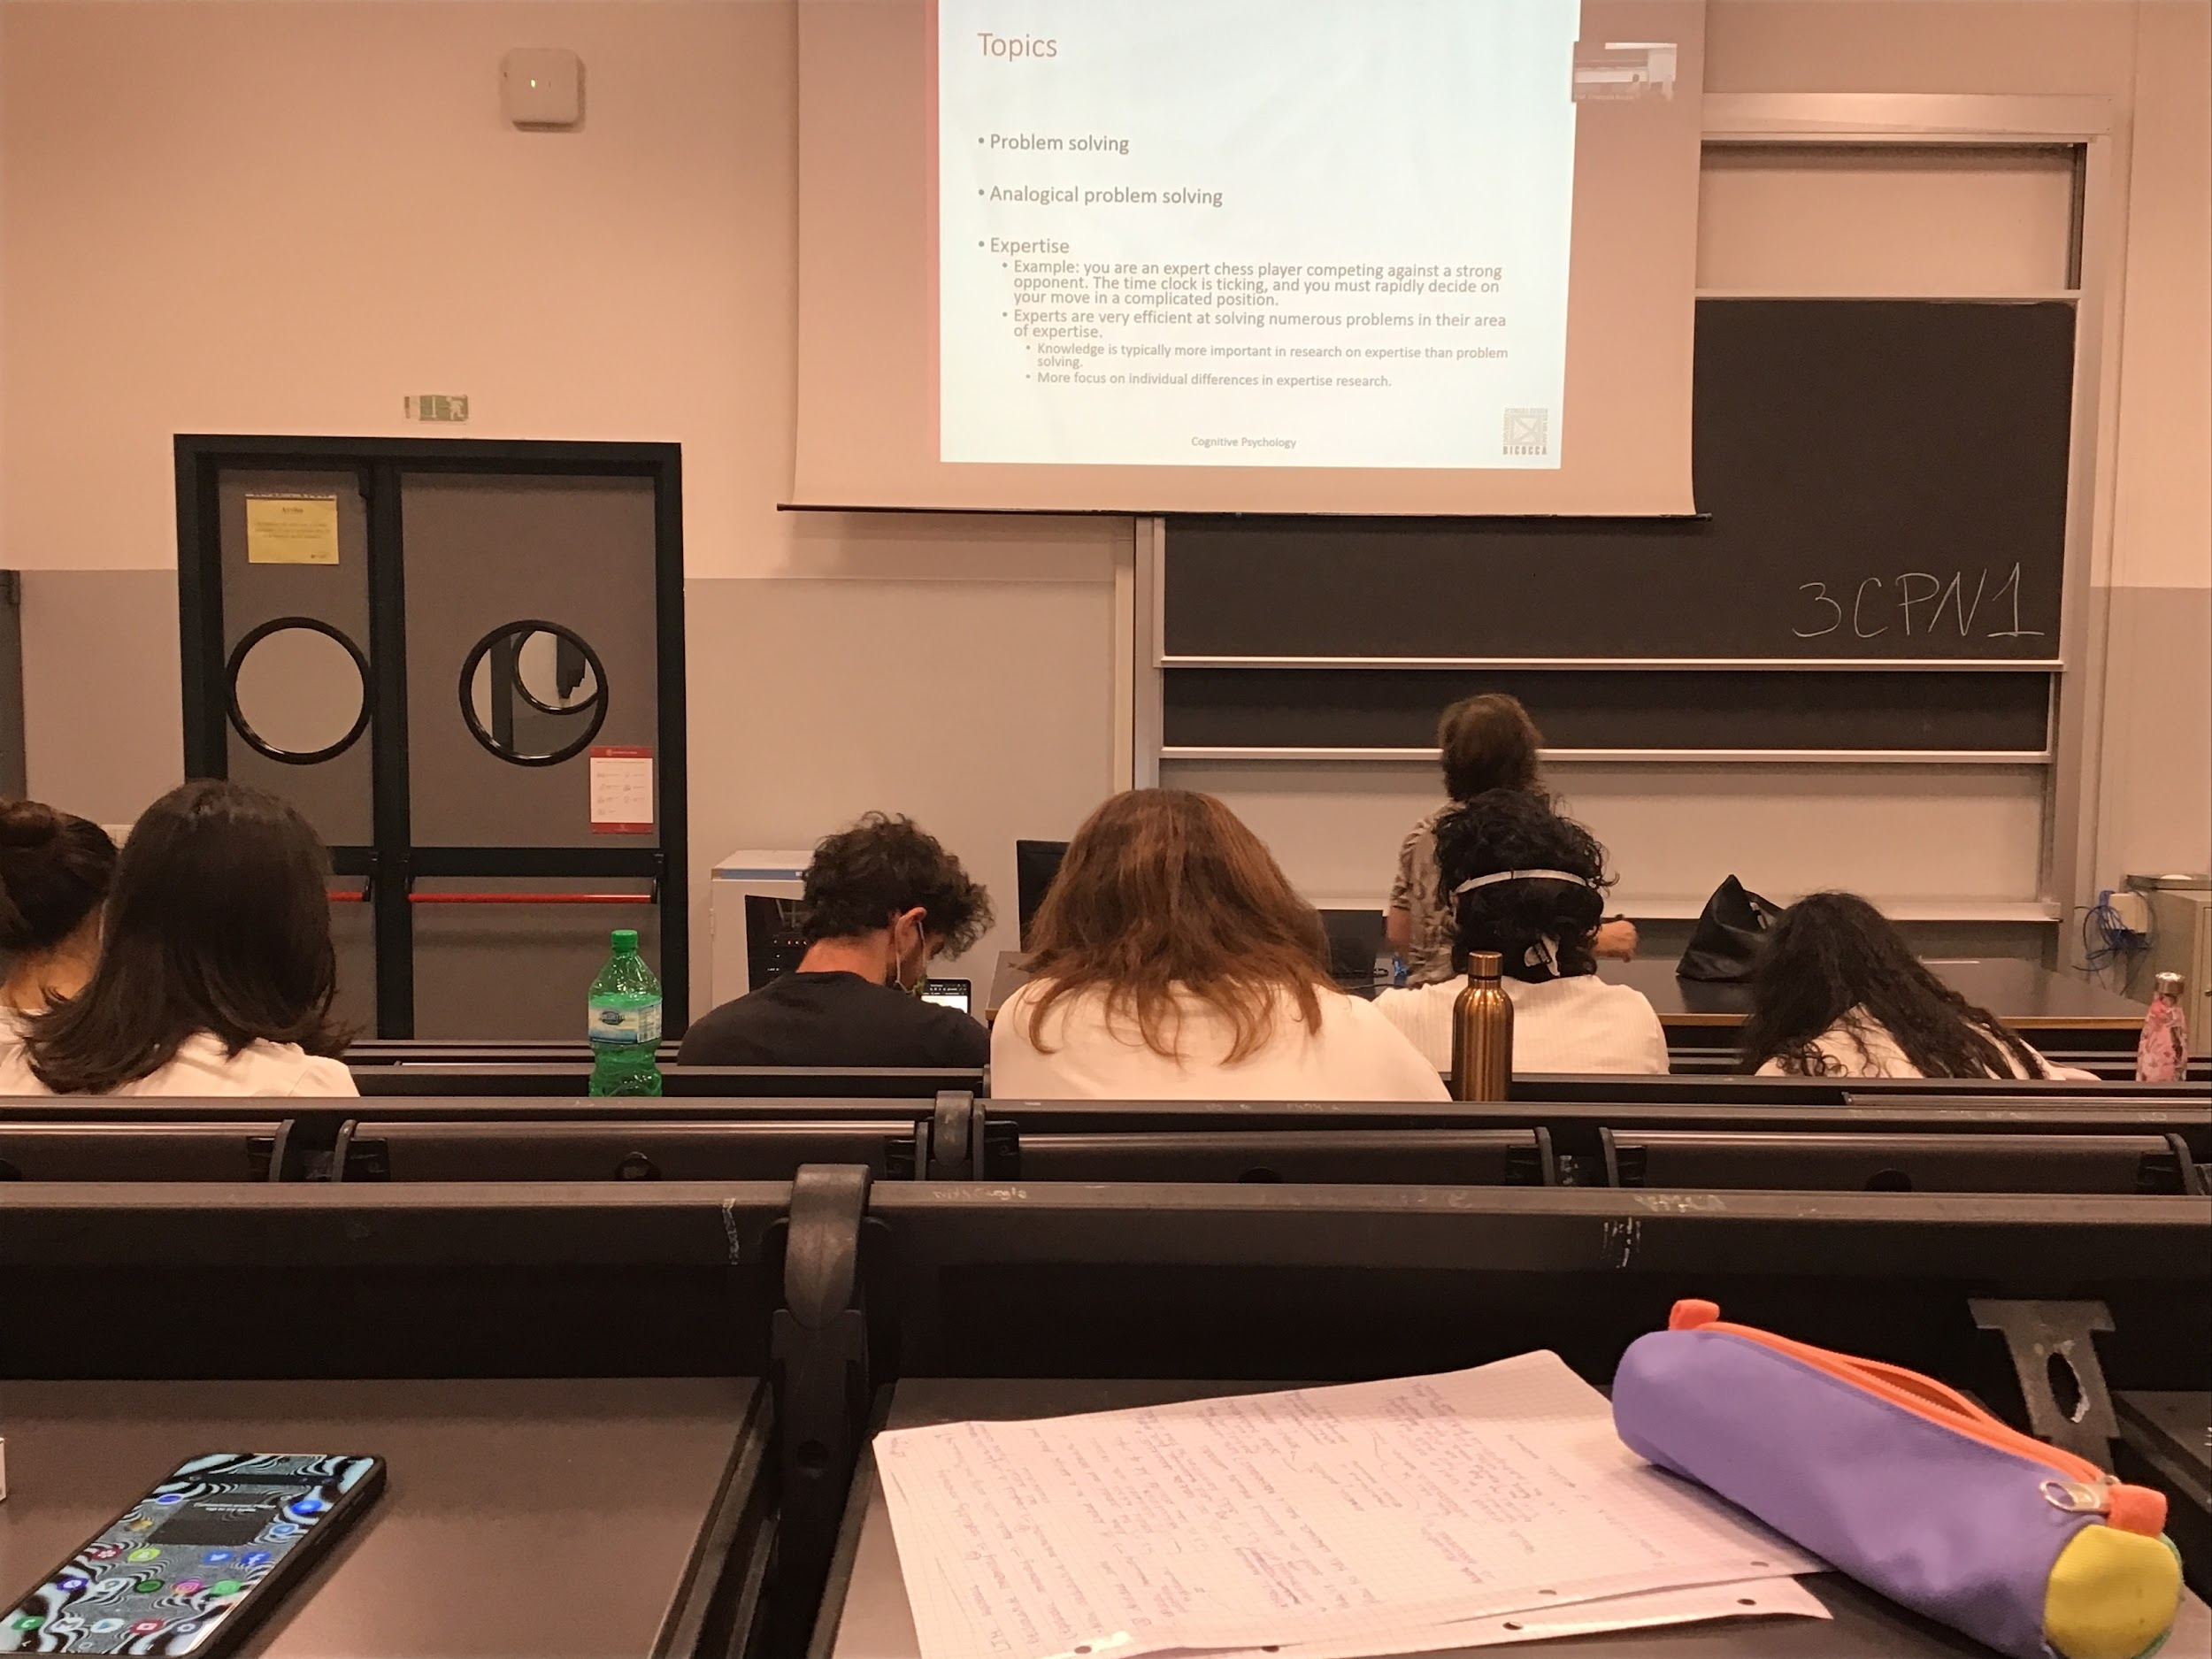

When using expertise (like expert chess player)

You have to choose very very fast your move

People have a lot experience in this type of general problems (chess playing) and there is a difference in behaviour and in an ability to solve the problem if you are an expert or not.

Comparing expert and novices and try to understand what expertise brings to you enabling you to solve problems in fast way

**Individual differences are the most important part**

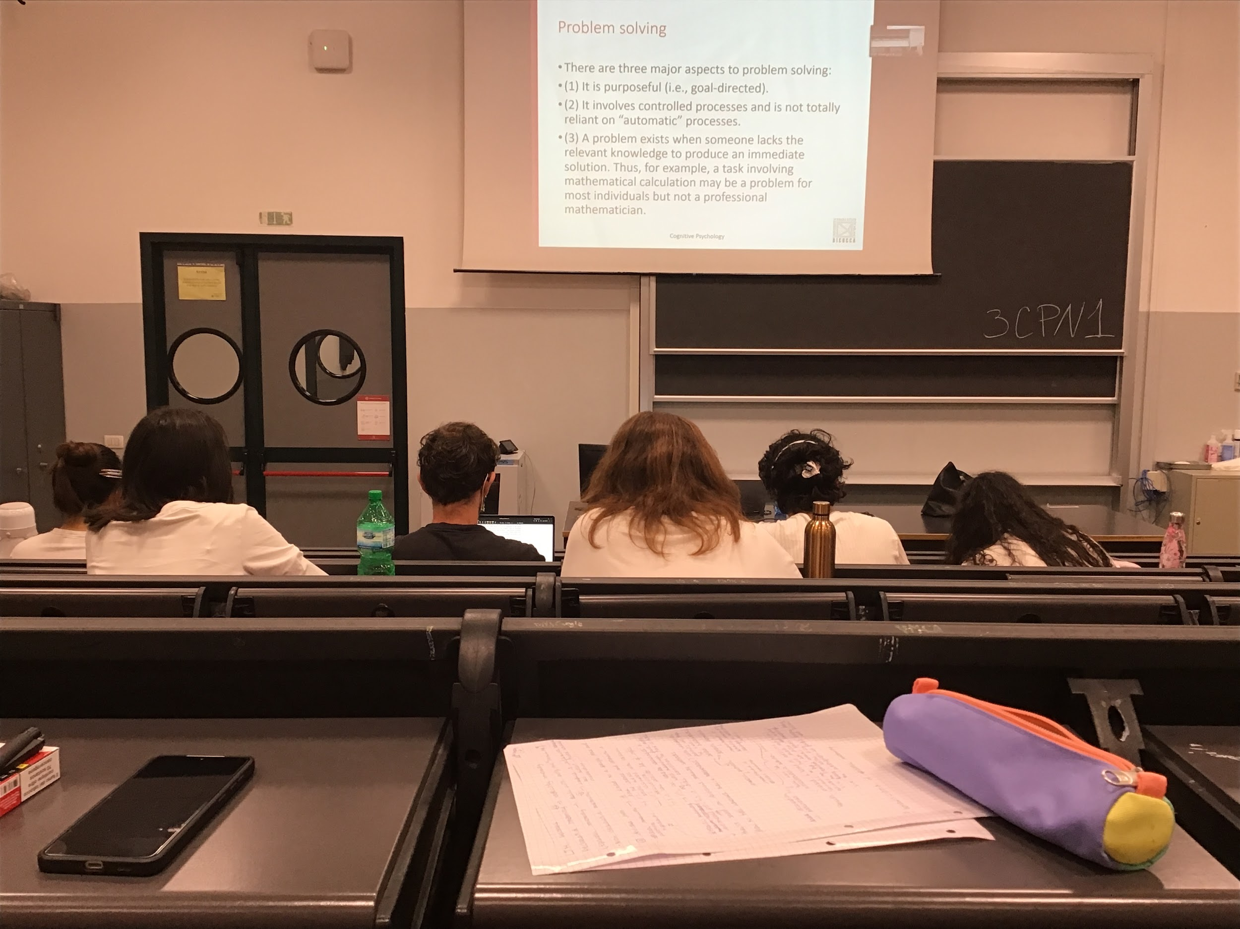

There is always a goal. All the time we need to reach a specific condition, we want to solve a problem

Most of the time the problem is solved through different conscious steps, there is no automatic solution, we have to think about different alternatives and choose one.

The problems are there when there is no automatic solution. If there is no automatic solution we are solving a problem

The problem is there because we don’t have enough knowledge to automatically solve, this means that **a problem can be a problem for some people and not for others**

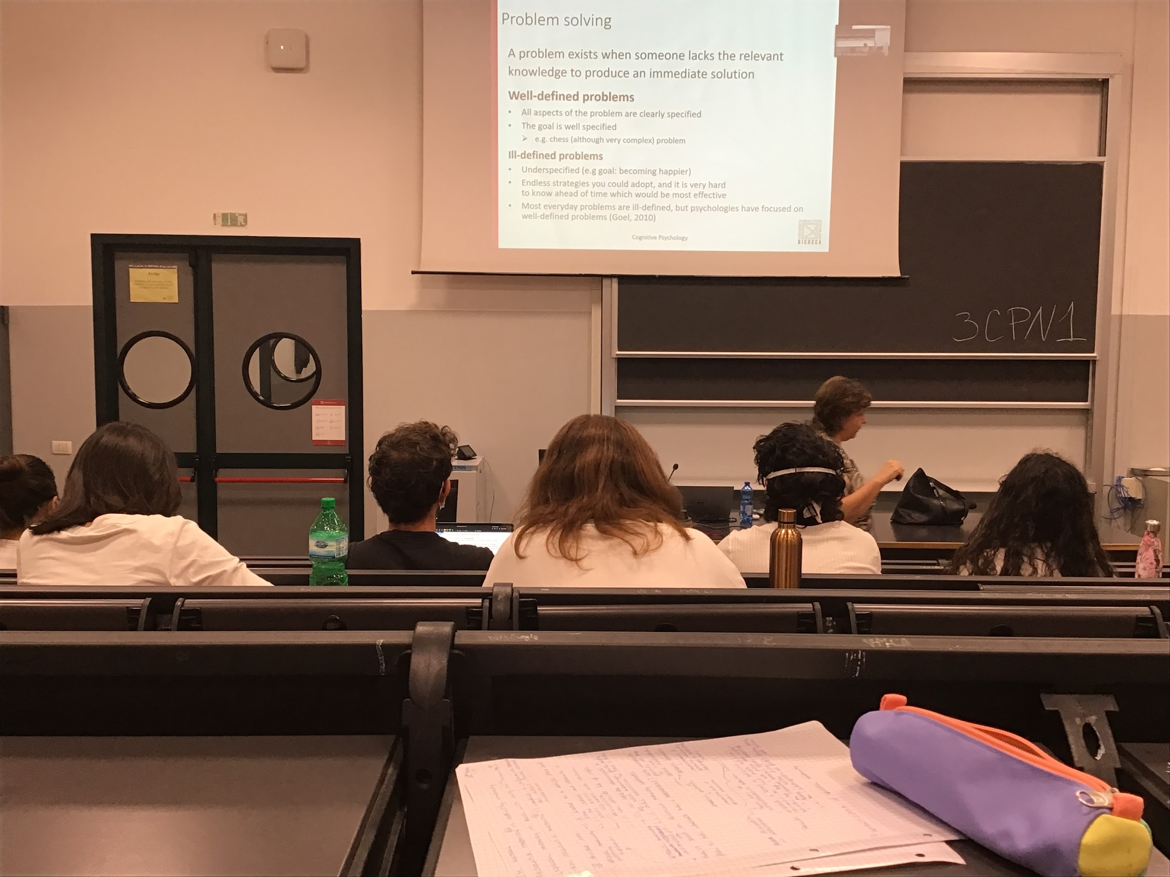

Different type of problems

* **Well defined problems**: problems in which I know exactly the situation I am in and the exact situation I am going to be. I know the rules that I have to follow. Very well define
* **Ill defined problems**: *I want to be happier* is ill defined, can go by different ways to solve it. Not like chess.. there are almost infinite strategies (on a chessboard you have a limited type of chosises). Very hard to understand. Can not predict if my choice is going in the right or in the wrong direction

Most of the time we have ill defined problems

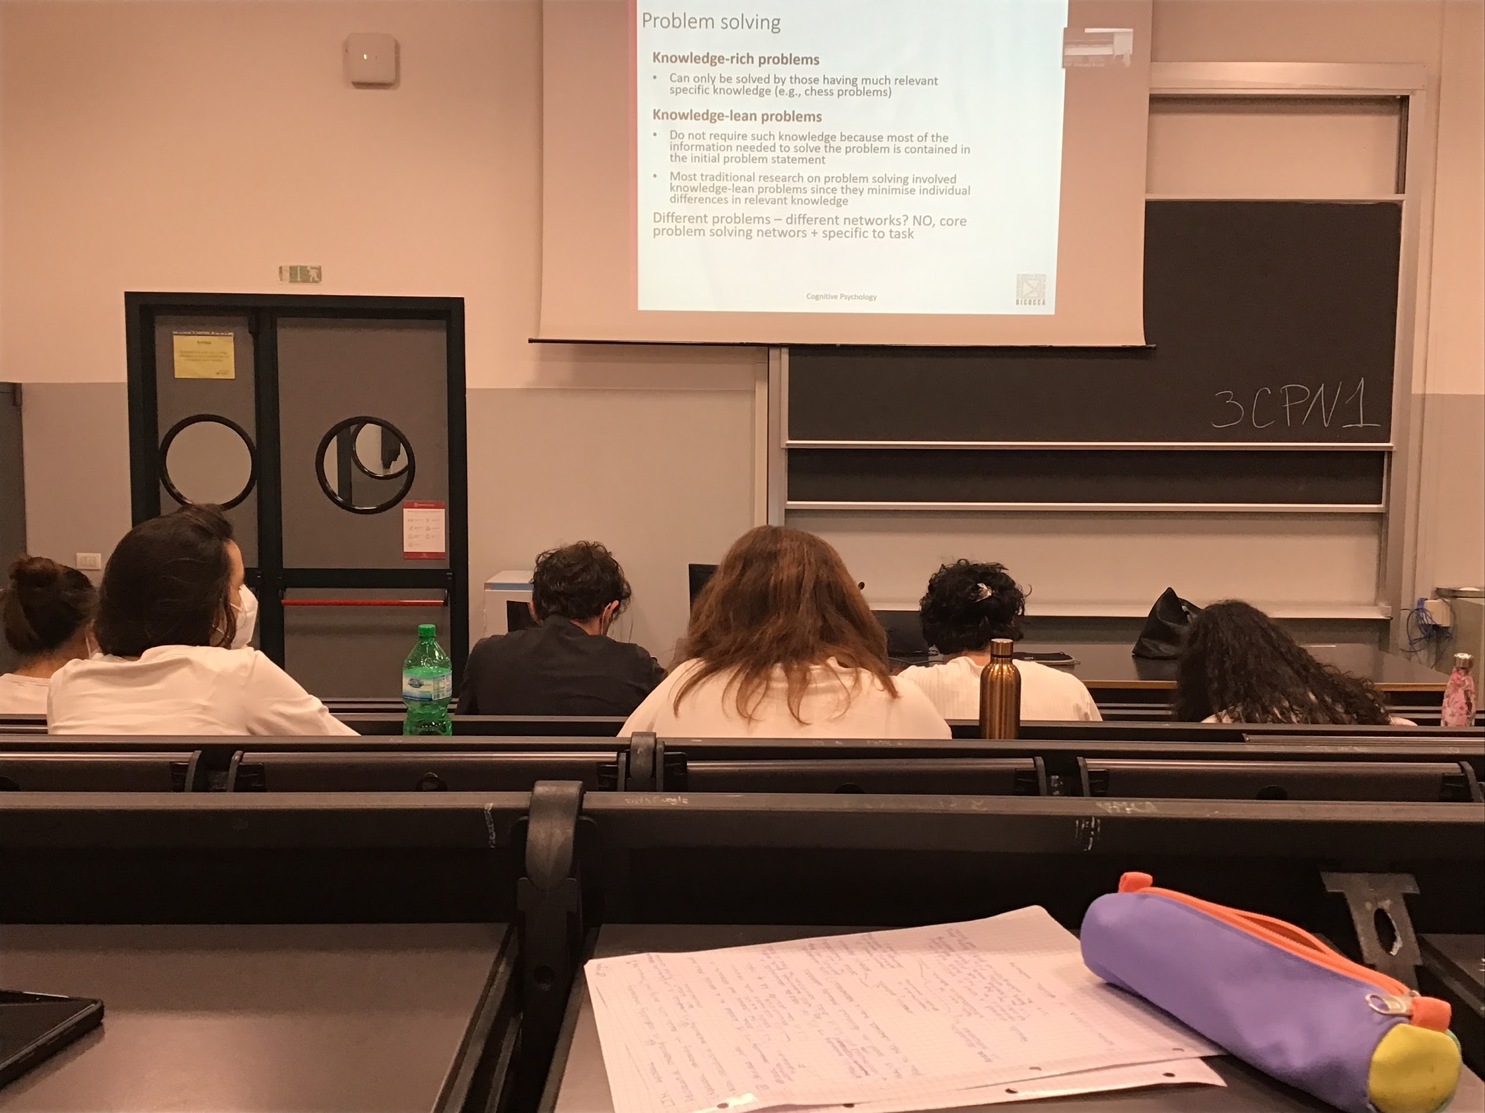

Another distinction:

* **Knowledge rich problem**: to be be able to solve it I must know a lot of stuff (to take the calculus course you have to study calculus), need to be an expert in some way to solve a knowledge rich problem
* **Knowledge lean problems**: problems that do not need to have general previous knowledge

Most research uses knowledge lean problems because if we need to understand how human solve problems I need to find things that do not impact much in personal differences.

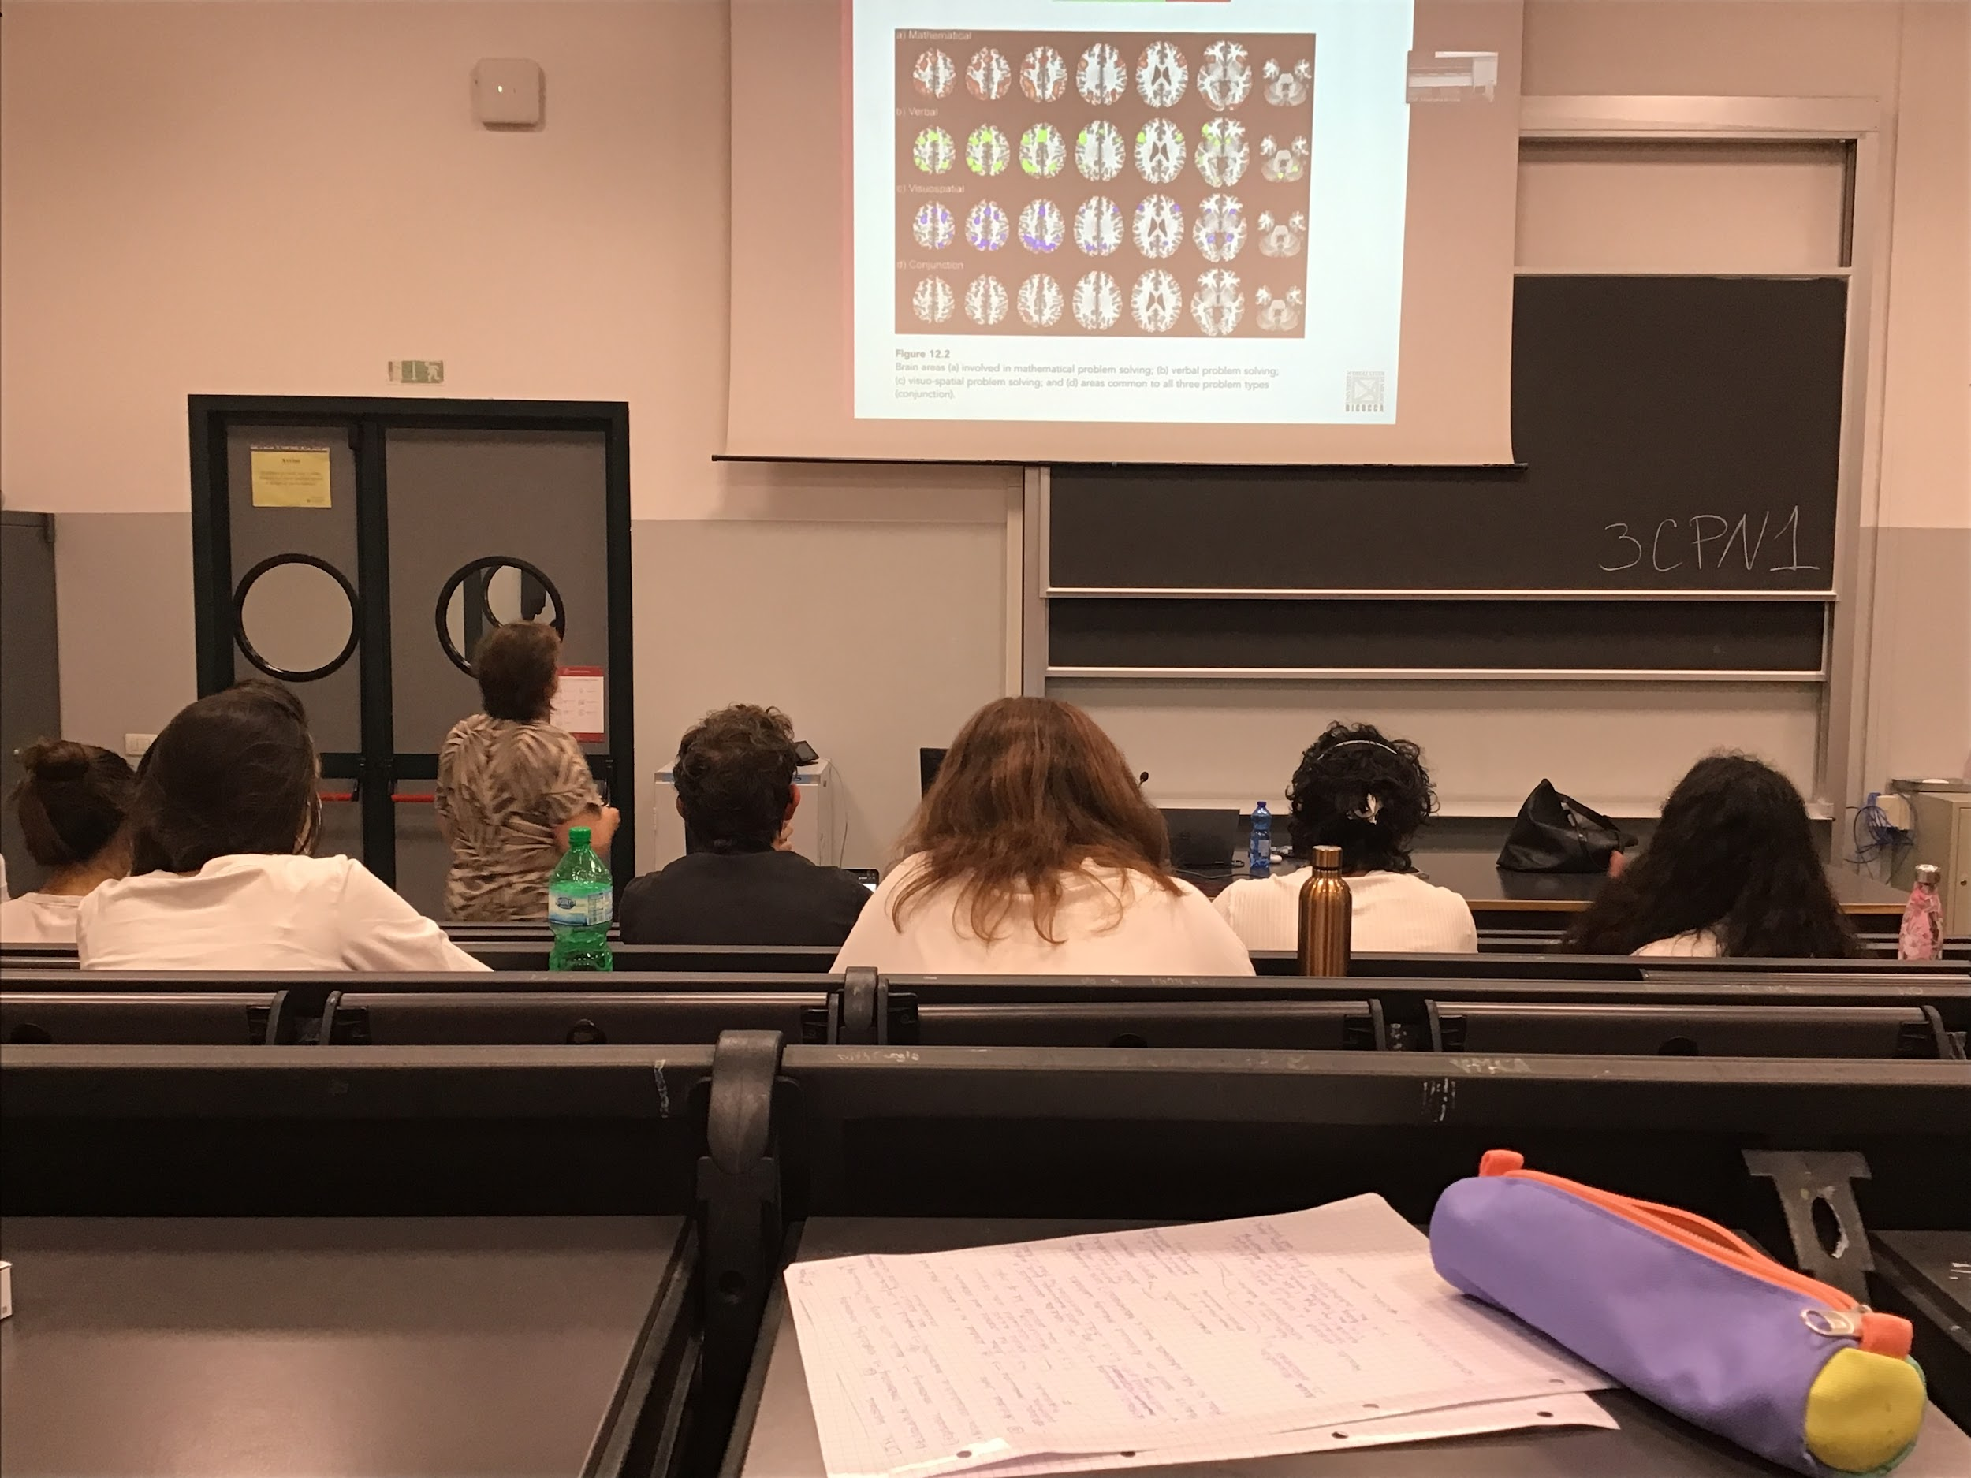

Brain areas activated in all different types of problems

There are areas in common and other areas specific for specific type of problem

In problem solving there is underlying network then enable us to perform task and specific areas used for specific type of problems

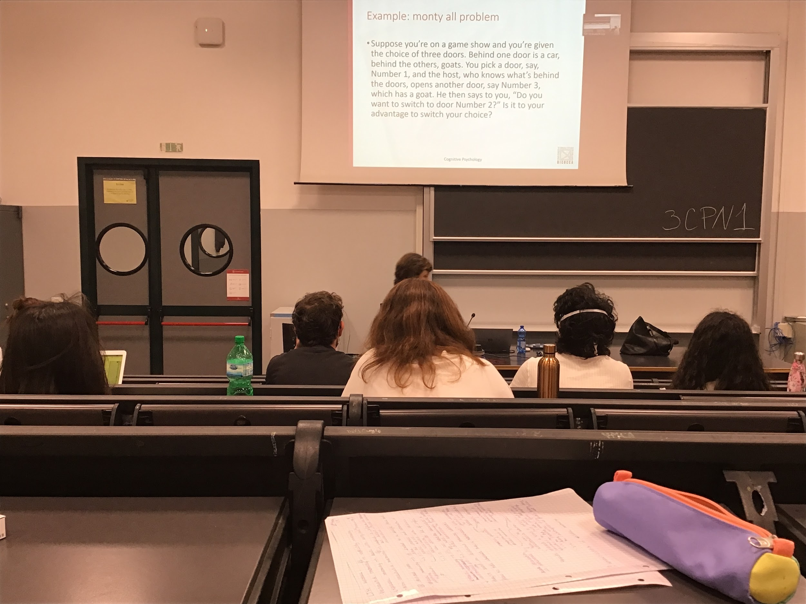

**Monty hall problem**: three doors, behind 1 door there is a sport car and behind the other 2 there is a goat

Open a door that contains a goat

Ask you to stay on your chosen door or switch.

You should switch, higher probability that if you switch you will get the car. The car is not always there, but it have an highest probability

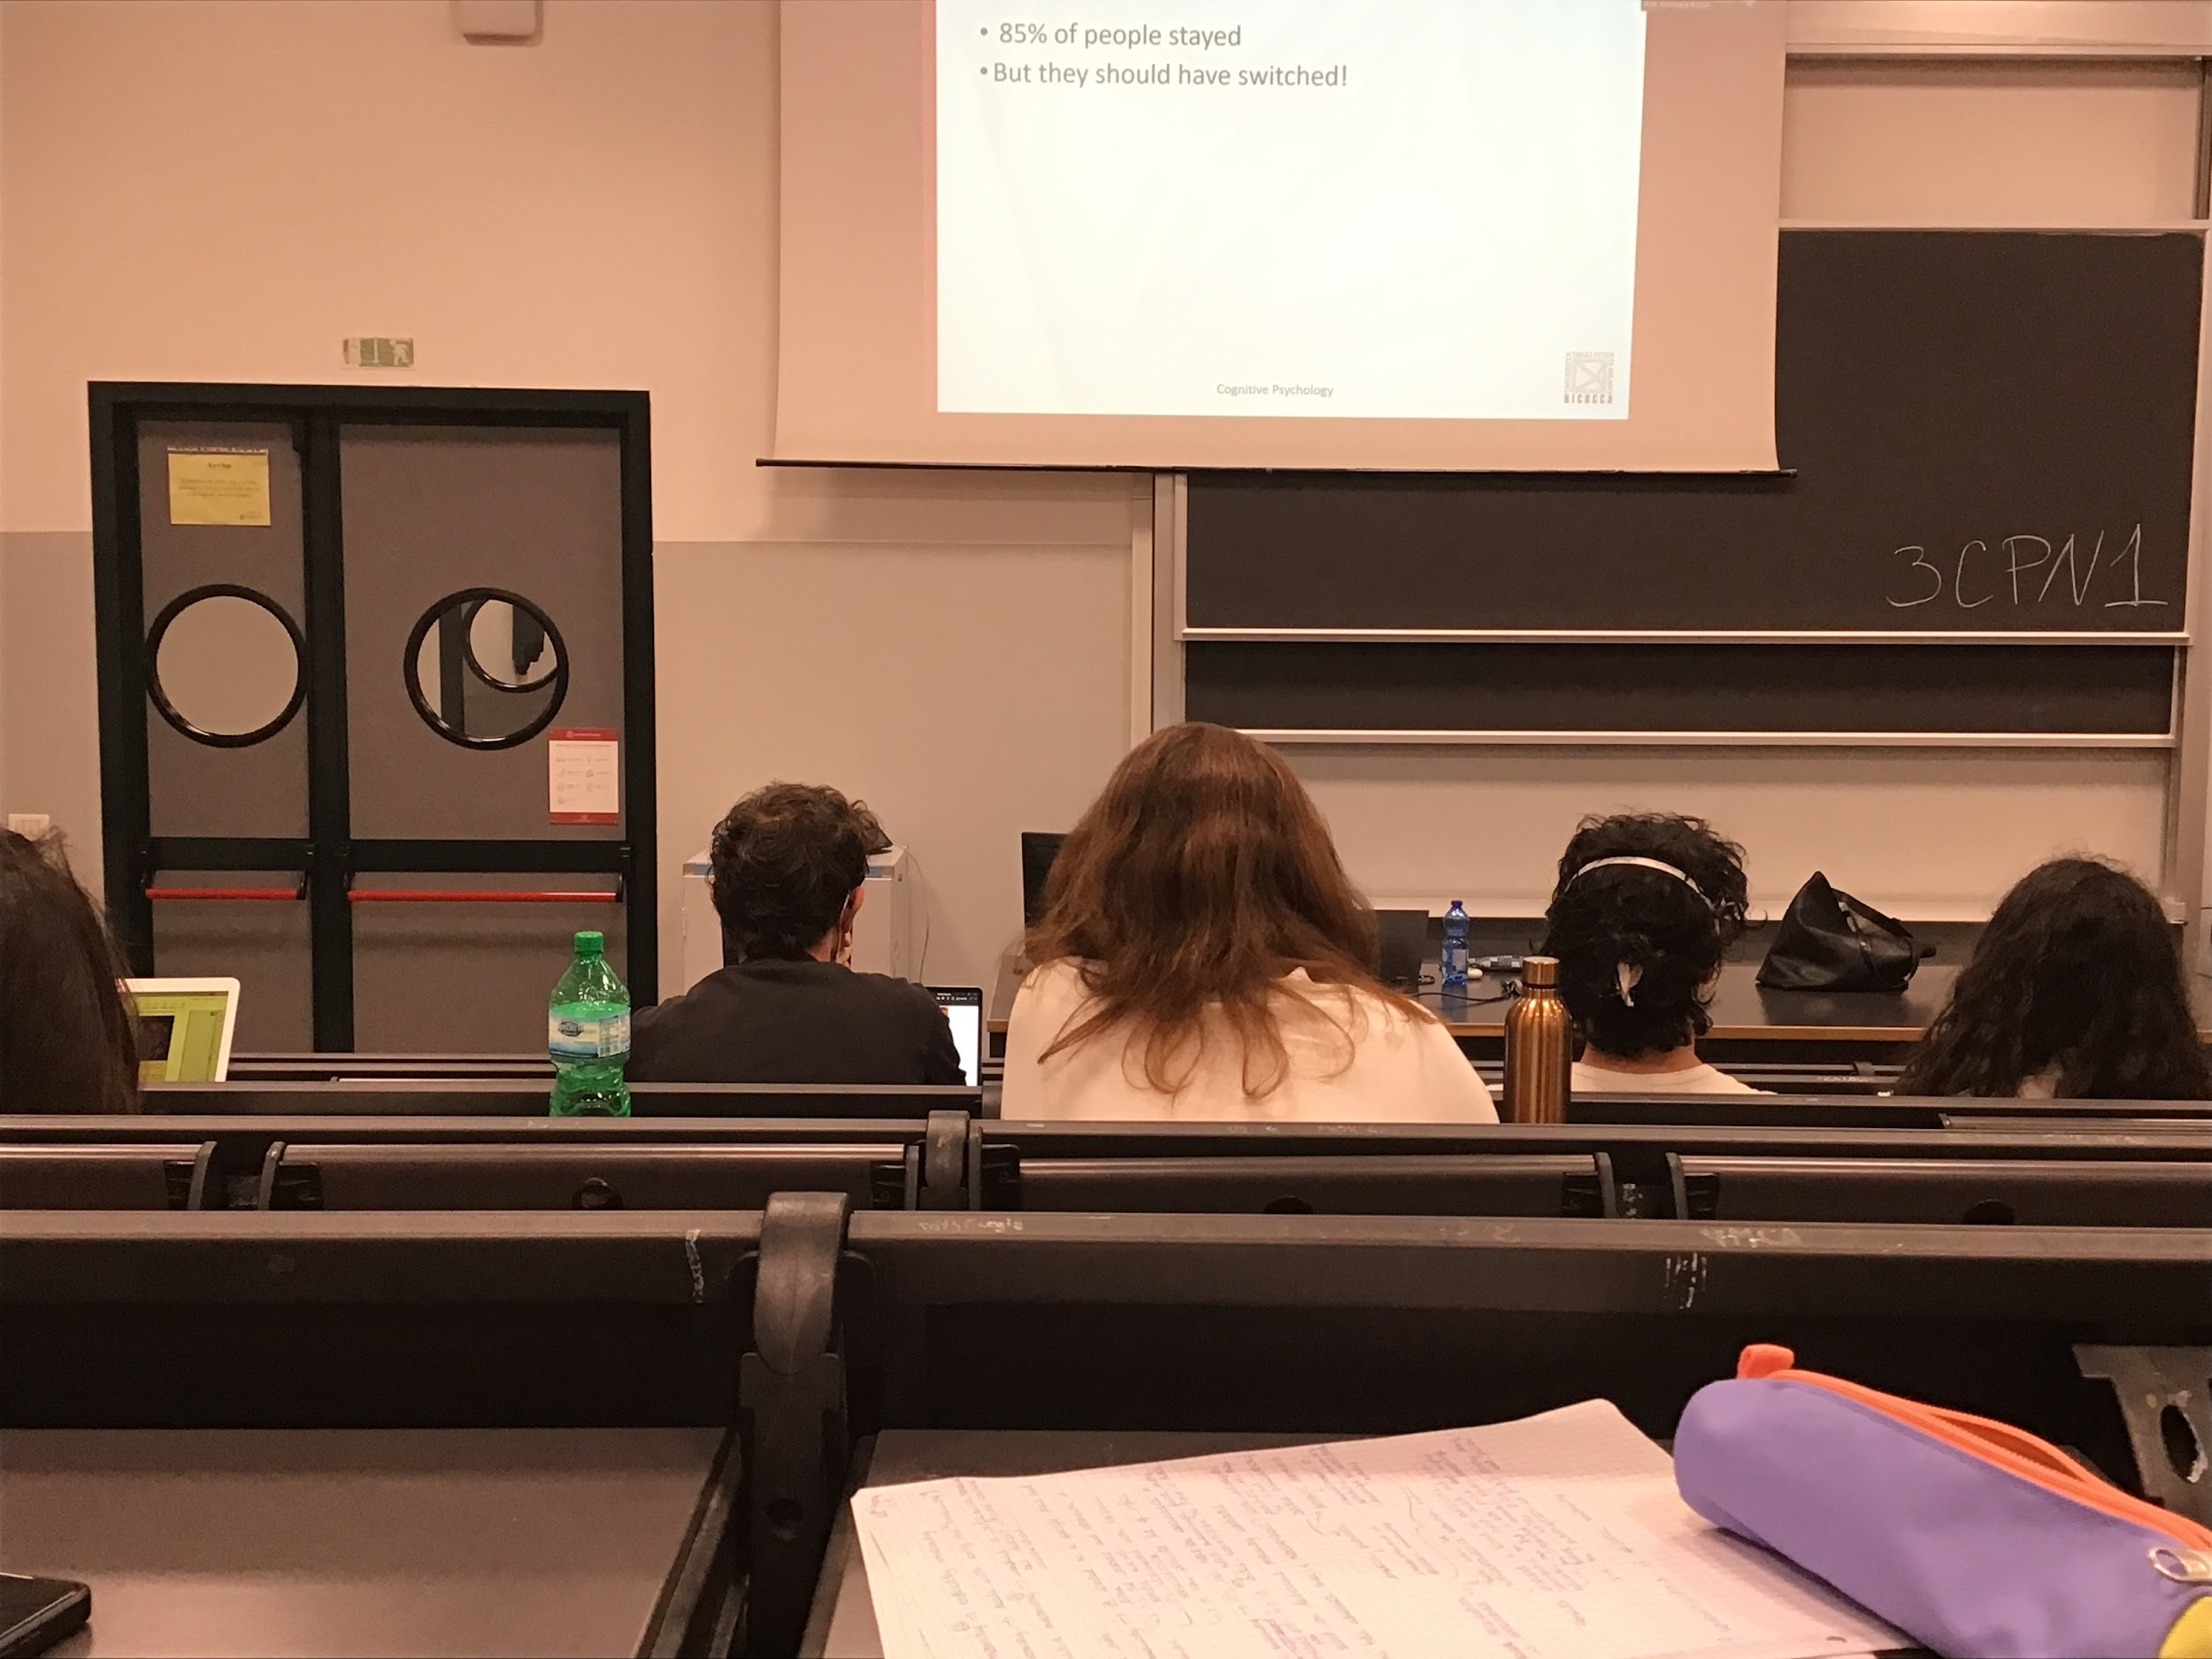

85% stay in their decision

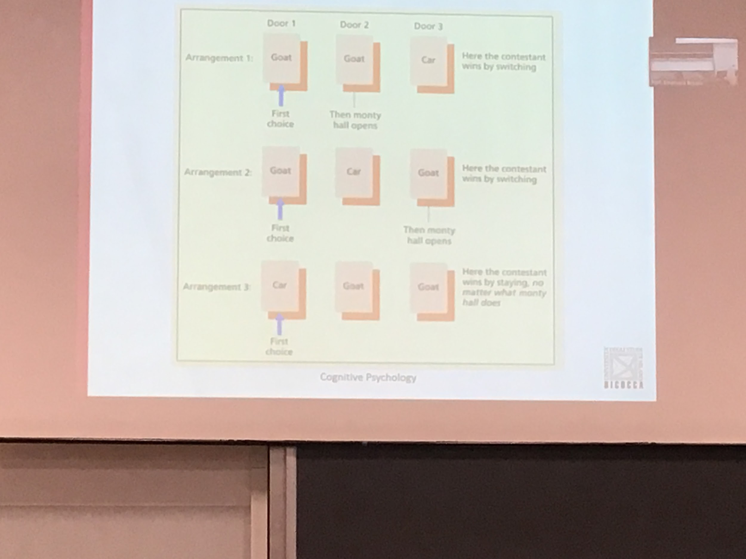

Three possible strategies

2 conditions out of 3 you are better if you switch. 66% of winning if you switch

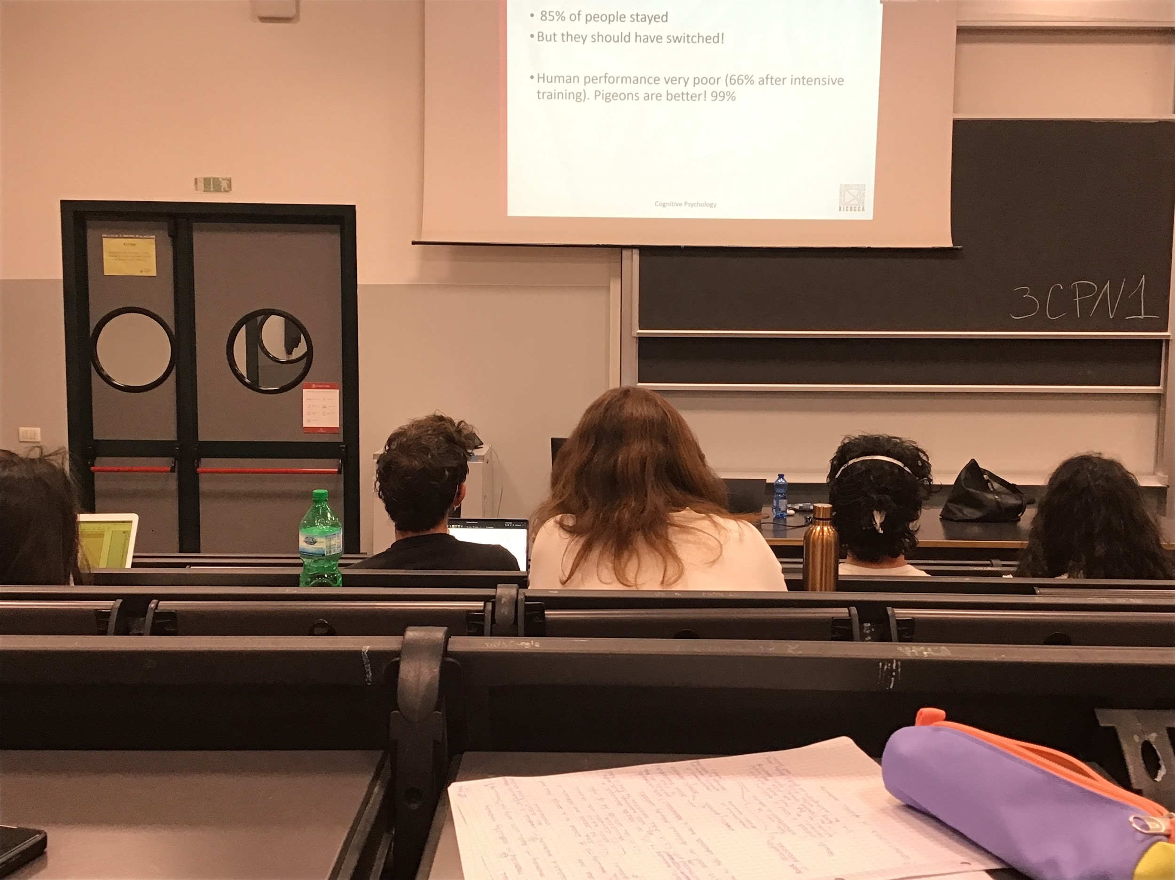

**Human performance is very poor**, even if we try many times with the same task actually people improve and 66% chooses the door, pigeons chooses 99% the task

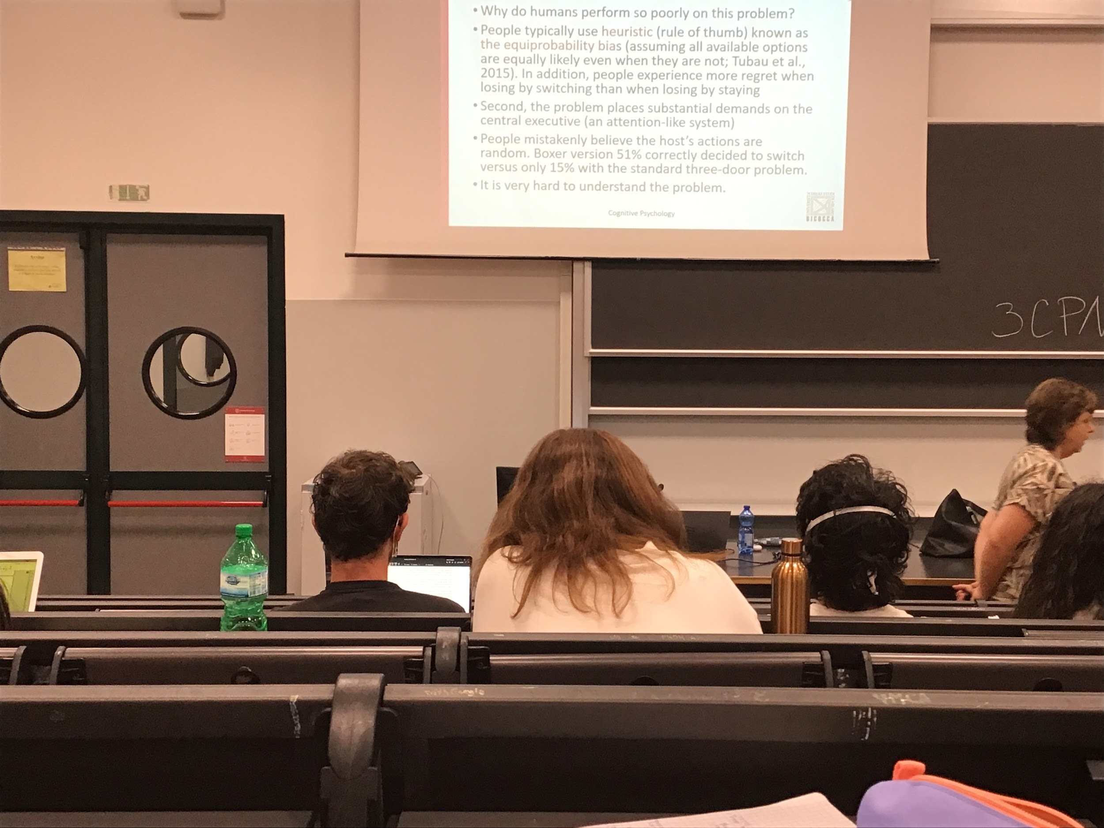

Why are we worse than pigeons?

* We like to use heuristic: the way we choose and solve many problems is to use the rule of thumb. We don’t want to sit down and compute all probabilities and we use an easier rule. For the monty hall problem we use the **equiprobability bias**. We think that all the door have the same probabilities even after the second step, but this is not true
* **Emotional component**: when I do this task many times, every time I switch and I get wrong I weigh the choices much more. Regret more switch when I choose the correct door, so I am not able to learn

It is a difficult problem

We think that the tv host who chooses the door is actually making a random choice, but in reality most of the time is not making a random choice. When I choose the goat he is forced to choose the other goat door, no alternative. Is not a random choice

If we make the same problem with boxers, one wins against the other and you have to select the strongest one. When I understand that the choose of the host is forced that I am much better at this task

Is a combination of reason on why I do not perform correctly on the task

Also it is not easy to construct and understand how to represent the problem and compute the probability. Even if is simple it is actually very complex

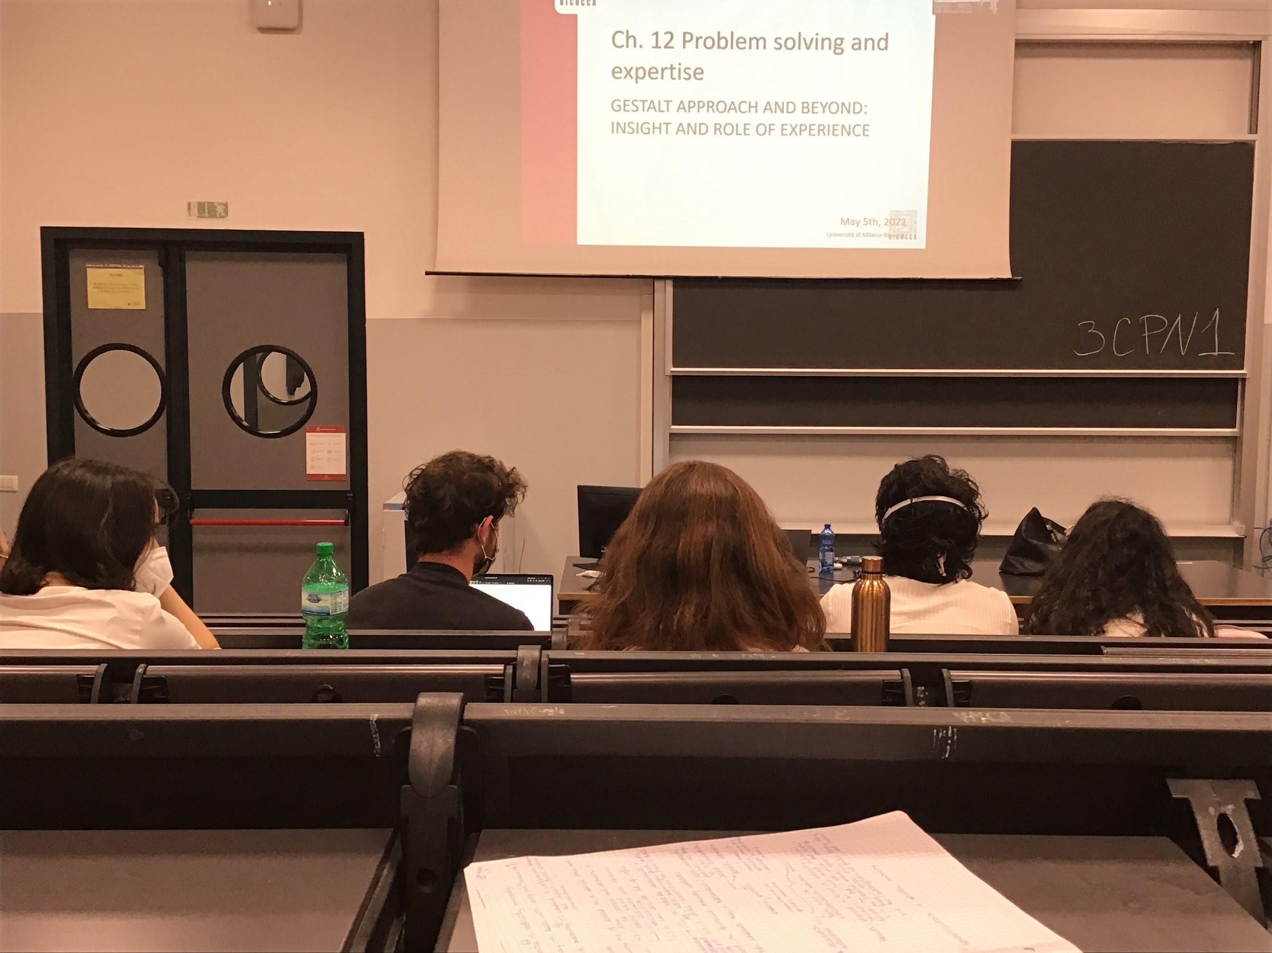

**Gestalt**: there are some laws of grouping. The information is grouped before we perform the choice. There is some underlying structure rules that determine our behaviour, applied also in problem solving

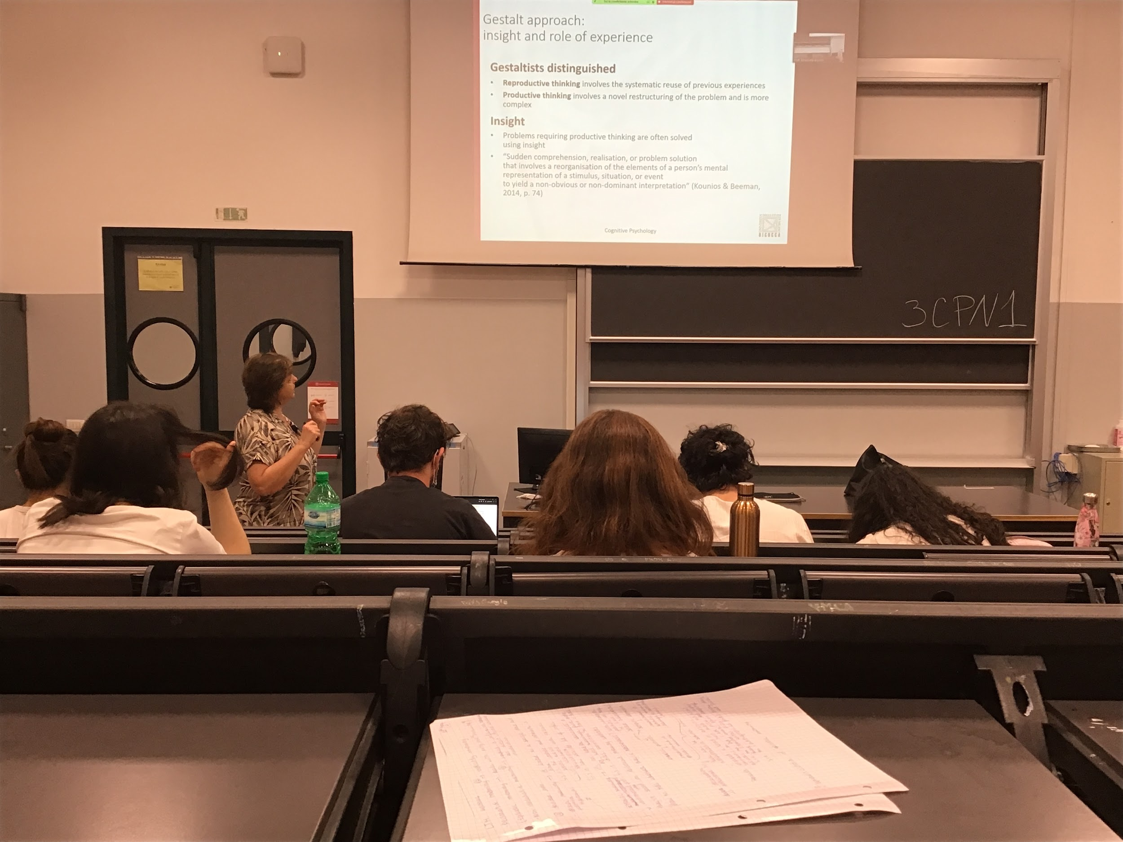

Distinguish between what is reproductive thinking and productive thinking

* **Reproductive thinking**: systematic use of previous experience. I have stored knowledge. I am in a similar knowledge, using what I have done before. Experience modulates my behaviour even in problem solving. Systematic refuse of previous experiences
* **Productive thinking**: the task is more complex, I have to restructure and to understand what the problem is and to find possible solutions

There are some specific situations in which productive thinking is solved not through analytical step by step solution but by insight.

Facing a problem that seems unsolvable, facing different alternatives, none seems correct. At a certain point you see a solution, it comes to your mind. Is not a derivation of your analytical reasoning, you just see how the problem should have been solve, suddenly comprehension that involves reorganisation of the elements

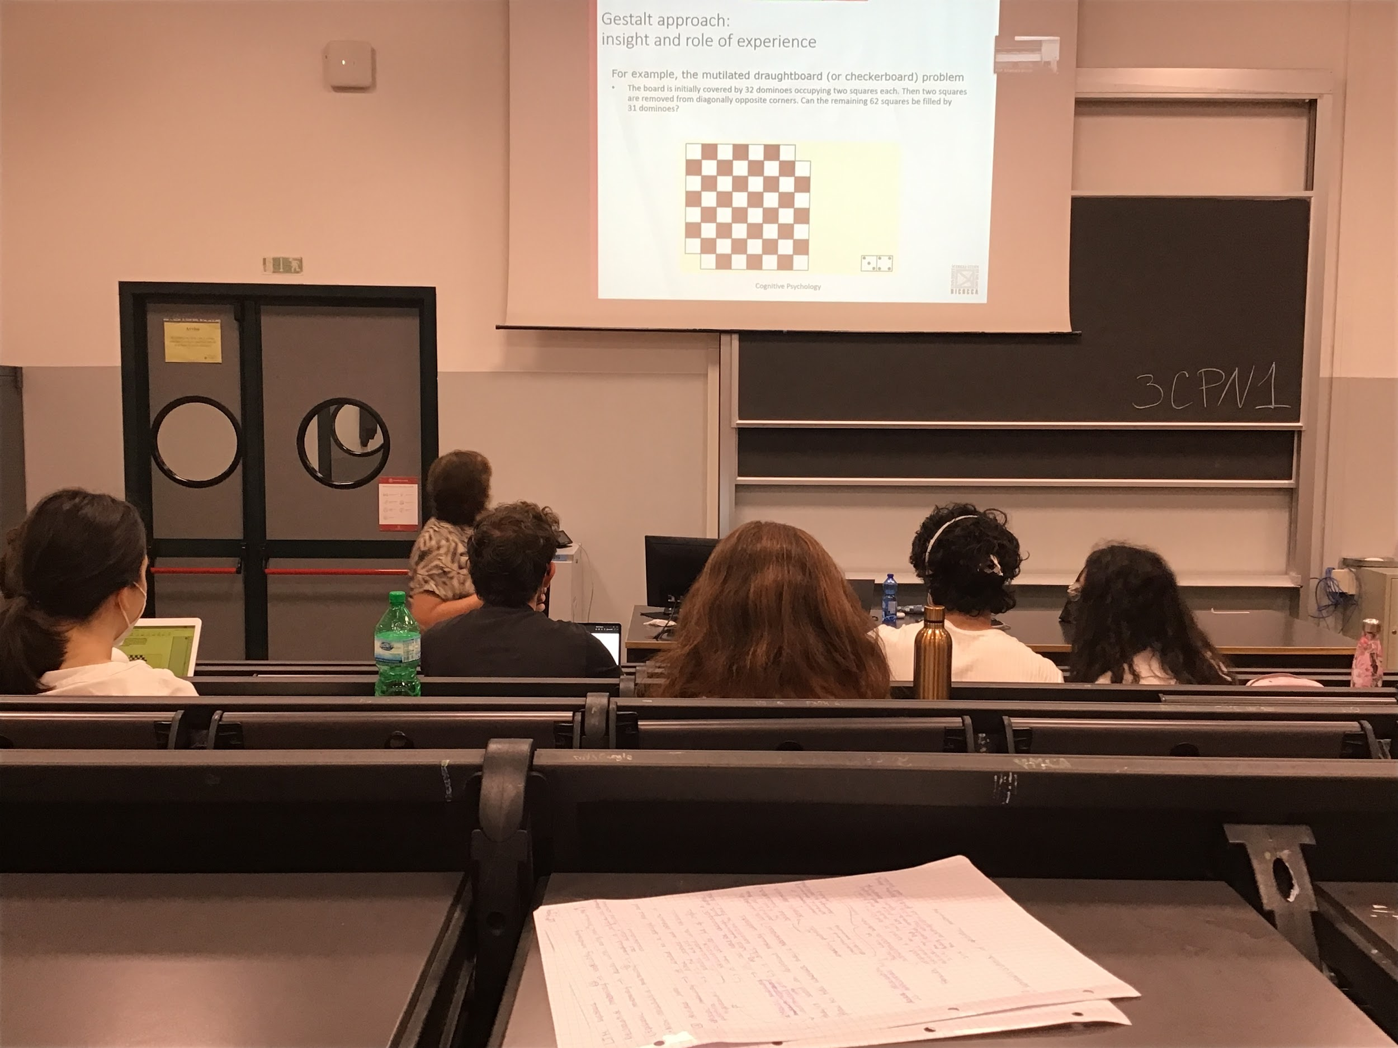

Experiment: rearrange 2x1 dominos to cover entirely the chessboard that does not have two squares

You can spend hours try to solve it, but at a certain point the solution comes out

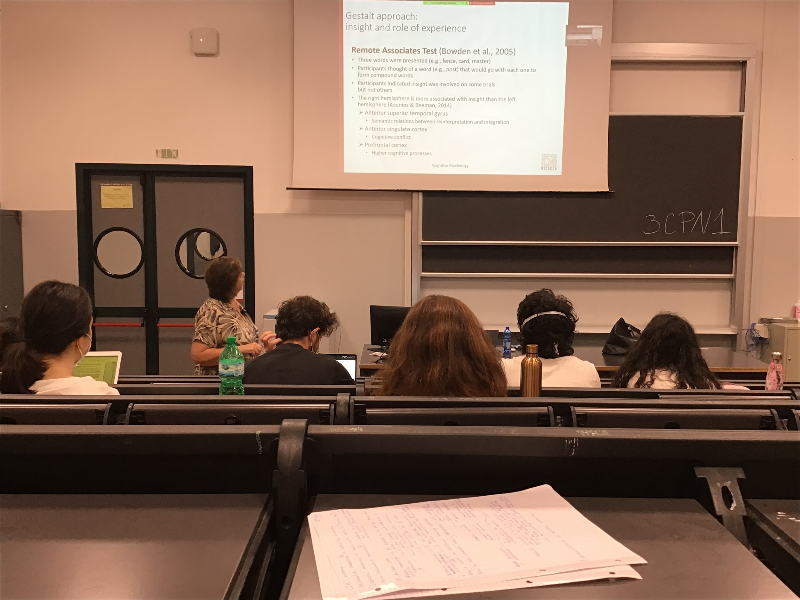

Experiment remote association test: three words, find another word that goes to all of the words and find compound words (parole composte). Try different combinations but you don’t find it, but at a certain point the word comes to your mind.

When you do this type of task ask also people if they solve it by sight (a sudden) or analytically?

Different brain areas are associated with different types of solutions.

* Right hemisphere more insight

There are different brain areas activated during insight and during analytic solution.

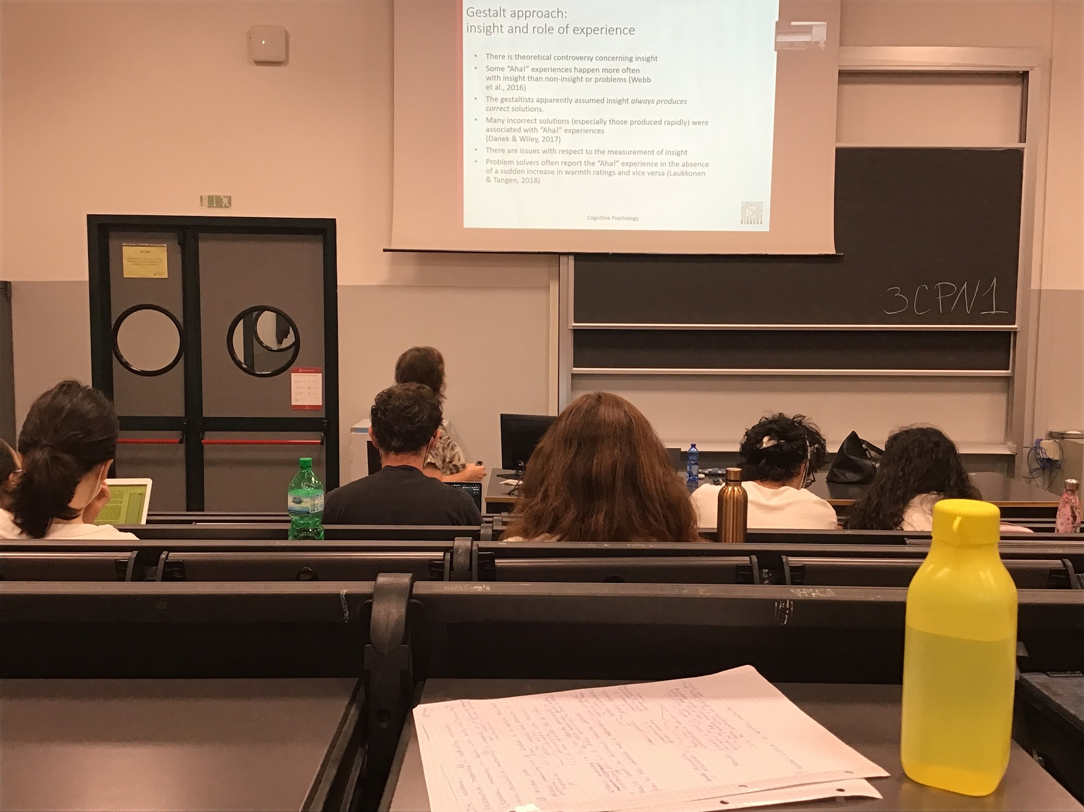

There is a problem with insight. According to the gestalt insight always produces the correct solution but in fact is not true, insight sometimes produces an incorrect solution. It is not very clear how to measure insight?

Not sure you arrived at the solution by insight and not by analytical steps or by exclusion. Very difficult to detect the differences